AASHTOWare Project PAL Plant Inspection Record
Quick Reference Guide

This QRG provides basic instruction for completing a sample record documenting inspection completed at a PAL supplier. For specific instructions on performing the inspection refer to the “PAL Inspection Guide” found in the EPG Section 106.12.

Definitions:
PAL - Pre-approved Acceptance List. Material on this list should have prior inspection and reporting (documentation) before arriving on the project.
PAL ID Number – ID number attached/labeled/fixed to the material shipped that matches the PAL sample record in the system. The ID number must be fixed to the shipment in such a manner that any person approaching the material can locate the number at any time throughout the use of the material.
Sample ID – Unique number for the sample record
Sample Date – Date the inspection was performed.
Note: Separate sample records are required for any samples taken. The plant visit record must be entered in the system first. Use the “Link To” field to tie each sample taken to the plant visit. This field should contain the Sample ID of the plant visit record.

From Dashboard click on
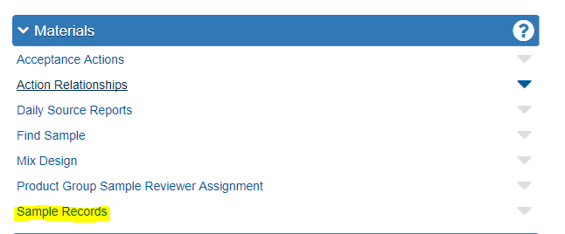

Complete the Sample Record as described in QRG “Sample Record – General” using the specific information listed below:
Sample Type = QPAL-PAL
Material Code = 0106XXPAL PAL Facility Quality Assurance Review
Intended Use = PAL Plant Inspection
Source = The Plant that was Reviewed
Test = Free Form

On the Free Form Agency View (Test), Enter all observations made while visiting the plant, as well as noting any samples that were taken.
Example:
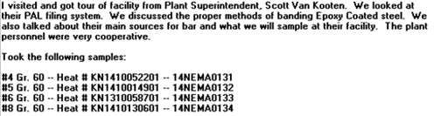

At a minimum the Inspector should include:

- The level of cooperation encountered at the plant.
- A description of the internal quality control program at the plant.
- The packaging, tagging (when tagging is necessary), and handling of products at the plant.
- The level of organization in regard to documentation.
- The plant’s procedure for handling and identifying any material that fails the quality control process.
- Any unusual practices noted during the inspection.
- Sample IDs with material description of samples taken at the plant.

Authorize the Record when/if appropriate

End of Quick Reference Guide

