AASHTOWare Project Regenerating Contract Lines for Original Materials and Acceptance Actions
Quick Reference Guide

This QRG provides basic instruction for the Regeneration of Material Components and Acceptance Actions / Action Relationships to bring back the original sample and testing requirements before any edits/additions were made by the User.
Edits made in the Contract Project Line Items and Contract Materials and Acceptance Actions windows are contract specific and will not carry over globally, or to other contracts.

Note: User must check the status of the Materials Summary before regenerating any lines. The process can and will effect samples records associated to the line intended to regenerate. This process will remove sample record lines associated with the line regenerated and will add them back as long as the regenerated line has the same material code assigned from the “Global” listing. If not, the sample record line is deleted regardless of the sample record status. If you have any questions or concerns, contact program administrators before taking action.

Definitions:
Project Line Item – Unique identifying chronological number associated with a Line Item Code.
Project Line Item Code – 9 digit number representing a specific action required by the contract.
Acceptance Action - The name for an acceptance action.
Acceptance Action Option - A group of actions with the rates and frequencies the actions will occur. An acceptance action option represents one possible way that a material, material category, item, or item family can be accepted for use.
Action Relationship - An action is a test, inspection, certification, or other action performed to or for a construction material or item. An action relationship is an association between an action and a material, material category, item, or item family. You cannot enter information in the system for tests or other actions until an action relationship is created between the action and the object of that action.

Log on using the Role = CM Sampling and Testing Requirements
From Dashboard click on either Contract Administration or Contract Progress and open the specific Contract.
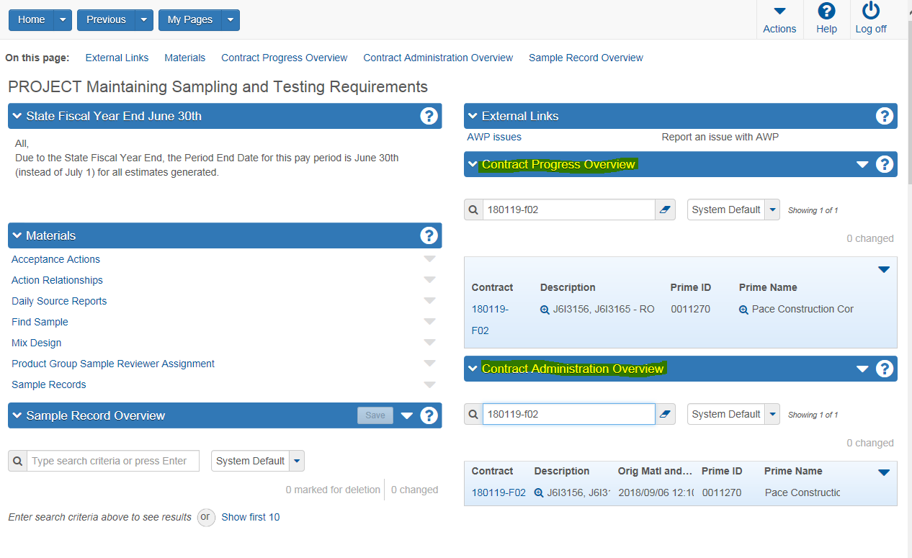

Use the seach bar to locate the contract and click on the contract number to open.
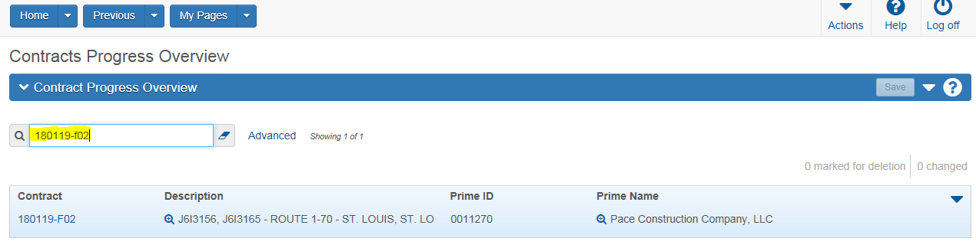

From the upper menu select Items:
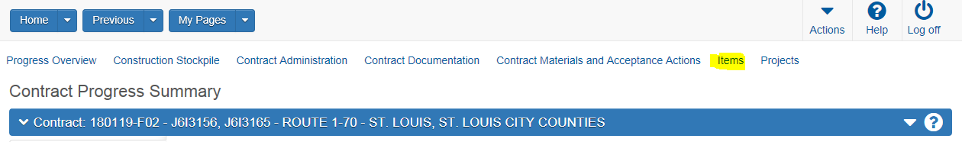
The Contract Items window will open as shown below. On the left side of the window are tabs for; General, Contract Project items, Contractor Items. At the top of the window is a search bar that allows for filtered searches.
General Tab:
In the center of the window is the project specific information, including:
Line Number = Contract Line Number.
Item = Contract Item Code associated to the line number.
Bid Quantity = Planned quantity.
Current Extended = Planned quantity times unit bid price for line item.
Item Complete = indicator on whether the item has been marked as “complete”.
Supplemental Description = Additional description of the line item when necessary.
There is also a diple that when activated will open the line and lists specific information related to the line item.

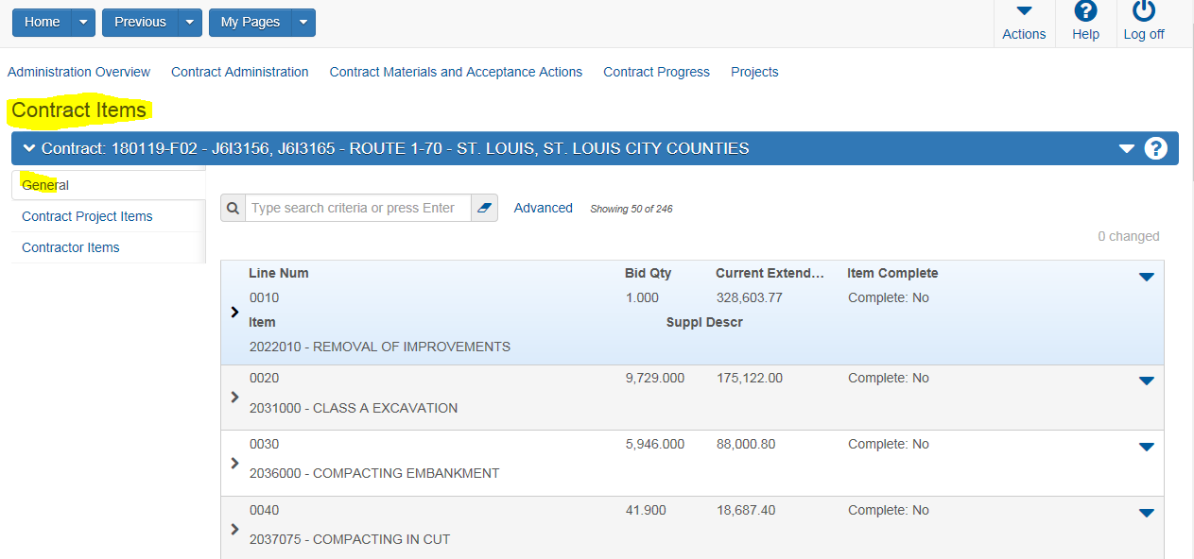

Contract Project Items Tab:
Click on the Contract Project Items link on the left side menu.
This is a complete listing of all the contract lines grouped by project category.

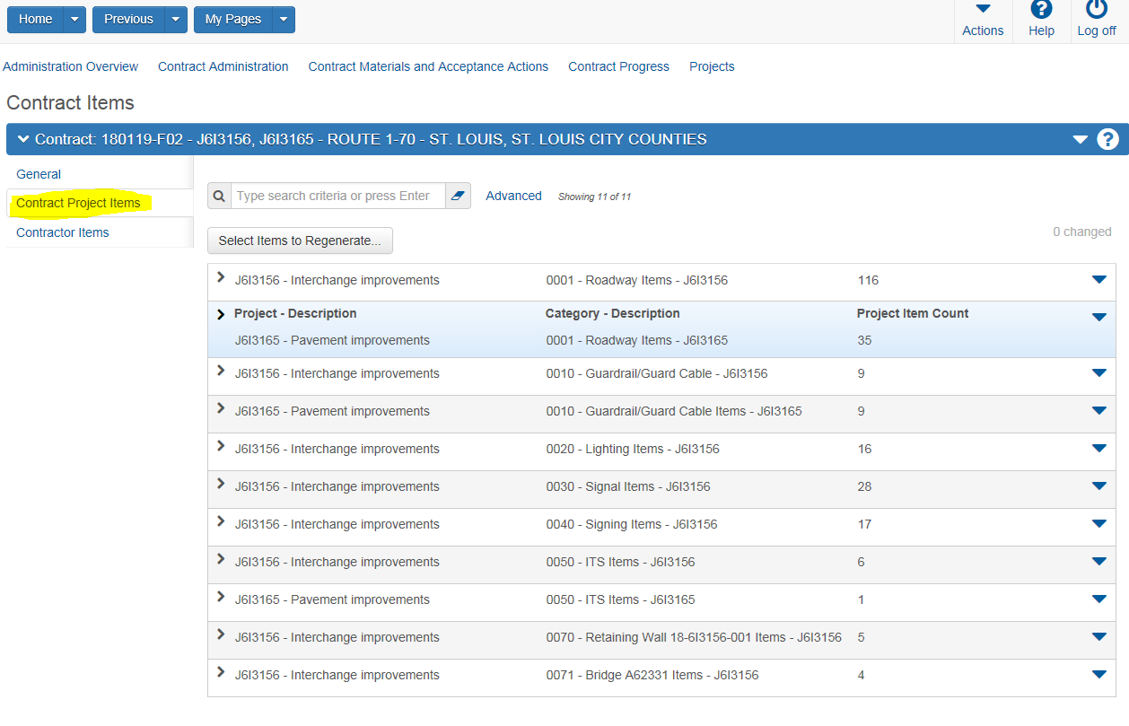

There are two methods to regenerate the original Acceptance Actions for a specfic line. One is to use the “Select Items to Regenerate” button and the other is to use the “Action Arrow” next to the specfic line. Both are discribed below:
Using the “Select Items to Regenerate” button. Select the button
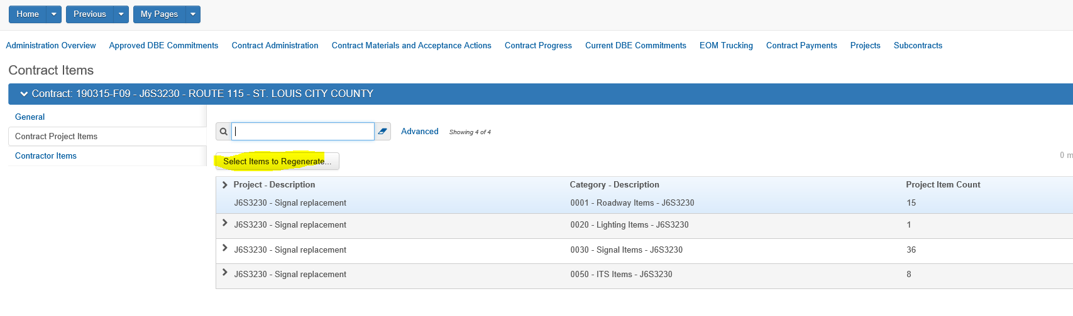
Click in the column next to the line(s) to regenerate. Green check mark should appear. When all sections are made, “Save”.
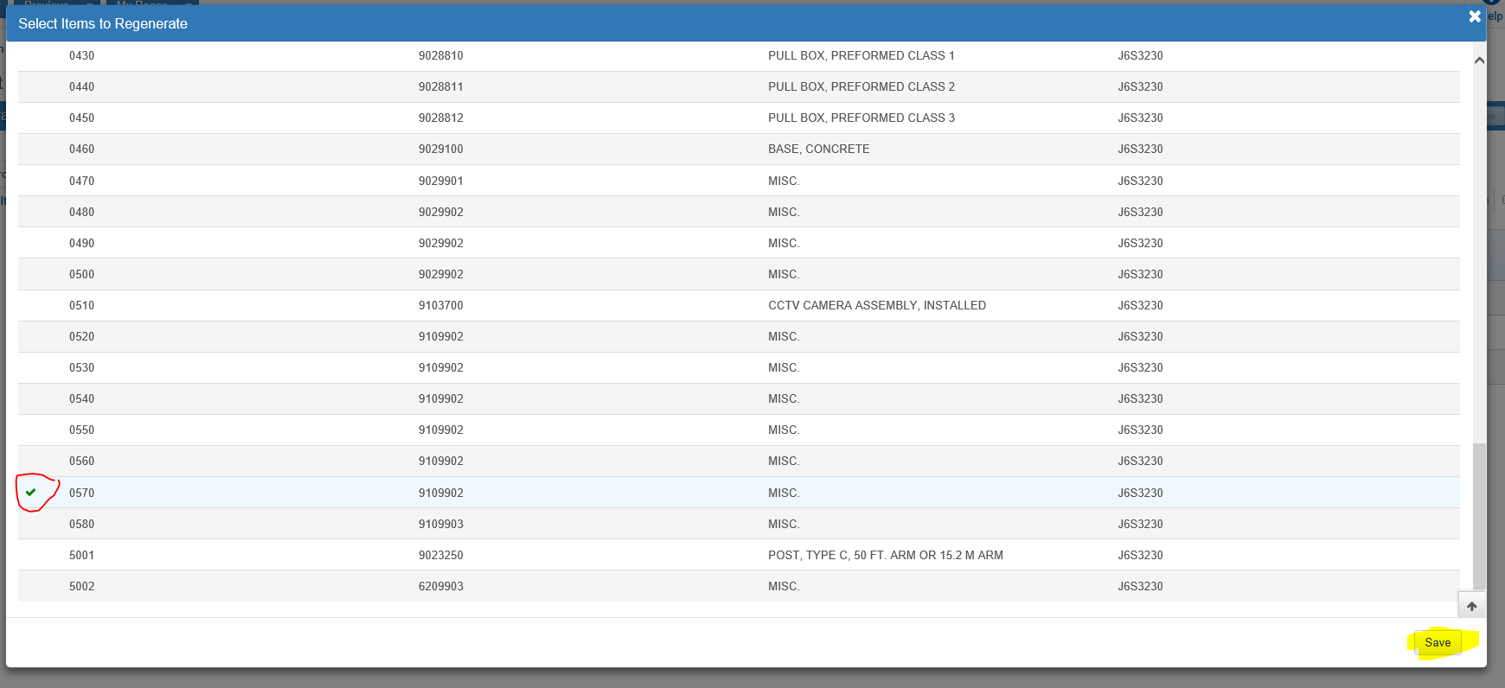

Should see a banner with the message shown below:
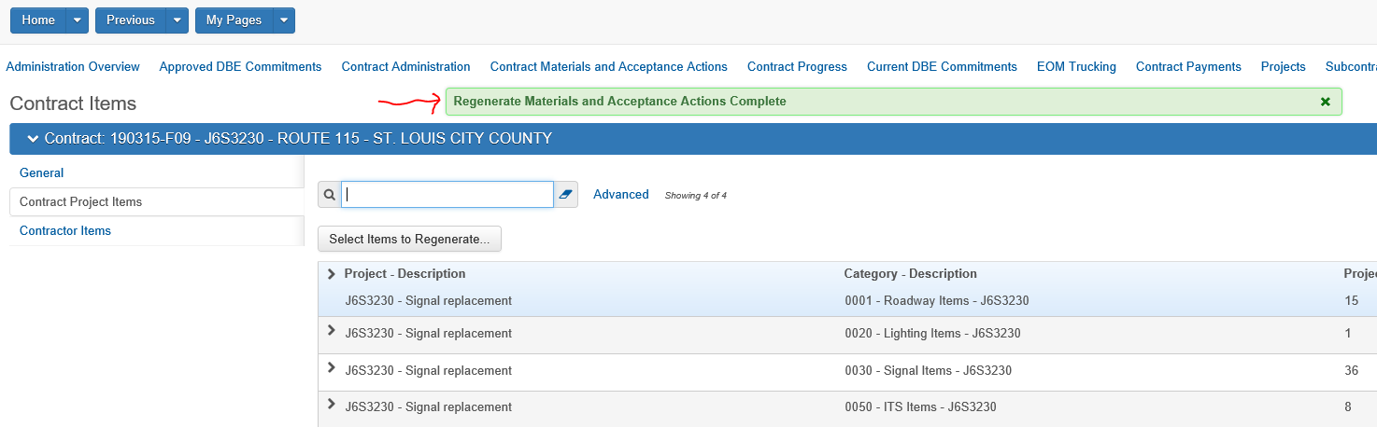
Alternate method is to use the action arrow on the line to regenerate.
Using the “diple (>)” to expand the grouping which contains the line number needed. (0020)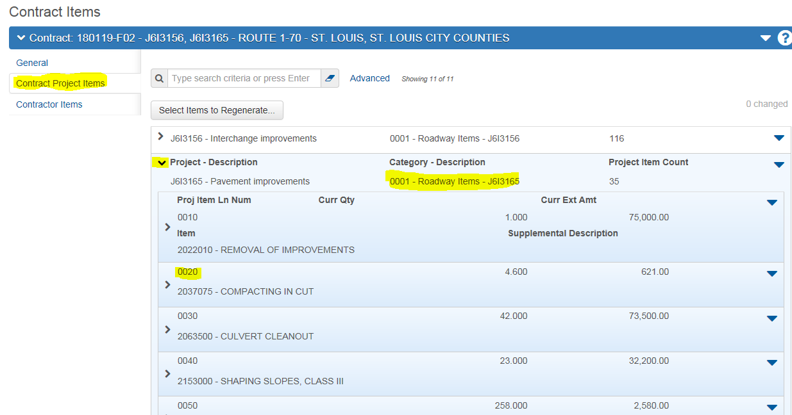

Using the Action Down Arrow for the specific line needed, select the “Regenerate Materials and Acceptance Actions”.
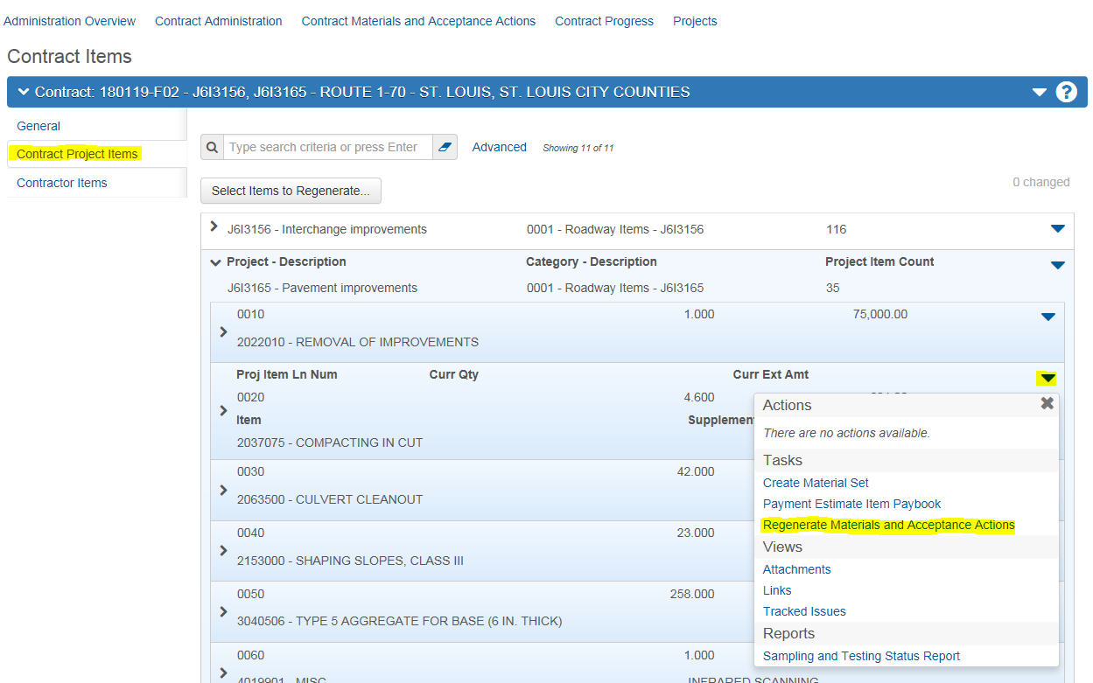

Should see a banner with the message shown below:

Checking back into Contract Acceptance Actions, the specified line(s) have been “taken back” to the original requirements.

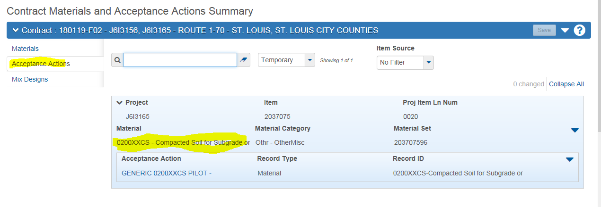

If the line regenerated does not have specfic “Global” Acceptance Action(s) currently set up, the line will not be available to select in Contract Materials and Acceptance Actions. It will need to be added back following the directions outlined in the QRG – MA Adding Contract Lines for Acceptance Actions. (Example would be “99” numbers)
If adding back a Material Code previouly assigned to this line, you could receive the following error message (where the ID # is dynamic):
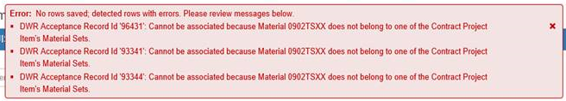

This is caused when there are approved (locked) DWR’s with postings to this line, and when regenerated the tie between Material Code – Material Set –DWR, is lost creating “orphaned” records.
The work around is to temporarily change the Material Set number, save it, add the required material code, save it, go back and change the Material Set to the previous, correct number and save.
The simplest manner is to add “test” at the end of Materials Set number, save, remove “test” and save again.

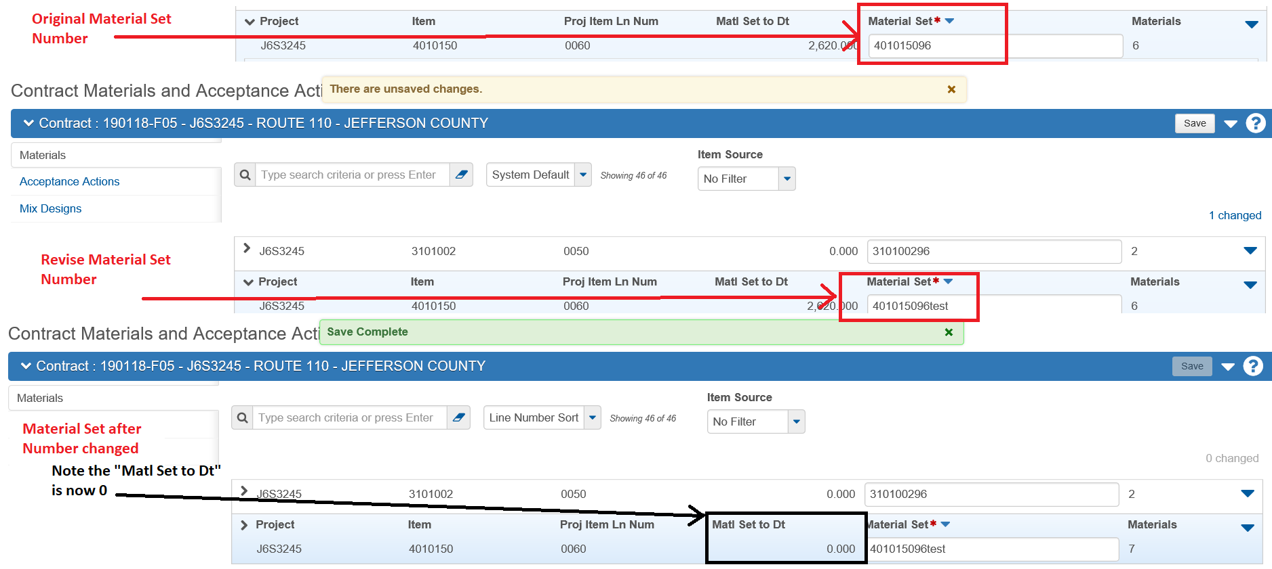

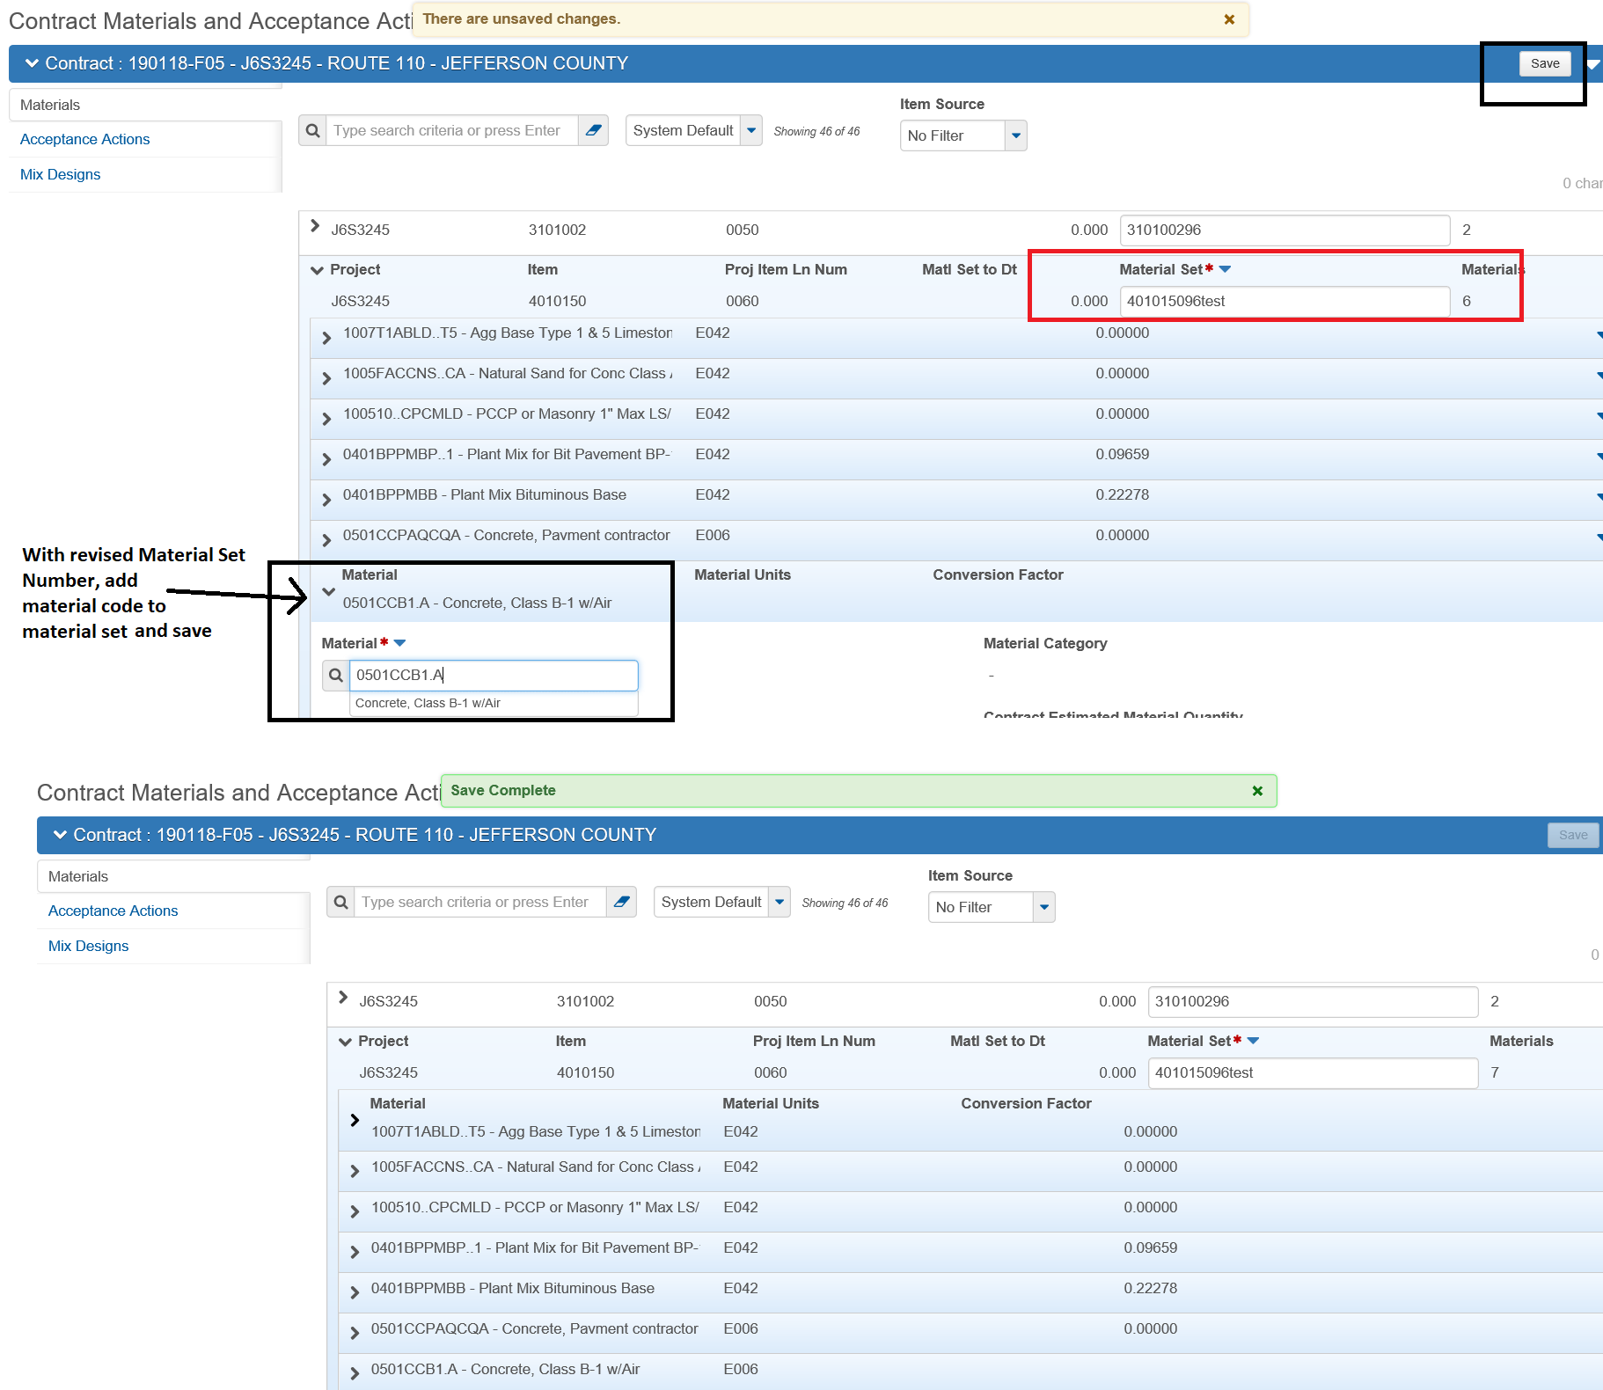
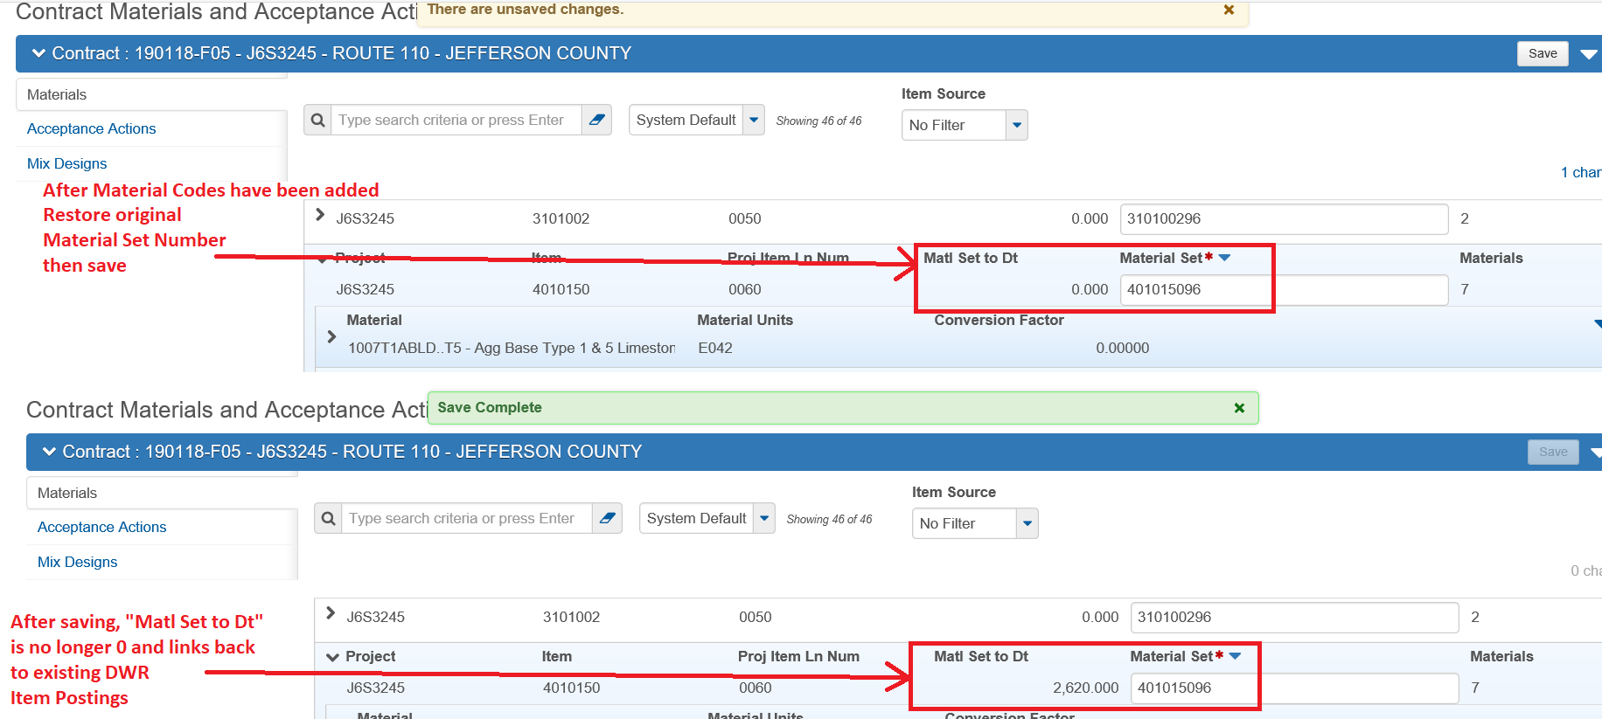
End of Quick Reference Guide

