AASHTOWare Project Accepted By Certification Sample Record
Quick Reference Guide
This QRG provides basic instruction for the creation of a Sample Record specifically accepting material based on a certification document

Acceptance based on a letter of certification is specifically allowed by specification (Specification Book or Job Special Provisions) for some materials and/or under specific circumstances. Before creating the sample record, be sure to read and understand the specific acceptance specification and record the specification number for reference in this sample record.

NOTE: Refer to EPG Section 106.19 for complete guidance on policy and procedures related to material acceptance based on certifications.

Regardless of the material type, the inspector must receive a written certification statement meeting the following requirements. This statement is required to be saved in the approved electronic contract storage area.
EPG 106.19.1.4
Statements Required from Contractor. The contractor shall state that based upon knowledge of the material or upon certifications, the material meets requirements of the listed specifications. The foundation for this statement shall be attached, and shall consist of supplier's, fabricator's, and manufacturer's certifications, or manufacturer's certifications, if purchased directly. Such contractor's statements need not be notarized unless specifically required by specifications. When samples are submitted by the contractor or the contractor's supplier to our laboratory for tests, the contractor shall certify that the samples represent the material which will be used.
Fabricator’s or Jobber’s Certifications. They shall state that the fabricator or jobber is familiar with requirements of the specifications for the project, citing section and paragraph numbers, and certify that the material came from lots which meet requirements as supported by attached manufacturer's certifications. All statements and certifications shall be identified by contractor's name and project number.
Manufacturer’s Certification. Manufacturers shall state that they are familiar with requirements of the specifications and certify that the material meets requirements of the cited sections and paragraphs. Mill test or typical analysis results shall accompany or be a part of the certification when applicable. The contractor's name and project shall be shown on the certification except when material is supplied to a fabricator or jobber for stock for sale to a number of contractors.
Check of Certifications for Suitability and Completeness. Certifications and statements should be checked by project forces or by district materials personnel or each may check particular portions of the certifications. Certifications should be checked against specifications to see that section references are correct, and that any test values reported comply with requirements. Certifications should be checked against material supplied to determine that the certification is applicable and valid.
Certifications, required by specifications, are to be specific as follows:
a. Company name and address
b. Material being certified
c. Statement that the material or product complies with the designated specifications, including explicit reference to those specifications, any subsections, and any detail necessary to clearly indicate the characteristics of the material.
d. Date certification was prepared
e. Batch, Lot, Heat or other identifying mark, as may apply, to clearly identify the material being certified.
f. Contract and project numbers when the contract requirements differ from the general material specifications or when the contract requires the certification be contract specific.
g. Applicable test data, when required.
h. Signature of an individual authorized to represent the company.
Summary. Certifications should be specific and:
a. Make reference to the particular specification in sufficient detail to show beyond reasonable doubt that the company is familiar with requirements of the contract.
b. State that the material or product meets those requirements. Certification should, if available or required, include applicable test data.
c. State that the certification applies to that material which was supplied for that particular project.
Certifications must be supported at project and district level. Field inspection reports and letters of transmittal should show that:
a. The certification has been examined and shows compliance with contract requirements.
b. The certification is believed to be applicable to the material delivered for the project.
c. The material has been examined and it is believed that it does meet contract requirements.
In order to assure that all these points are covered on the inspection reports for material accepted on basis of certifications, some statement such as the following is necessary: "Based on examination of the attached certifications and an examination of the material, we believe that the certifications are applicable and that the material conforms to the requirements of the specifications. Material accepted."

Follow all directions given in the QRG – Sample Record General, except as follows.

Sample Type = District Project
Acceptance Method = Certification Review
Assigning Tests:
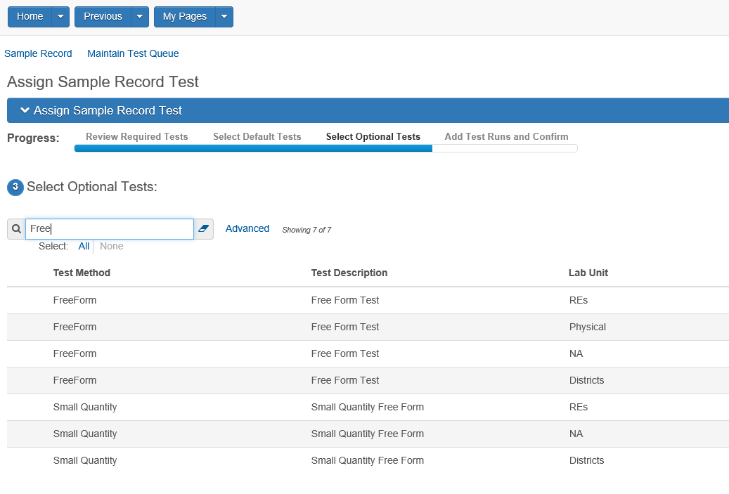
Add the test that represents who/where the certification was reviewed.

To enter test results, make sure the specified test is highlight and select the action arrow on the right side (downward pointing arrowhead). Below the Category “Views” you will find the available Agency Views associated to the highlighted test. Click on the highlighted view shown below:
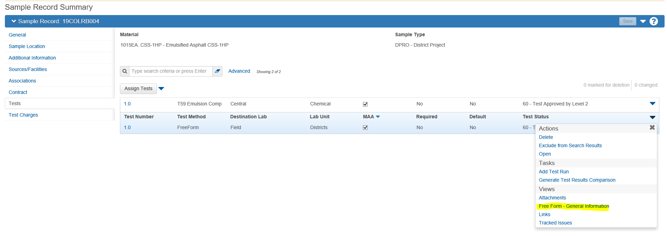
Add a statement as required in EPG 106.19.1.4. Authorize the record as detailed in QRG Sample Record - General
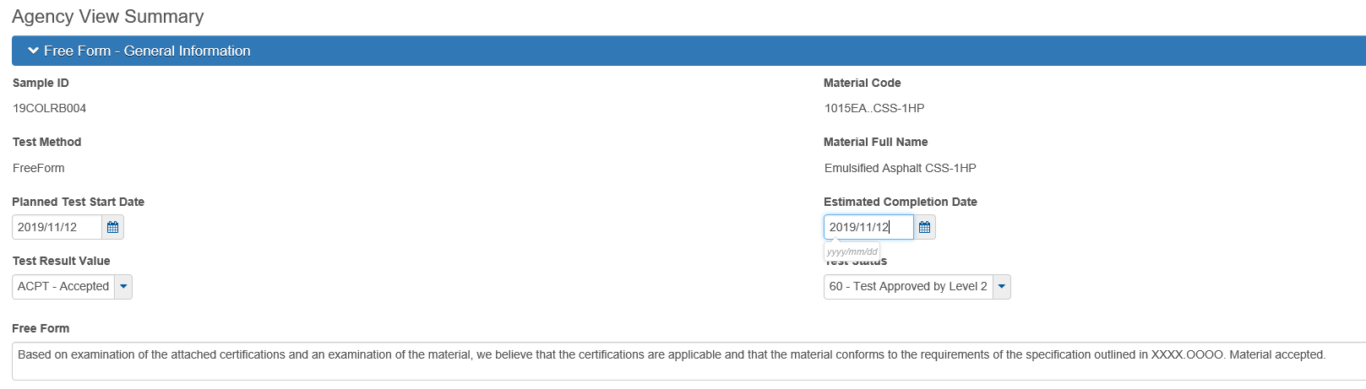
End of Quick Reference Guide

