AASHTOWare Project Sample Record – Changing Sample Type, Material Code and/or Source
Quick Reference Guide
This QRG provides basic instruction for the making changes to an existing sample record “Sample Type”, “Material Code” and/or “Source”, on a saved sample record.

Please study QRG Sample Record-General for guidelines on creating a Sample Record.
Open the sample record by which ever means preferred.
If the record is authorized, it must be unauthorized before changes can be made. This requires Role = Sampling and Testing Requirements or Role = Resident Engineer. Contact the District Materials Department for assistance if needed.
To remove authorization from a sample record, select Unauthorize from the Actions menu on the sample window. The system clears the values in the Authorized By and Authorized Date fields and saves the changes automatically. The sample record is no longer read-only and can be modified as needed.
Note: All tests must be removed (deleted) before any changes can be made to the Material Code, Source or Sample Type. Be sure to have the tests results saved elsewhere before deleting the tests as you will need to add the tests (and results) back before re-authorizing the sample record.
Also – note the Sample Status field after deleting tests. It should be blank. If not, try refreshing the screen (F5). It will need to be changed to approved after adding back test(s) and test results.

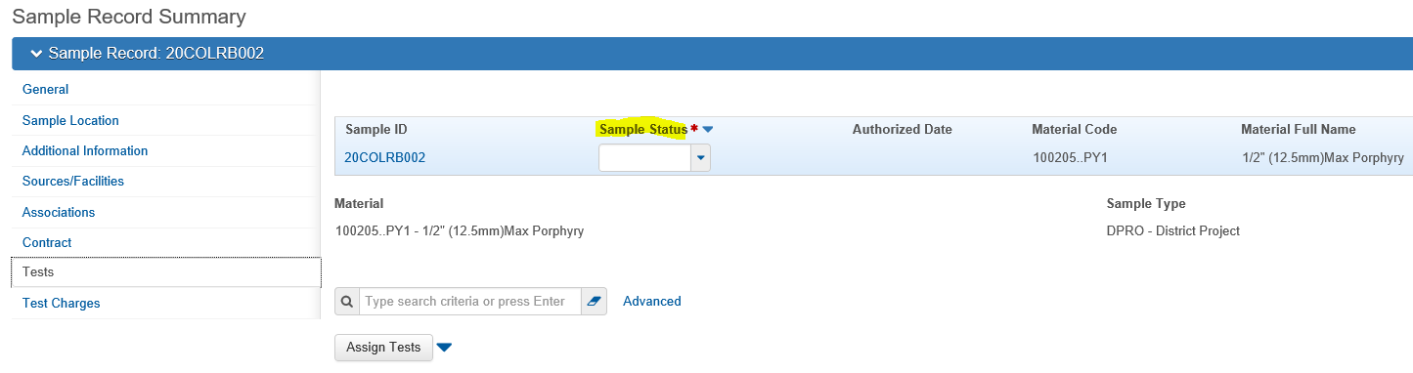

Sample Type Change:
Once the test(s) have been deleted the Sample Type can be changed and saved without further actions.
Materials Code Change:
The Material Code and the Source are associated (linked) in a manner which once a Material Code is selected, the Source(s) available will be limited to the Source(s) which have the selected Material Code associated to it.
The Material Code can be changed to another product (Material Code) that has been associated to the same Source prior to making the change. (As long as all test have been deleted).
Note: Anytime you make change in the Material Code, change the “Represented Quantity Units” to match the new material or the record may not save correctly. If you are getting the message “Save Successful” and the material keeps reverting back to the prior code anyway, the problem most likely is the Represented Quantity Units were not changed or not changed correctly.
If the Material Code you require does not have the current Source associated (not available to select from Source list), contact the District Materials Department and asked for the needed Material Code be associated to the Source. See AWP MA QRG - Associating Materials to Sources/Facilities.
Once added to the Source, the Material Code can be changed. (Refresh sample record window, F5 on keyboard, before changing material code).
This assumes a Source change is not necessary.
Source Change:
A Source may be changed by selecting a different Source, as long as the new Source has the current sample record Material Code associated to it. If the Source is not available in the source listing, the material code is not associated. Contact the District Materials Department and asked for the Source to have the needed Material Code associated to it. See AWP MA QRG - Associating Materials to Sources/Facilities.
Once the material code is added to the Source, refresh the sample record window and the new source should be available in the listing.

Material Code and Source Change:
If the Material Code and the Source both need to be changed, and the new Material Code should not be associated to the existing Source, please follow the steps below:
- Change the primary source to 300000000X “Producer Supplier not designated.”
- Refresh the page (hit F5) so that AWP recognizes the Primary Source has changed.
- Change the material code “Save”
- Change the primary source based on the revised material code

If the material code is not associated with Source = “Producer Supplier not Designated”, contact your District Materials Department or ReDEV and request it be added.
Note: If the needed source is already listed as an additional source, you cannot add it as the primary source. You have to delete the additional source before you can select that source to use as the primary source.
End of QRG

