AASHTOWare Project Sample Record - General
Quick Reference Guide
This QRG provides basic instruction for the creation of a Sample Record.

Note: Automated spreadsheets are available for use that will create the sample record in AWP. Either method is acceptable, creating the sample record manually directly in AWP or using the spreadsheets. This guide should be used to generate an understanding of the full principles of creating a sample record regardless of the method used.

QC spreadsheets (CRE2O) are located on the MoDOT website:

Contractor Resources/Quality Management/
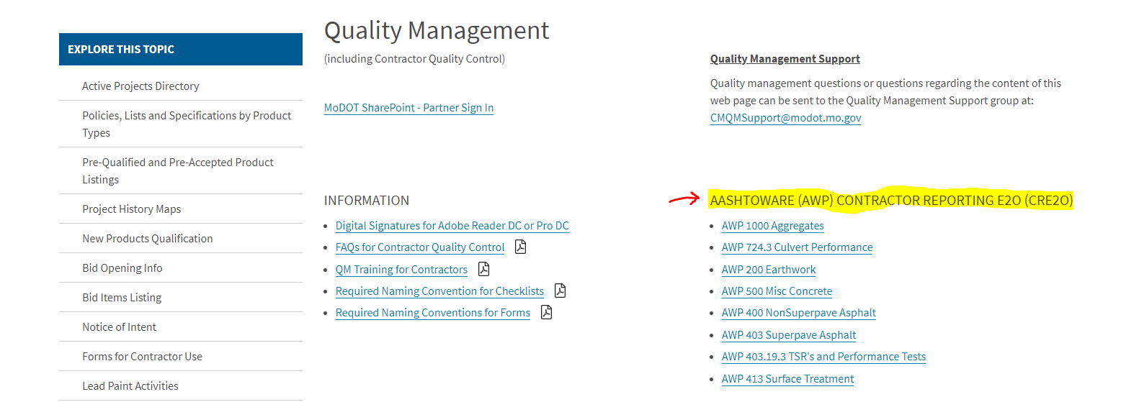

QA spreadsheets (E2O) are located in eProjects/Templates are for MoDOT internal use only.

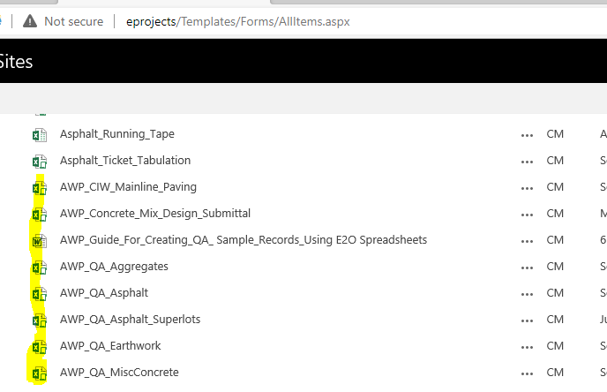

A sample record provides a place for sampling and testing data for materials used by MoDOT. Reporting or assigning of material to a specific item of a specific contract is accomplished via a sample record. Sample information is used to identify all samples shipped to the Central Laboratory for processing or processed within the districts. Basic sample information and the results of all tests performed in the field are entered. The Central Laboratory will enter results of tests performed at the Central Laboratory.
The sampler is identified as the individual who obtained the sample. Generally, only the original sampler should make changes to a record. If a person does alter a sample record, they should make a disposition remark to denote what changes they made.
Throughout the system, access is restricted to show only those sample records associated with your administrative office or an office that is lower in the administrative office hierarchy. Your administrative office is determined by the contract authority assigned to your active user role. If a sample record is associated with contract project items, you must also have contract authority for the parent contract in order to access the sample record or associated tests. In addition, if a sample record is associated with a limited sample access role, only users who are logged on with that role can access the sample record and its associated tests.
From the Dashboard select Sample Records under the Materials Category.
To create a new sample record, select Add from the Actions menu on the Sample Record Overview component header or Add New from the Actions menu on the Sample Record Summary component header.
If you are calling up a previously saved record, type the number into the search field. You can bring up a listing of previously saved records based on similar prefixes by typing partial numbers.
All samples should be authorized when the information is complete or is as complete as possible. When material represented by a sample is associated to a line item for a Contract, that sample shall be Authorized* to complete the association. This authorization is necessary to allow the payment of the material on the estimate. Samples processed solely within the district shall be authorized by district personnel designated by the districts to do so. Samples submitted to the Central Laboratory shall be authorized by Central Laboratory personnel.
When a sample has been authorized, no modifications may be made to it unless the user has the authority to Unauthorize the sample. If an authorized sample is found to contain erroneous data, that sample may be revised using the Unauthorize process, and remarks entered explaining the reason for the revision, or the sample may be revised using the Revise function.
To authorize a sample record, the sample must have an acceptance method and an authorizable sample status. If the sample record has been split and is set to Authorize as Group, all splits from the sample record are authorized and unauthorized as a group. All splits from the same sample record must be in an authorizable sample status in order to be authorized as a group.
After authorization, the sample record becomes read-only, and the system removes it from all sample queues (Receive at Destination Lab, Receive at Lab Unit, Maintain Test Queue, Enter Test Results, Review Tests, and Review Samples).
To authorize a sample record, from the Sample Record, select Authorize from the Actions menu.
The system sets the Authorized By field to the current user, sets the Authorized Date field to the current date and time, and removes the sample record from the list on the Review Samples component. The sample record is now read-only, although you can add remarks of the remark type Disposition. If the selected sample record is part of a split sample record group that is set to authorize as a group, all of the splits are also authorized. The changes are saved automatically.
To remove authorization from a sample record without creating a new editable copy of the record, select Unauthorize from the Actions menu on the sample row. The system clears the values in the Authorized By and Authorized Date fields and saves the changes automatically. The sample record is no longer read-only and can be modified as needed. Authority to unauthorized is limited.
Central Lab Samples:
Samples submitted to the Central Lab shall have the following information printed directly on the sample, sample container, or sample tag: Sample ID Number, Material Source (where the sample is obtained), Product Name (with grade and size, when necessary to fully describe sample), and any Special Instructions.

Some materials need additional information including:
Concrete Cores – ID NO.
Date of Pour (Not date cored)
Cement Factor (Not water/cement ratio)
TEST ON (Specific date)
Special testing information

Concrete Cylinders – ID NO.
Date of Pour
Cement Factor (Not water/cement ratio)
TEST ON (a specific date)
Special testing information

Steel Products – ID NO.
Grade
Heat/Lot #
Size
PHONE/FAX RESULTS
Field information
Bituminous Cores – ID NO.
Mix NO.
Special Instructions such as TEST EACH CORE SEPARATELY
PLEASE CONTACT (user @ phone number) BEFORE TESTING

Bituminous Loose – ID NO.
Mix NO.
Special instructions may include information like:
SAMPLED FROM 4th TRUCK
PHONE/FAX RESULTS
POSSIBLE CONTAMINATION
NEED AC CONTENT
NEED Gmm, Gmb, etc.
Lot #, Sublot #, Comparison Sample # if appropriate
(ex. TSR samples and CT index/RT index/Hamburg - performance test samples)
Special Instructions for Central Lab Samples:
Some special instructions can be reduced to the following key words, which are also defined and clarified when appropriate. Special Instructions go on tag and in "General Remarks" section of the sample record.
Absorption as Received - For aggregates.
Chemical Analysis – Culvert metal sample being submitted for normal testing that also requires a chemical analysis.
Date of Pour – Date when concrete cylinders were made.
DSR Only – Daily performance graded binder sample taken at an asphalt plant.
Due Date – Date when test results are expected. (Used primarily with soil samples.)
Experimental – Material which is to be retained for an indefinite period. The submitter of this material shall inform the Central Lab when the material is no longer needed so it may be disposed.
Initial – Larger rock samples obtained from ledges prior to crushing.
Material Code – For general materials samples, first four digits of material code would be as useful as the product name.
# of # – for multiple bags or containers for accountability in receiving the material.
Quantity and Length – for bolts, the lot quantity and the length of the bolts.
Resample – Indication that the sample being submitted is a resample.
Rush – Results needed as soon as possible.
See Remarks – Notification to the laboratory that there are some special circumstances regarding the sample.
Source – Producer production approval sample obtained every two years.
Special Investigative – A sample being submitted for special tests. Normally the laboratory has been contacted by telephone in advance for this type of testing.
Trial Mix – Trial mixture material is submitted for standard processing including that to be stored by the lab for future use.
The Remarks field is filled in accordingly, including special testing instructions. Identification of a sample by marking the lid, or other packaging easily separated from the sample, is not acceptable. Sample tags are available from Headquarters Construction and Materials. The tags are made with a special, very durable paper. For best results, when the tag is wired or tied to the sample, use both holes in the tag. The intent of the tag is to identify the sample. Please attach the tag so the sample data is easily seen. These self-sticking cylinder tags are also available from Headquarters Construction and Materials.
Creating a New Sample Record
From the Dashboard select Sample Records under the Materials Category.
To create a new sample record, select Add from the Actions menu on the Sample Record Overview
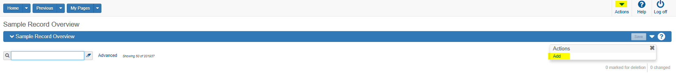General Tab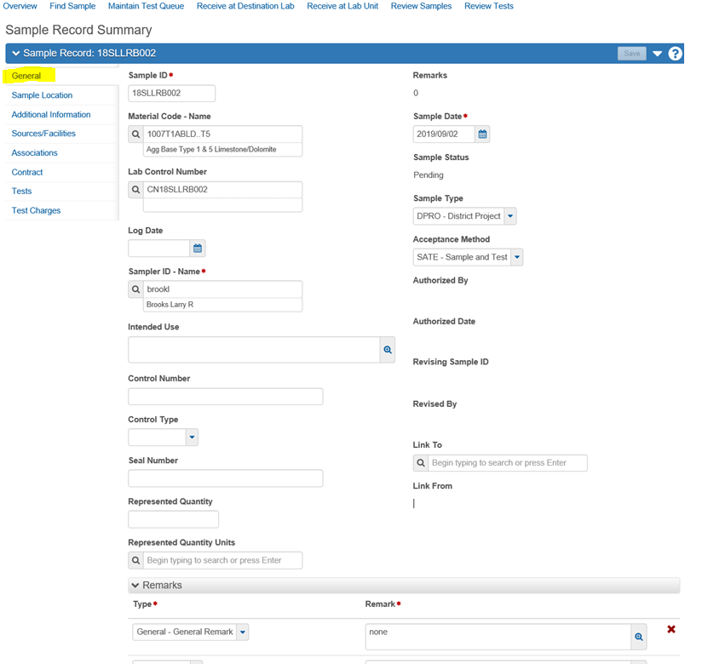
Sample ID:
Each sample of material taken for the Department is assigned a unique identification number by the following standard:
1st –2nd Position Last two digits of the year
3rd -4th Position District or Division identifier. Use the two-letter designation for the district (NE, NW, KC, CD, SL, SW, SE) or a letter for a sample submitted by a division (non-district) personnel. For division personnel we are suggesting that the following letters be used. Consultants working directly for MoDOT should use CC as the district identifier. Consultants working for a contractor should use QM as the district identifier
Materials M
Construction C
Bridge B
Maintenance A
General Services G
Photo Lab PL
Preliminary Studies P
Research D & T R
Risk Management K
Non-MoDOT X
CRE2O (Contractor) QM
QA Consultant CC (Note: not for use with QC samples)

5th – 7th Position The user's initials. The initials are assigned by Headquarters when access is granted, to assure uniqueness. Use upper case (capitals).
8th – 10th Position Use 3 digits, with leading zeros, which count up sequentially for each additional sample.
11th Position May be added to the Sample ID if deemed necessary. Also used to differentiate this sample from a duplicate ID where both Ids have been issued prior to entry in SiteManager.

Examples: 2012 + Central District + John R. Doe + 001 + X = 12CDJRD001X
or
2012 + Materials + James D. Smith + 001 = 12MJDS001
(Special instructions for a Non-MoDOT ID)
4th – 5th Position Initials assigned to a non-MoDOT organization by the SiteManager Administrator. Use upper case (capitals).
6th – 9th Position Use 4 digits, with leading zeros, which count up sequentially for each additional sample.

Example: 2012 + Non-MoDOT(X) + Carter Waters + 0001 = 12XCW0001
The PAL unit at headquarters is expressly permitted to use a 4 digit number in lieu of the 3 digit number indicated above, due to the number of records created in a year.
Example: 2012 + Materials + Sally A. Tall + 0001 = 12MSAT0001
Central Office work units have been assigned a further breakdown for sample identification at a group level.
Materials, Field Office MFO
Materials, Physical Lab MPL
Example: 2012 + Materials + Physical Lab + 0001 = 12MPL0001
District Materials, where samples have traditionally been posted to a ledger and identified on a district wide basis, are also allowed the option of submitting samples using the following format. The last two digits of the year plus the two letter designation for the district plus MA for Materials, plus 4 digits (with leading zeros) is allowed.
Example: 2012 + Northeast District + Materials + 0001 = 12NEMA0001
Both identification options may be used by any district.
If the sequential number reaches 999, then a new sequence is started with A01, when that reaches A99, use B01, and so on. For District wide IDs, if the number reaches 9999, then a new sequence is started with A001, when that reaches A999, use B001, etc. User ID numbers should be tracked by documented means.
Enter a valid ID number. If you make a mistake and save an incorrect number, correct the number and save again.

Material Code:
This is a required field. Select the material code and description that best fits the sample material or information documented by the record. If you need to change material codes after adding tests, you will have to delete all the tests before changing.
Materials Code Change:
The Material Code and the Source are associated (linked) in a manner which once a Material Code is selected, the Source(s) available will be limited to the Source(s) which have the selected Material Code associated to it.
The Material Code can be changed to another product (Material Code) that has been associated to the same Source prior to making the change.
Note: Anytime you make change in the Material Code, change the “Represented Quantity Units” to match the new material or the record may not save correctly. If you are getting the message “Save Successful” and the material keeps reverting back to the prior code anyway, the problem most likely is the Represented Quantity Units were not changed or not changed correctly.
If the Material Code you require does not have the current Source associated (not available to select from Source list), contact the District Materials Department and asked for the needed Material Code be associated to the Source. See AWP MA QRG - Associating Materials to Sources/Facilities.
Once added to the Source, the Material Code can be changed. (Refresh sample record window, F5 on keyboard, before changing material code).
This assumes a Source change is not necessary.

SMFMI Name: (Approved Products)
This is a required field for some material codes. The name of the Source Material Facility Material Identification record. SMFMI is a method to uniquely identify a like material supplied by the same source or facility, such as a batch, lot, seal, or stockpile. MoDOT is using this field to identify Brand Names. Crashworthy End Terminals are a good example of when this information must be entered. Click in the field and press “Enter”. A list of available Brand Names should pop up. This field is searchable by either the “Brand Name” or the “Company Name”. If none are available, “no records” will be displayed. If there should be a Brand Name available, and it is not, Contact the Program Administrator. SMFMI names do not exactly correspond to the Brand names per the limited length of the fields (SMFMI name is only 20 characters vs. 40 characters for SiteManager brand names).
Brand Source ID- Source Name:
This field is automatically populated by the system when a SMFMI selection is made.
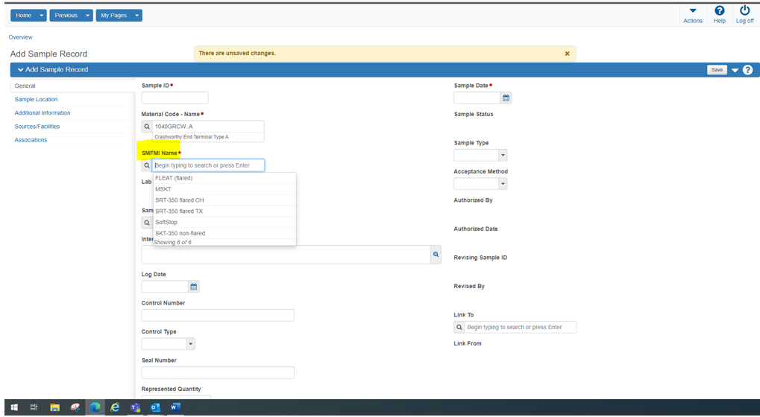
Material Codes that require a SMFMI to be entered before “Saving” is allowed.
Material Code | Material
0505CXSF | Silica Fume Admixture
1040GRCW..A | Crashworthy End Terminal Type A
1040GRCW..B | Crashworthy End Terminal Type B
1040GRCW..C | Crashworthy End Terminal Type C
1040GRCW..D | Crash Cushion -Type D
1040GRCW..E | Crash Cushion -Type E
1053CFMMA | Concrete Crack Filler (CF) - MMA @
1053CSBR | Concrete Sealer Linseed&MinSpirit Blend
1053CSSIL | Concrete Sealer (CS) - Silane @
1054CXACCL | Type C Accelerating Admix W/ Chlorides @
1054CXACNC | Type C Accelerating Admix No Chlorides @
1054CXAE | Air Entraining Agent for Concrete @
1054CXLE | Latex Emulsion Admixture @
1054CXRB | Type B Retarding Admixture for Concret @
1054CXS | Type S Admixture for Concrete @
1054CXWA | Type A Water Reducing Agent for Concre @
1054CXWD | Type D Water Reduce & Retard Admix Con @
1054CXWE | Type E Water Reduce & Accel Admix Con @
1054CXWF | Type F High Range Water Reduce Agent @
1055CMMLDST1D | Clear Pavement-Bridge Dissipating Cure @
1055CMMLDST2 | White Pavement-Bridge Dissipating Cure @
1055CMMLT1D | Clear Pavement Cure (non-dissipating) @
1055CMMLT2 | White Pavement Cure (non-dissipating) @
1057JMCCFJ | Closed Cell Foam Expansion Joint Matl @
1057JMHP | Hot Pour Elastic Joint Material @
1057JMJCPLERFT | Extruded Rope/Flat Type Plastic Joint @
1057JMJCPLTG | Trowel Grade Plastic Joint Compound @
1057JMJCSS | Silicon Sealant for Sawed/Formed Jnts @
1057JMJCSSEX | Silicon Sealant for Expansion Jnts @
1066MREM | Non-Metallic Expansive Mortar
1073JMOCFJ | Open Cell Foam Exp. Joint @

Lab Control Number:
When the sample represents a material with a lot/sublot from where sample was taken, populated the Control Number with the lot/sublot information and select LOT from the dropdown for Control Type. (Note: Not required for SuperPave or TSR samples.)
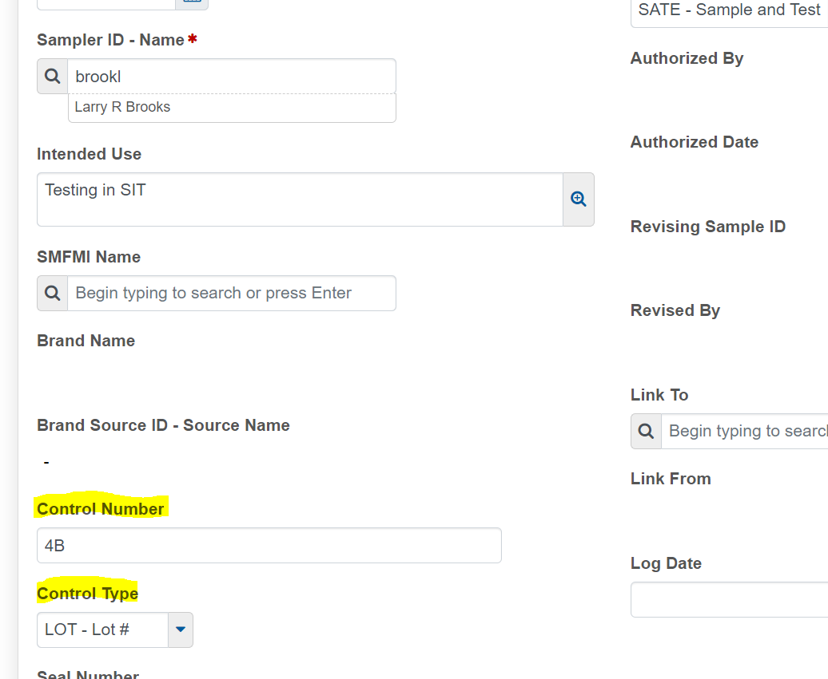

Log Date:
This date is populated only by Central Lab personnel and should never be populated by District personnel. It is used to document when a sample arrives at the Central Lab for processing.
Sampler ID:
This is a required field. Currently only MoDOT and Consultants performing QA testing personnel are available in the list per AWP limitations. For samples taken by MoDOT, the person who initially obtained the sample or information indicated by this record is shown here. Typically, the sampler shall also be the individual entering the sample data. For Contractor QC samples initiated through CRE2O, the sampler will be the MoDOT person designated by the contractor as the contact for that record.
Intended Use:
The intended use of the material should be entered. For material to be held in a supplier's stock, enter "Stock for Future Use".
Control Number:
The number associated with the Control Type which the Producer/Supplier or Manufacturer has assigned to the material represented by this sample. If no number has been assigned and the material can be identified in lots or batches by personnel performing the sampling, the Control Number may be assigned by the sampler. When multiple numbers apply to the sample, typically for 2-part and 3-part paints or epoxies, the numbers will be separated by commas and will have an identifier added when appropriate, for example: “A:5B32WAA, B:6C43XBB” (Note the identifiers, “A” and “B”). If there is not enough room for all the characters assigned, the second or third series of numbers can be placed in the Seal Number field, which is adjacent to the Control Number field. If the number provided by the Producer/Supplier contains special characters such as “-“, “/”. “|”, “\”, convert all such characters to a dash (“-”) as you enter the value. Example “A:7C/44G\16” would be entered as “A:7C-44G-16.
Control Type:
The identification assigned by the Producer/Supplier (e.g. heat number, batch number, lot number), when applicable. Select the proper identification from the drop-down listing.

Seal Number:
If the material represented by the Control Type and Number has been sealed to prevent modification, make note here. This function is rarely used. Seals may be found on rail cars, truck, tanks, and other similar transportation or storage devices. This field is also used for additional detail that will not fit into the Control Number field.
Represented Quantity:
This is a required field. The quantity of the material represented by the sample.
Represented Quantity Units:
This is a required field. The unit for materials purchased under a Non-Construction contract, or that are the sole component of a contract bid item shall be that unit of measure as indicated on the contract bid item, if a contract exists, or the unit that would apply if the material were to be used on a typical contract. Unit for materials in all other situations including the instance where the material is one of several components of a contract bid item shall be as indicated on the Dashboard-Reference Data-Materials window. The default unit system is English. Metric units may be used only when the material is known to be part of a metric contract or when certifications are required and metric units are designated in the certification. The unit is automatically loaded by the system based on the default unit set in the Material Information window.
Remark Type:
If needed, select the pertinent remark for an unauthorized sample or “Disposition Remarks” for an authorized sample. Be sure to enter a descriptive remark.
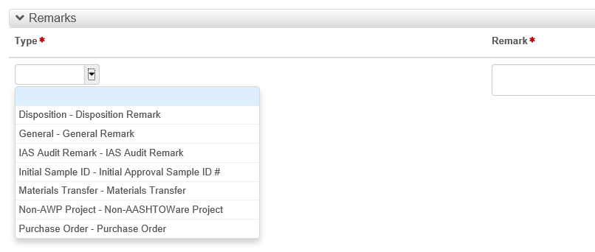
Remarks:
Up to 3999 letters/spaces can be used. Be descriptive and specific. Anyone other than sampler/creator shall enter their userid and date entered at the beginning of remarks. All special instructions to the Central Lab are entered here.
Sample Date:
This is a required field. This is the date when the sample was obtained. If no sample was obtained, enter the date of the inspection. If no inspection occurred, enter the date of any other activity being documented with the sample record.
Sample Status:
This field is automatically filled in by the system. It is an identifier for the current status of the sample record.
Pending: When a sample record is created.
Logged: When a test is assigned to a sample record.
Received at Destination Lab: When the sample record is received at the destination lab.
Received at Lab Unit: When the sample record is received at the lab unit.
In Testing: When the sample record is being tested.
Pending Authorization: When all tests on a sample record are approved.
Approved: When the sample record is approved but not authorized.
Authorized: When the sample record is authorized.
Void: When the sample record has been made void.
Note: All Tests must be deleted from a Sample Record before any changes can be made to the following. Be sure to save the test results as the tests and results will need to be reentered after the changes have been made:
- Change sample type
- Change material code
- Change/add primary source
- Change/add primary facility

Sample Type:
This is a required field. All sample records involved with satisfying specification requirements for a specific Contract must use the correct Sample Type associated to the material in the “Action Relationships” so as to satisfy the sampling and testing requirements, otherwise a discrepancy will be flagged on the estimate. The correct Sample Type should be determined prior to creating the sample, based on the predetermined requirements and verified by checking either the Sampling Checklist or the “Sampling and Testing Status Report”. If the sample is not a specific to a contract the user should select the Sample Type which best reflects the reason for the sampling. Listed below are all of the Sample Types:
QA QA Quality Management.
QC QC by MoDOT.
QCC QC Contractor Data / Quality Management.
QCQA QC Contractor / QA MoDOT Quality Management.
QPAL PAL– PAL material report or sample directly related to a PAL facility visit.
(The PAL facility visit is performed by the District and is non-contract specific. The PAL materials report is Contract specific but is only entered by the Central Office.)
COST Compaction Standard – This is used to represent a sample related to the compaction standard for aggregate or base.
PC Product or Process Check – This is used for samples obtained to check the quality of products and/or processes to determine if they remain acceptable or qualified. Not to be used for aggregate.
GAI Aggregate Initial – This is to be used for ledge stone samples submitted for initial approval testing.
GAS Aggregate Source – This is to be used for aggregate source approvals and for first time samples from a new producer with no project designation established for the material.
NWPD New Product – For submitting a sample of a new product through the new product process and associated testing.
TM Trial Mix – This is used for samples obtained for mix design purposes.
IASA IAS Audit - Used by the IAS auditors to report results of Independent Assurance Sampling
EQIP Equipment Verification – Used for records related to equipment used in testing or other processes where performance affects contract compliance.
LQAL Laboratory Qualification – Used to report results of laboratory qualification testing.
SOIL Soil Survey – For soil samples not covered by PESC, PESF, or PESP.
PESC PrelEngr Soil Survey – Complete – This is for classification and moisture density determinations.
PESF PrelEngr Soil Survey – Fertility – This is for fertility testing.
PESP PrelEngr Soil Survey –Partial – This is for classification only.
DPOR Purchase Order – This is to be used for sample processed in the district where a purchase order is involved.
DPRM Permit Work – This is for a sample record related to a permit.
OFFS Off System - Any sample or record related to an Off-System project.
INFT Informational or Investigative – This is to be used for records when no other sample type fits. Often these records will be unique cases.
Sample Type Change:
Once the test(s) have been deleted the Sample Type can be changed and saved without further actions.

Acceptance Method:
This is a required field. All sample records involved with satisfying specification requirements for a specific Contract must use the correct Acceptance Method associated to the material in the “Action Relationship’s” so as to satisfy the sampling and testing requirements, otherwise a discrepancy will be flagged on the estimate. The correct Acceptance Method should be determined prior to creating the sample, based on the predetermined requirements and verified by checking either the Sampling Checklist or the “Sampling and Testing Status Report”. If the sample is not a specific to a contract the user should select the Acceptance Method which best reflects the reason for the sampling.
Both Contract specific and Non-Contract specific will be one of the following:
APAL Accepted by PAL (Central Office or Maintenance P.O. use only)
APQC Approved Producer QC/QA – Material supplied by approved producer and accepted on QC/QA
CERT Certification Review – Certification is reviewed
CPIA Pilot Concrete Plant Inspection Audit – Concrete Plant Inspection Audit records.
CETE Certification and Testing – Certification is reviewed, material is tested.
LBLA Label Analysis – Label on container is compared to specification or purchase order
NPCO New Product Coordinator Direction - Used only at the direction of the New Products Coordinator
PAOA Prior Approval or Acceptance – Material approved on basis of sample taken earlier (note sample ID number)
PQOB Pre-qualified or Brand Name – Material appears on pre-qualified or accepted brand name list
PQTS Pre-qualification Sample – Acceptance method dependent on material pre-qualification process.
SATE Sample and Test – Sample taken and tested
TEST Testing – Material tested (measured) on site, no sample taken
VSUL Visual Inspection – Material meets specification based on visual examination
Authorized By:
This is automatically filled by the system when the sample is authorized. The sample is to be authorized when all testing is completed or no further testing is to be performed, and all necessary data has been entered. Authorization shall not be delayed in order to record contract data for the purpose of reporting to a contact.
Authorized Date:
This is automatically filled by the system when the sample is authorized.
Revising Sample ID:
The sample record identification that the current sample record is modifying.
Revised By:
The Sample ID of the revised sample record.

Link To: (Currently not functioning – leave blank. Use remarks instead.)
Use this when an existing sample is related to another sample. The second sample is "linked to" the first sample. A third sample may be "linked to" the second sample by the same means.
Additional information regarding use of a Link for transferred material. A sample record is created for the transferred material. It is linked to the original sample record (which reported the material to the contract). On the new sample record, a Contract tab positive quantity is reported to the desired contract(s) and negative quantity is entered for the contract from which the material was transferred. Include in the remarks why the material was transferred. Make certain unused material exists in the quantity transferred.
Link From:
This field is automatically filled when a future sample is linked back to this sample.
Sample Location Tab
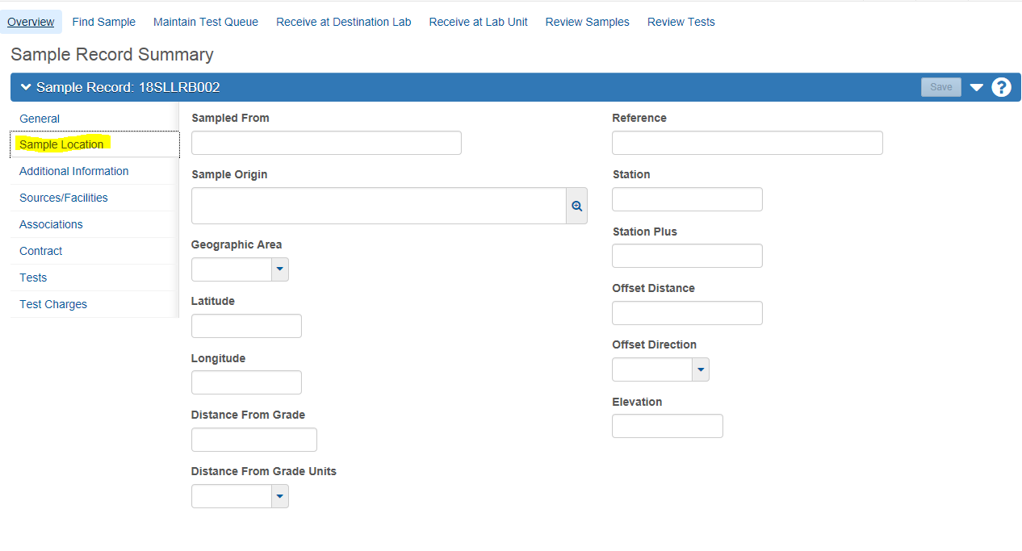

Sampled From:
The specific point at which the sample was taken (e.g. belt, stockpile, roadway, drum, bundle, stock, etc.).

Sampled Origin:
The general location from which the sample was taken (e.g. quarry, plant, project). In some instances, it is necessary to include the specific quarry, or plant, or other information when not captured elsewhere.
Geographic Area:
Select the MoDOT region in which the sampler is located. Samplers from Headquarters use District – Central Office.
Latitude:
Optional – not required at this time
Longitude:
Optional – not required at this time
Distance from Grade:
The distance from the finished grade for samples taken from subgrade.
Distance from Grade Units:
Appropriate “Dist from Grade” units shall be selected.
Reference:
The line from which the offset is measured.
Station:
The station number location where the sample was taken, when applicable.
Station Plus:
Station of where the sample was taken. This field indicates the second part of the station number (e.g., 23.33 of 1+23.33, 34.10 of 223 + 34.10).
Offset:
The distance from the reference line of where the sample was taken, when applicable.
Offset Direction:
Direction of where the sample was taken in reference to the centerline (e.g., left of centerline, right of centerline, on centerline)
Elevation:
Optional - The altitude above sea level or ground level where a sample was taken.
Additional Information Tab
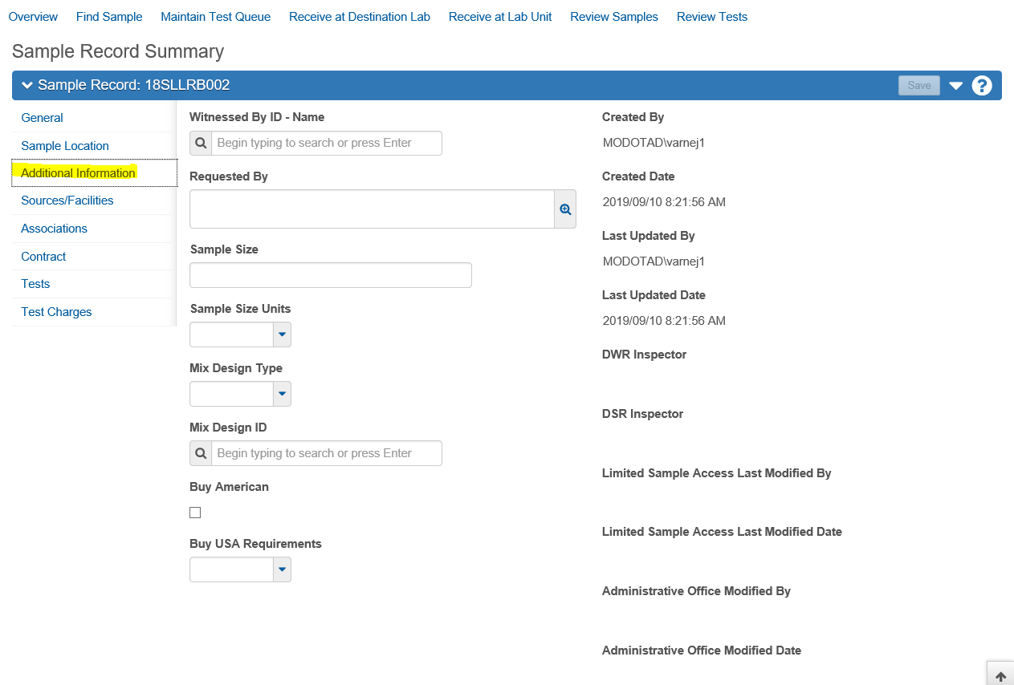
Witnessed By ID:
The person who witnessed the sampling process when it is not a routine sample and witnessing is required. Witnessing is typically required when resampling due to a dispute over the original sample’s characteristics

Requested By:
The person or entity who requested the sample, if applicable, is listed. It may be left blank if it is a routine sample, or no specific request has been made.
Sample Size:
The size of the sample submitted to the Central Laboratory so Laboratory Receiving can confirm full shipment. For samples processed in the district, this field may remain blank.
Sample Size Units:
Appropriate Sample Size Units shall be selected from list or, if the required unit is not included in the list, the unit may be typed in the Sample Size field with the Sample Size value.
Mix Design Type:
If the material sampled is controlled by an existing mix design, select from the mix type from the list. This field is filtered based on the Material Code selected earlier.
Mix Design ID:
The identification number of the mix design represented by this sample should be typed in or selected.
Buy American:
Indicates the material was made in the United States of America per the Buy American Act. Not populated at this time.
Buy USA Requirements:
Documentation required accepting materials for the Buy American Act. For Materials accepted based on AASHTO Product Evaluation & Audit Solutions, this field must be completed by selecting the appropriate description from the drop-down list.
Created by:
The name of the person who added this record to the system. This field is automatically populated by the system.
Created Date:
The date and time this record was added to the system. This field is automatically populated by the system.
Last Updated By:
The name of the person who most recently changed this record. This field is automatically populated by the system.
Last Updated Date:
The date and time this record was most recently changed. This field is automatically populated by the system.
DWR Inspector:
If created from DWR, User who created the DWR from which the sample record was created. This field is automatically populated by the system.
DSR Inspector:
If created from a DSR, User who created the DSR from which the sample record was created. This field is automatically populated by the system.
Limited Sample Access Last Modified By:
The person name (first, middle, and last) of the user who last modified the limited sample access user roles for a sample record. This field is automatically populated by the system.
Limited Sample Access Last Modified Date:
The last date when the limited sample access user roles were modified for a sample record. This field is automatically populated by the system.
Administrative Office Modified By:
The ID of the person who most recently modified the Administrative Office for a sample record. This field is automatically populated by the system.
Administrative Office Modified Date:
The date the Administrative Office was last modified for a sample record. This field is automatically populated by the system.

Source and Facilities Tab:
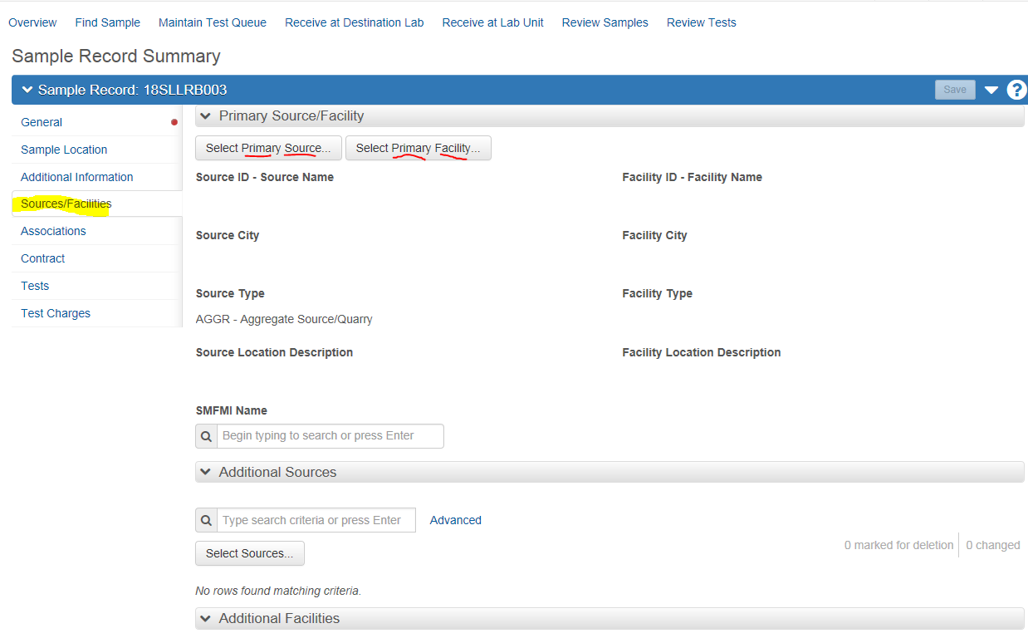
Producer/Supplier. The Primary Source is the Producer or Supplier of the material sampled. Generally, the Producer/Supplier is not a contractor or subcontractor. For example, asphalt binder taken at an asphalt plant, the producer/supplier of the asphalt binder would be the terminal or refinery it came from, not the asphalt plant. The Primary Facility is the ledge number, plant number, etc. which further describes the sample source.
Source ID - Name:
Use the search function and locate the Producer/Supplier for the sample material. If correct Source is not available, contact your District Materials Representative as the material selected may need to be associated to the source.
Source City:
This field is automatically populated by the system.
Source Type:
This field is automatically populated by the system.
Source Location Description:
This field is automatically populated by the system.
Facility ID – Name:
Use the search function and locate the specific information relative to the Source designated for the sample material. Once selected, the user will need to “save” before the selection is visible in the field. If correct specifics are not available, contact your District Materials Representative as the material selected may need to be associated to the facility.
Facility City:
This field is automatically populated by the system.
Facility Type:
This field is automatically populated by the system.
Facility Location Description:
This field is automatically populated by the system.

Additional Sources & Facilities:
Additional Sources and Facilities should be used for all PAL samples and for samples which are supplied by a “distributor” and have a separate manufacture. Guardrail is a good example.
For a PAL facilities and\or shipping record, the Producer/Supplier should be the manufacturer of the product being tested, and will not necessarily be the same as the facility where the sample is being obtained.
Please note the following:
Source Change:
A Source may be changed by selecting a different Source, as long as the new Source has the current sample record Material Code associated to it. If the Source is not available in the source listing, the material code is not associated. Contact the District Materials Department and asked for the Source to have the needed Material Code associated to it. See AWP MA QRG - Associating Materials to Sources/Facilities.
Once the material code is added to the Source, refresh the sample record window and the new source should be available in the listing.
Material Code and Source Change:
If the Material Code and the Source both need to be changed, and the new Material Code should not be associated to the existing Source, please follow the steps below:
- Change the primary source to 300000000X “Producer Supplier not designated.”
- Refresh the page (hit F5) so that AWP recognizes the Primary Source has changed.
- Change the material code “Save”
- Change the primary source based on the revised material code

For more detail information on changing Material Code and changing Sources, see the QRG “Sample Record Changing Sample Type, Material Code or Source”

Associations Tab:
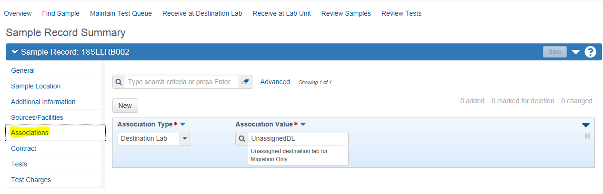
Associations:
The Associations tab contains a list of entity values associated with the material sample. You must associate a sample record with one or more destination labs. When you create an association between a sample record and a destination lab, it determines which lab units can process the sample. Only lab units associated with the destination lab have access to the sample record. (Note: For users and user roles that need access to other sample records on a regular basis, your system administrator can assign access rights.)
If the sample represents material/tests processed only at the District Level – select the “Field Lab” option. If the sample represents material processed by the Central Lab – select the Central Lab option. If the sample represents both tests performed at the District and Central Lab – add both separately.
To create a new association for this sample record, click the New button. The system adds a blank row at the top of the list. Enter or select values in the Association Type and Association Value fields
Association Type = Destination Lab
Association Value = Central Lab or
Field Work or
IAS or
Do not use Non-MoDOT Lab or
Do not use Unassigned destination lab for Migration Only
Do not use the “Non-MoDOT Lab” or “Unassigned destination lab for Migration Only” labs, these destination labs are only in AWP for migrating data from SiteManager.
When you are finished, click the Save button. When you change the value in the Association Type field, the system automatically clears the Association Value field. Click the Save button to save your changes. (Note: You cannot add or change associations for a sample record after tests are assigned to the sample record.)
Contract Tab:
The Contract tab on Sample Record associates contract project items that consumed the material tested with this sample. This provides a record of the location and quantity of the sampled material used for items on various contracts.
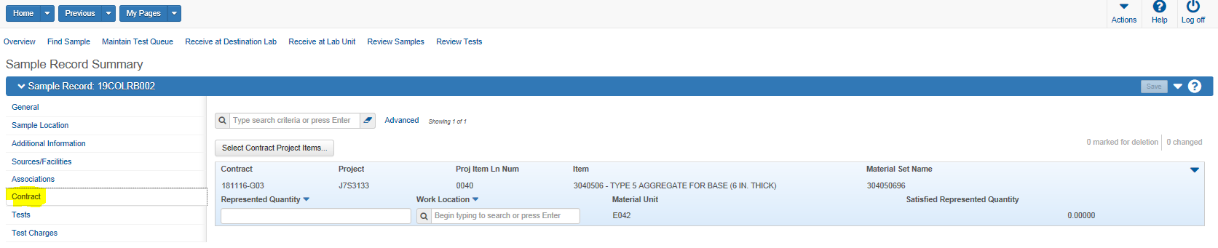

Contract:
Note: Do not use the Search field to add Contract lines. The Search in this window only searches lines that have already been added.
To add one or more contract project line item(s) to this sample record on the Contract tab click the Select Contract Project Items button. The system displays a modal window for selecting contract project line items on contacts for which the current user has contract authority. Click a contract project line item to select it. The system adds a check mark at the beginning of the row. You can click the row again to clear the selection. Continue selecting contract project line items as needed. Multiple project lines as well as multiple contracts can be added simultaneously.
When you are finished, click the Save button. The system adds the contract project line items you selected to the list on the Contracts tab and displays a message to confirm that your changes were saved.
Project:
This field is automatically populated by the system.

Item:
This field is automatically populated by the system.
Material Set Name:
This field is automatically populated by the system.
Federal State Project Number:
This field is automatically populated by the system.
Project Item Line Number:
This field is automatically populated by the system.
Work Location:
Pick from the available listing by either clicking in the field and hitting “Enter” or if you know what it should be, you can start typing and it will find it.
Material Unit:
This field is automatically populated by the system.
Represented Quantity:
Enter the quantity reported to this line item, for this contract, represented by this sample.
Satisfied Represented Quantity:
This field is automatically populated by the system. It should reflect total quantity reported on prior sample records.

Remark Type:
Currently use the only option “General Remarks”. May be edited in the future to allow for standard types of Central Lab samples.
Remarks:
Up to 3999 letters/spaces can be used. Be descriptive and specific. Anyone other than sampler/creator shall enter their userid and date enter at the beginning of remarks. All special instructions to the Central Lab are entered here.
Test Tab
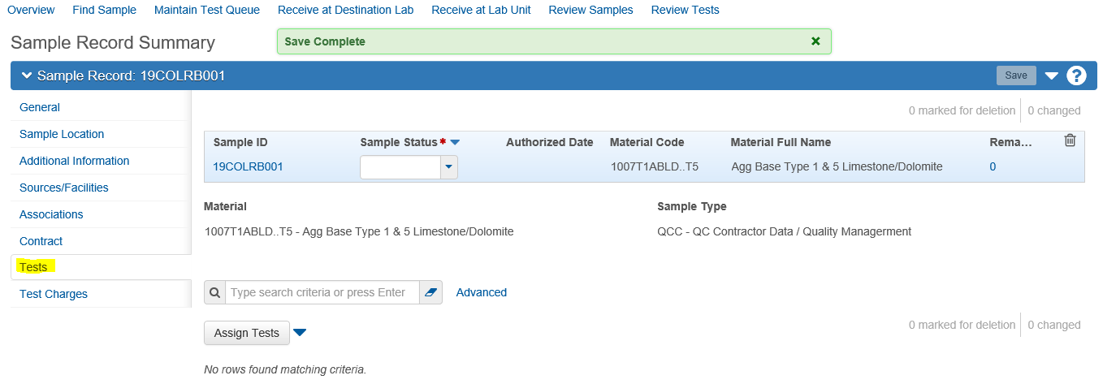
Note: Test will not be available until after Lab Associations have been select above.
The Tests tab on the Sample Record allows for tests assignment to the sample. For a test to appear in the list, the current user must have an active testing qualification and an active qualified lab association for the sample record test. This is normally handled by Headquarters at the time the user is set up in AWP, but may need to be updated as user’s upgrade the number of test they are certified to perform
Use the “Assign Tests” button to take you to Step 1 – Review Required Tests. Use the arrow on the right of the screen to move to “Step 2 -Select Default Tests”. Use the arrow again to move to Step 3 -Select Optional Test. Lastly, use the arrow, at the bottom of the screen on the right, to move to Step 4 –“ Add Tests Runs and Confirm”. Confirm when you are satisfied you have selected the correct tests.
Currently all tests are found under the “Select Optional Test” category. Multiple tests can be selected and assigned at the same time.
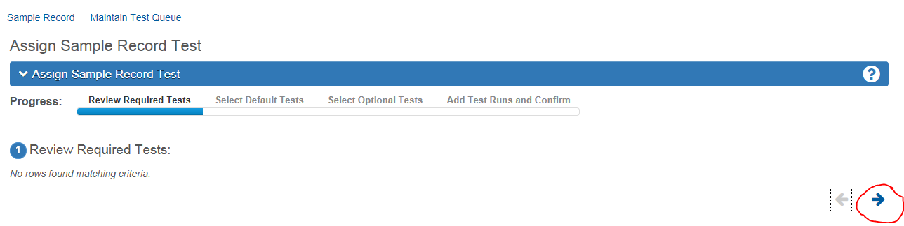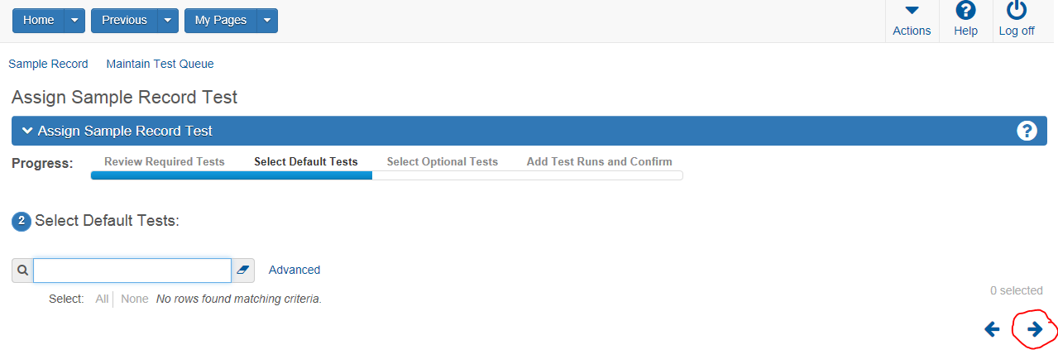
Test Tab Continue
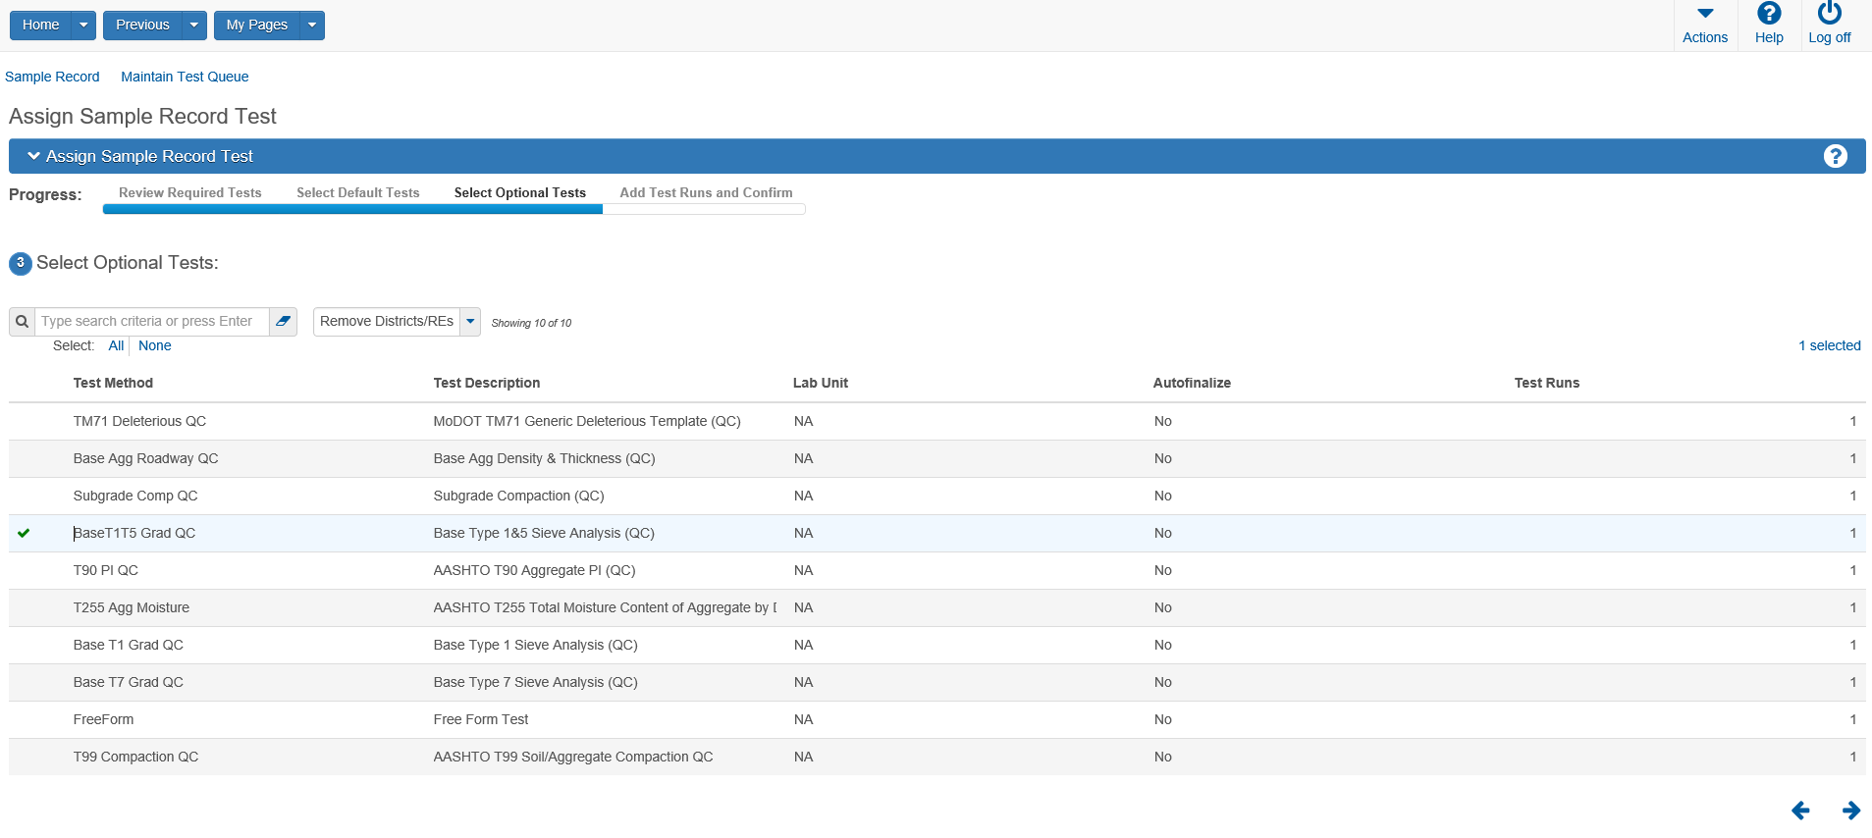

If multiple “runs” of the same test are to be performed on the sample, add the number of runs before Confirming:
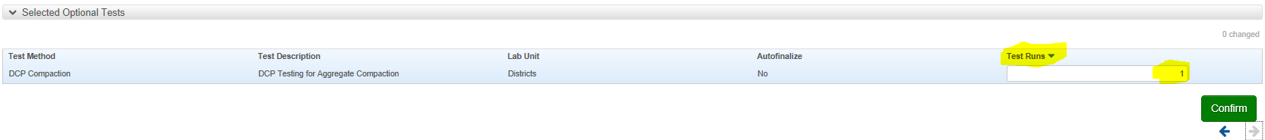
After confirming:
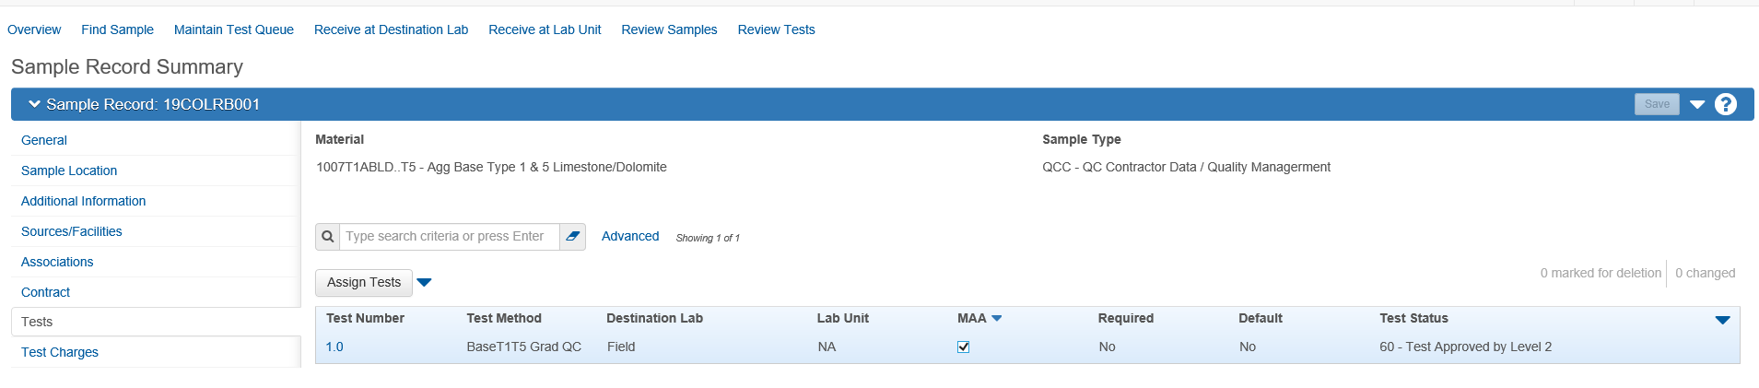
Test Number:
Unique number for a sample record test. Multiple runs of the same test method assigned to a sample record are numbered sequentially with a whole number, decimal, and a zero: 1.0, 2.0, and so on. Test numbers for repeated test runs are incremented by one tenth: 1.1, 1.2, or 2.1, 2.2, depending on the original test number. This field is automatically populated by the system.
Test Method:
Names identifying the test associated to the sample. This field is automatically populated by the system.
Destination Lab:
The geographic Lab Location. This field is automatically populated by the system.
Lab Unit:
The specific section within the larger Lab. This field is automatically populated by the system. Currently this will always be NA.

Materials Acceptance Actions (MAA):
Indicates whether the test counts toward the material acceptance actions. This field is automatically populated by the system. If unchecked, this test will not count towards exceptions.
Required:
Indicates whether the test is a required test for the sample record's unique combination of material code, sample type, and destination lab. This field is automatically populated by the system.
Default:
Indicates whether the test is a default test for the sample record's unique combination of material code, sample type, and destination lab. This field is automatically populated by the system.
Test Status:
Current status for a sample record test. Default values: 0: Test Cancelled. 05: Test Assigned. 10: Test in Queue. 11: Test Re-queued. 20: Being Retested. 21: Retest. 40: Test Complete. 50: Test Reviewed by Level 1. 60: Test Approved by Level 2. 81: Test Referred back to Lab. This field is automatically populated by the system.
Note: Test Sample Status is automatically populated at “60- Test Approved by Level 2” when test is first added. Do not change this status as this status is required as a step to authorization.

Test Tab Continue – entering test results
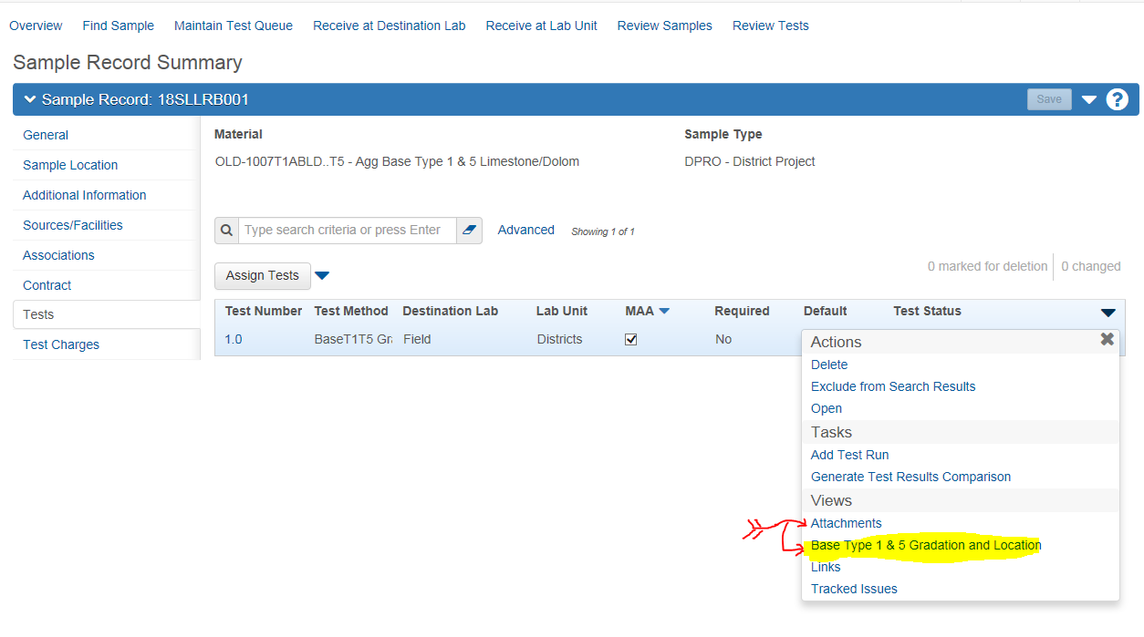
To enter test results, make sure the specified test is highlight and select the action arrow on the right side (downward pointing arrowhead). Below the Category “Views” you will find the available Agency Views associated to the highlighted test. Click on the selected. Enter results.
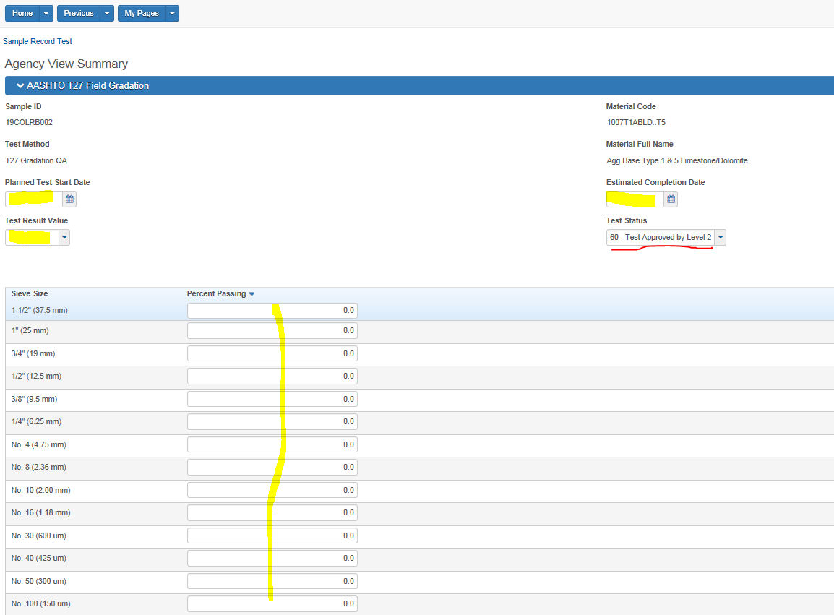

Once test dates, data and results are entered and saved, use the previous down arrow to select Sample Record Summary to return to the sample record.
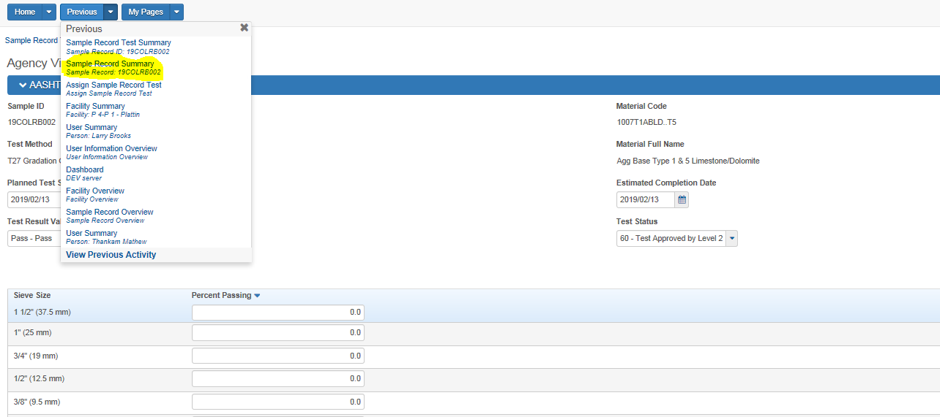

Further information can be view by “opening” the test. Currently the system is configured as to make this unnecessary to process a sample. The user can see this information by either clicking on the blue test number or using the action arrow and selecting open.
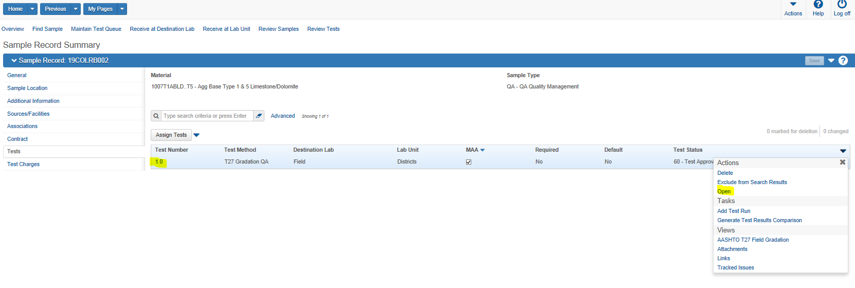
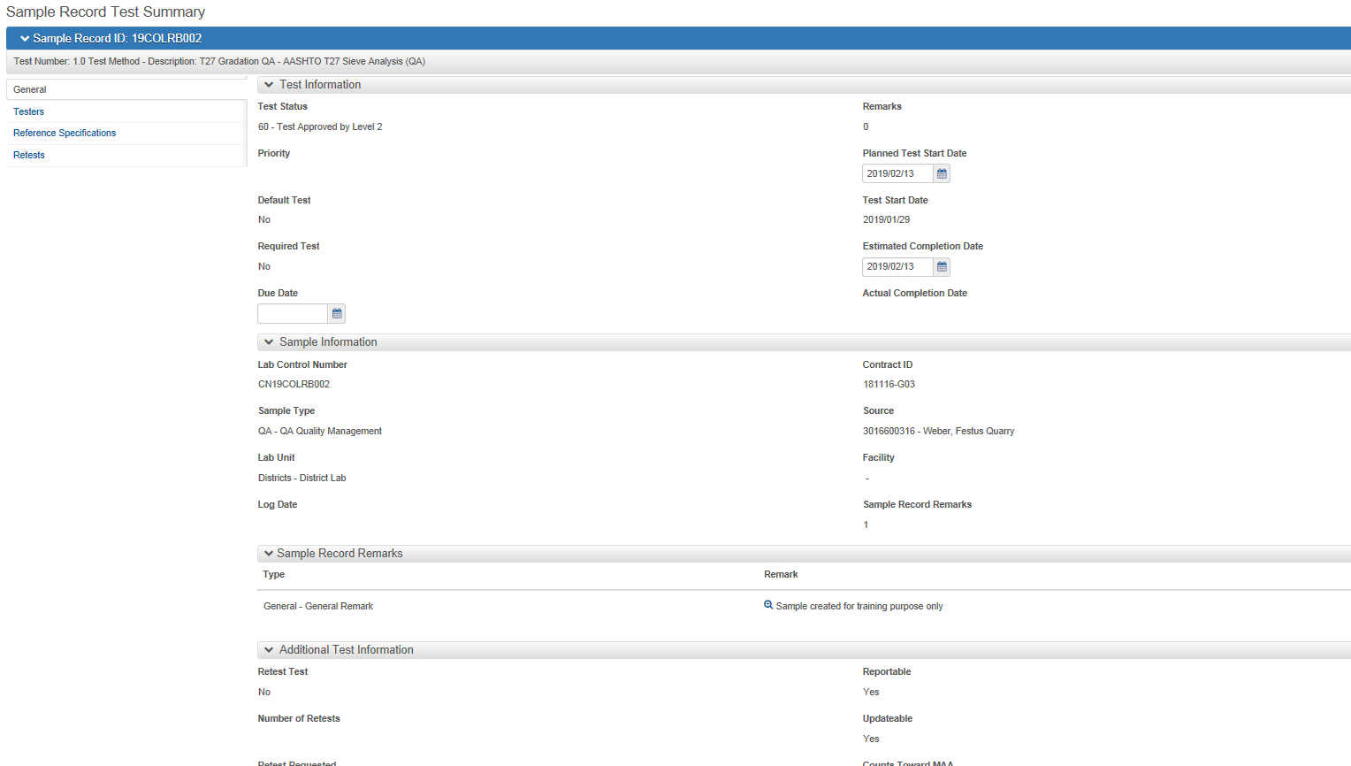
The “Actual Completion Date” is populated by the system when the tests is marked complete. Do not change or enter in this field.
Test Tab Continue –
Before the sample record can be authorized, the sample record status must be changed from “Pending Authorization”. There are two alternate methods to accomplish this.
The first and preferred is by navigating to the Test window on a sample record. From this window you are able to change sample record status. Select an authorizable sample status. Generally this will be “Approved”. This is the recommended Best Practice as it reduces the possibility of errors.
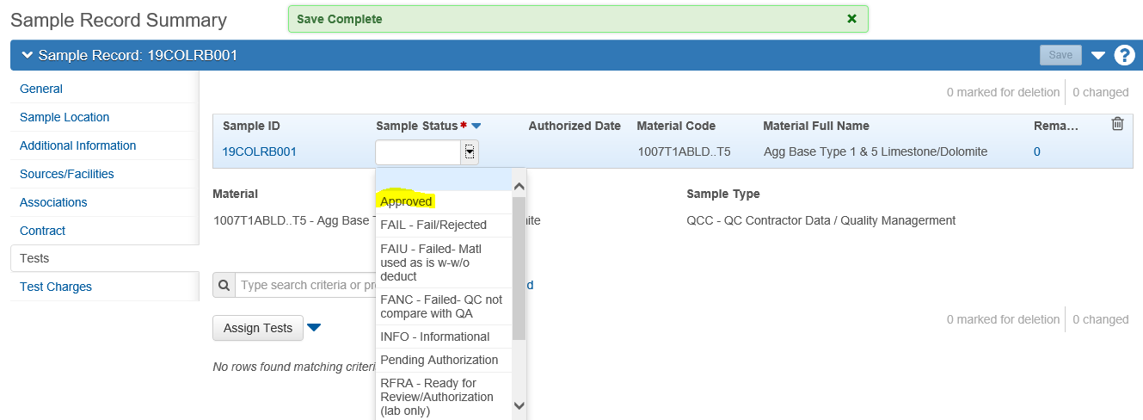
The second method is by using the Sample Record Overview” which has been modified to allow this change. Select an authorizable sample status, save, go back to record and authorize. Multiple records can be changed at once before saving.
Be accurate in addressing the records as you could change one inadvertently.
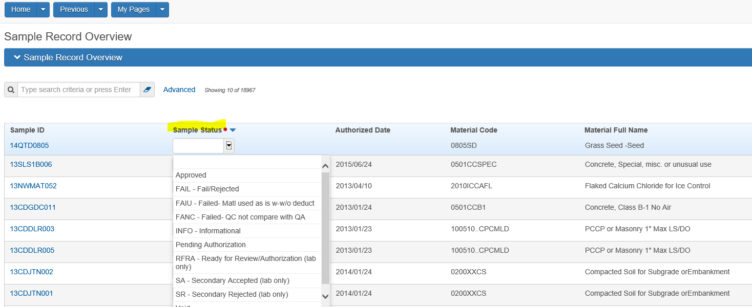
Be sure to “Save” before going back.

Test Charges Tab - We are not currently using this tab for anything
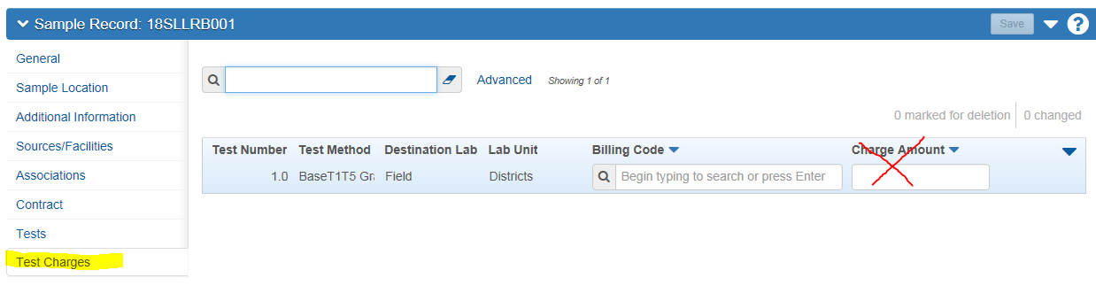
Authorizing a Sample Record (Sample sent to Lab should never to be authorized by the District).
Use the Action down arrow on the left of the screen to access “Authorize”. If the system finds the record acceptable, it will authorize, save and lock it. The “Authorized by” and “Authorized Date” are automatically filled in by the system.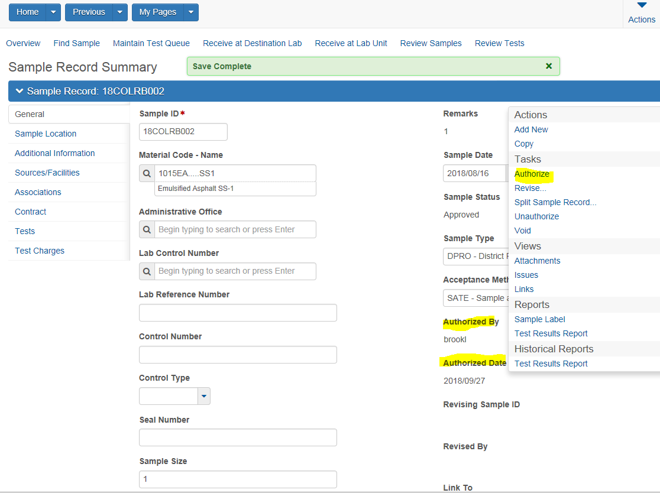

If an authorized record needs to be un-authorized to correct test data or add tests, the “Sample Status” will need to be changed to allow the additions.
The easiest work around is to unauthorize the sample, go to the test tab and add the test that is needed or if correcting data on existing test, add a random available test first. Once saved, the status will change to pending authorization. The user would than delete the random test added and correct the data or complete the additional test data whichever applies. Then re-authorize the record.

Correcting a Sample Record ID
You can fix a Sample ID on a sample record if you make a mistake entering a Sample ID, though the “Lab Control Number” appears as if it cannot be corrected.
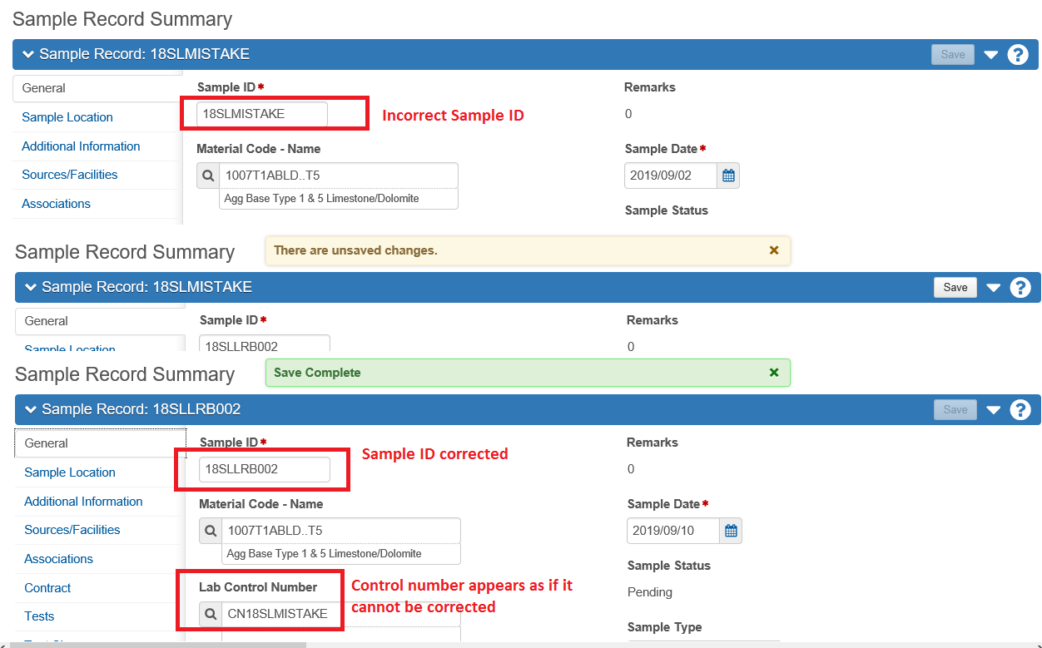
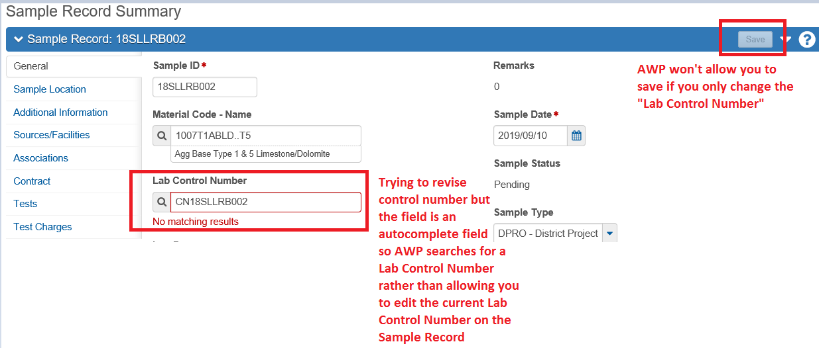

Short Summary for creating a Sample Record:

From the Dashboard select Sample Records under the Materials Category. To create a new sample record, select Add from the Actions menu. If you are calling up a previously saved record, type the number into the search field. You can bring up a listing of previously saved records based on similar prefixes by typing partial numbers.
General Tab - Enter:
Sample Id
Material Code
Sampler ID
Intended Use
Control Number (if applicable)
Control Type (if applicable)
Represented Quantity:
Represented Quantity Units:
Remark Type:
Remarks:
Sample Date:
Sample Type:
Acceptance Method:

Sample Location Tab - Enter
Sampled From
Sampled Origin:
Geographic Area:
Latitude: Optional – not required at this time
Longitude: Optional – not required at this time
Distance from Grade (when applicable)
Distance from Grade Units (when applicable)
Reference (when applicable)
Station (when applicable)
Station Plus (when applicable)
Offset (when applicable)
Offset Direction (when applicable)
Additional Information Tab - Enter
Sample Size:
Sample Size Units:
Design Type (when appropriate)
Mix Design ID Type (when appropriate)
Buy USA Requirement (when appropriate)

Source and Facilities Tab - Enter
Source ID
Facility ID
Additional Source ID (when appropriate)
Additional Facility ID (when appropriate)
SMFI – Populate Brand Name for PAL samples (when appropriate)
Associations Tab - Enter
Associations (Destination Lab(s))
Contract Tab - Enter
Contract
Work Location:
Represented Quantity:
Test Tab - Enter
Select the test
Enter the results
Planned test Start Date
Estimated Completion Date
Test Results Value
Change the status from “blank” to “Approved”.
Authorize the Record when/if appropriate

End of QRG

