AASHTOWare Project Sampling and Testing Status Report

Quick Reference Guide

This QRG provides basic instruction for using the Sampling and Testing Status Report to help with determining current sampling and testing requirements assigned to a contract, as well as required samples/quantity and acceptable samples/quantity.

One method to determine the current set up is using the internal report called “Sampling and Testing Status Report”. It list the Contract specific requirements by line item

It is accessed from the Global Actions down arrow located on the top right of the screen. Select “Generate Report”.

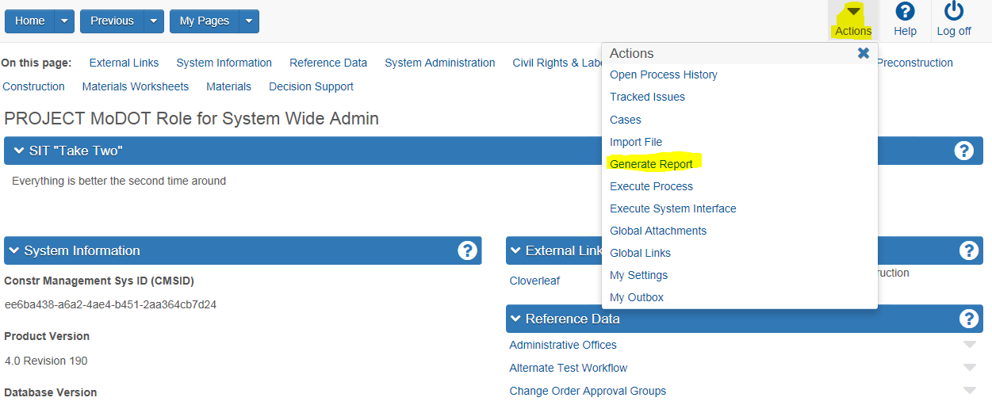

In the Search Bar, search for “Sampling and Testing”, click next to it in the left margin to get the checkmark. Process should move to the next screen automatically, if not click on the right arrow as highlighted below.

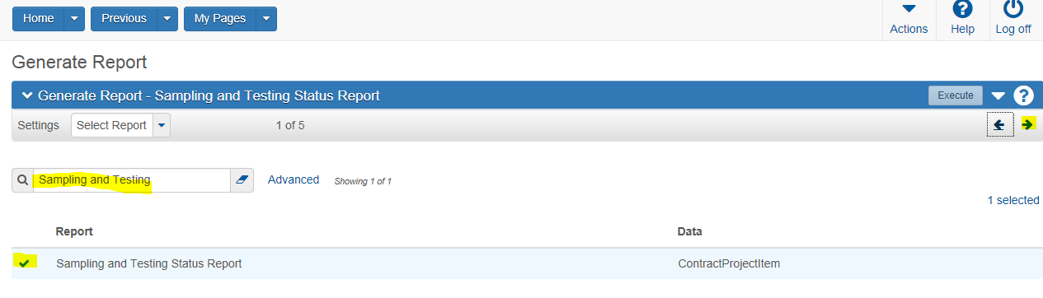

In the Search Bar, type in the Contract Number. Click next to the line item you want to see in the left margin to get the checkmark. You must evaluate the lines individually. Multi-Select is not a option. Once you have selected the line, click the Execute button on the top left.

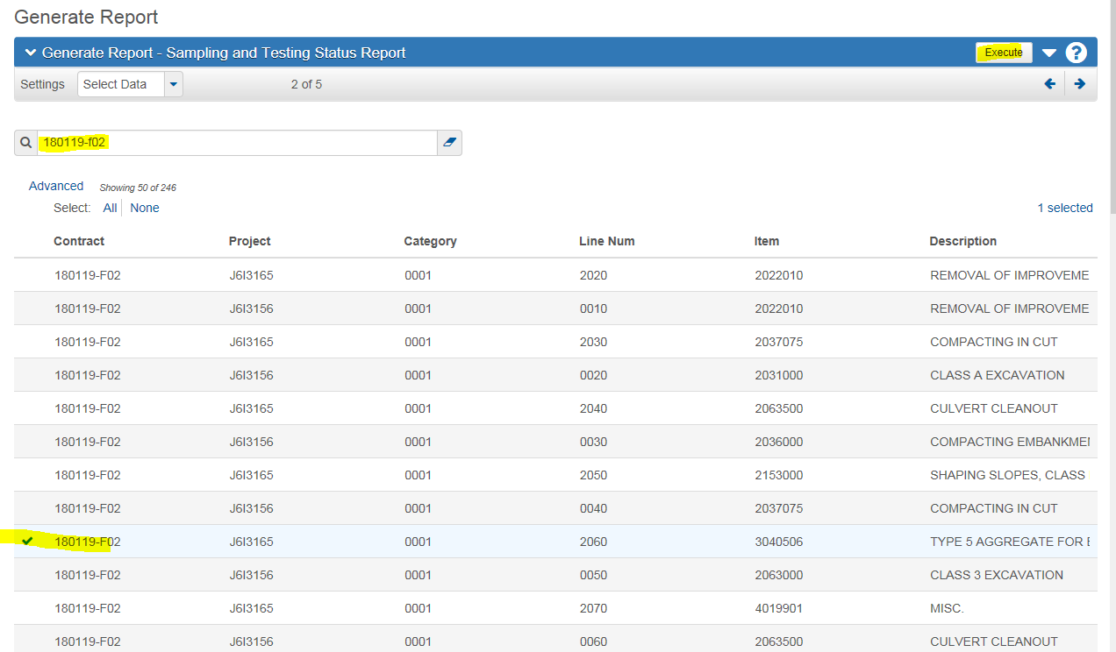

The Sampling and Testing Status Report is tiered into three units.

(Note: the four fields listed in brown are required to match on the sample record. They are Material Code, Sample Type, Acceptance Method and Test Method).

The **top block** contains project Line Item information and is only shown once at the beginning of the report.

Current Quantity = the Plan Quantity +- any Change Order amounts.

Quantity Posted To Date = total pay units posted in DWR’s for this line.

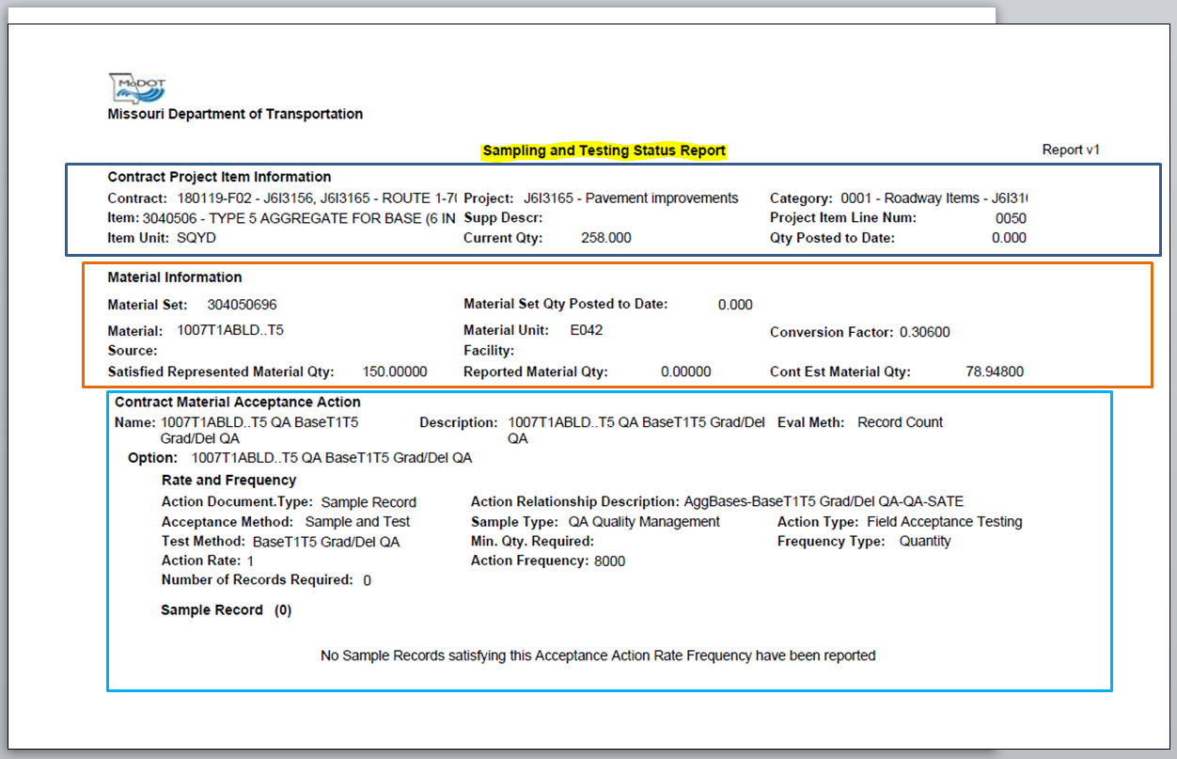

The **middle block** contains the Materials Component information for the line listed above. Since there can be many material components to make up a line item, this block will repeat each time a new material component is considered. This block includes the following information:

Material Set = designated group of materials, any of which could be used to meet requirements.

Material Code = specific material. Required for a acceptable record.

Source = if only a specific supplier will meet the requirements use to force compliance

Material Set Qty. Posted to Date = total quantity posted in DWR’s for this “group” of materials.

Material Unit = this is the inspected units.

Facility = production plant name/location if the “Source” above is populated.

Conversion Factor = converts inspected units to pay units (ex. Tons to square yards).

Satisfied Represented Material Qty. = total inspected quantity reported on Sample Records

Reported Material Qty. = total Qty posted in DWR’s for this Material times Conversion Factor.

Contract Estimate Materials Qty. = Plan Quantity +- any Change Order times Conversion Factor.



The **bottom block** is a subset of the Materials Information and lists the requirements. In AWP the sampling and testing requirements are known as “Materials Acceptance Actions” and “Action Relationships”. This block will repeat for each “Action” required for the specific material listed above. This block includes the following information:

Contract Materials Acceptance Action Name = Identifier for the MAA

Description = Same as the name

Evaluation Method = determines if exceptions are based on “sample count” or “total quantity”.

Option = If multiple MAA are acceptable they are listed here. This example is same as above.

Rate and Frequency = Title letting user know what is listed below.

Action Document Type = The kind of documentation necessary for completion of the action.

Acceptance Method = The sample record acceptance method required for acceptable record.

Test method = The sample record test method required for acceptable record.

Action Rate = Numerator in equation determining the number of required samples.

Number of Records Required = Number of records required base on Reported Mat’l. Qty.

Sample Records = Number of current sample records meeting these requirements.

Action Relationship Description = Identifier for the AR and the test(s) associated with it.

Sample Type = The sample record sample type required for acceptable record.

Minimum Quantity Required = If not blank then at least the amount must be reported.

Action Frequency = Denominator in equation determining the number of required samples.

Action Type = The type of contract action as classified by the agency.

Frequency Type = option to override sample count based on quantity ( /contract, /week, etc.)

Sample Records = number current number of satisfactory samples.

Statement across bottom of page = current status of requirements for specific AR.

Number of samples is determined by the following equation:

(Plan Quant +- Change Order) x Conversion factor x (Action Rate / Action Frequency),round up



Please note : The samples listed as meeting the requirements in the Sample Status Report will not display until the line has quantity posted for pay.

Use the Cognos report “Checklist” to get around this,  the Status report will update once quantity is posted.

