AASHTOWare Project Using the Find Sample Function

Quick Reference Guide

This QRG provides basic instruction for using the Find Sample Function to help organize searches related to Sample Records

The Find Sample function should be available for use regardless of your Role.

From the Dashboard, under the “Materials” category, select “Find Sample”

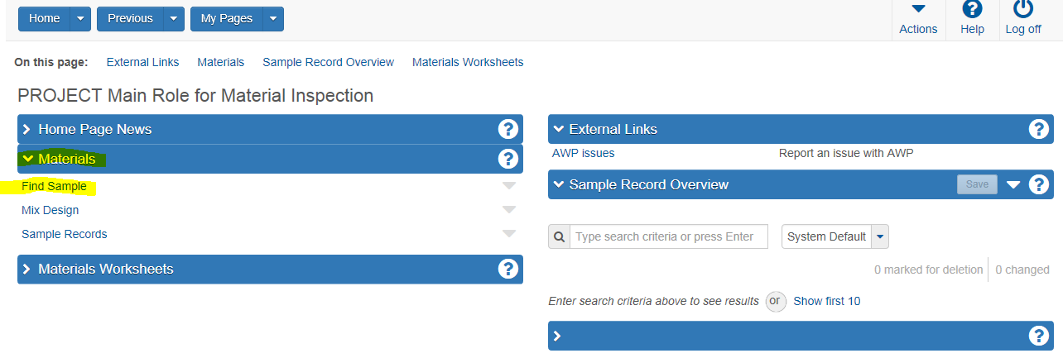

The Find Sample window will open and appears as shown below. The top half of the window is separated into three blocks; Entity, Fields, And Criteria.

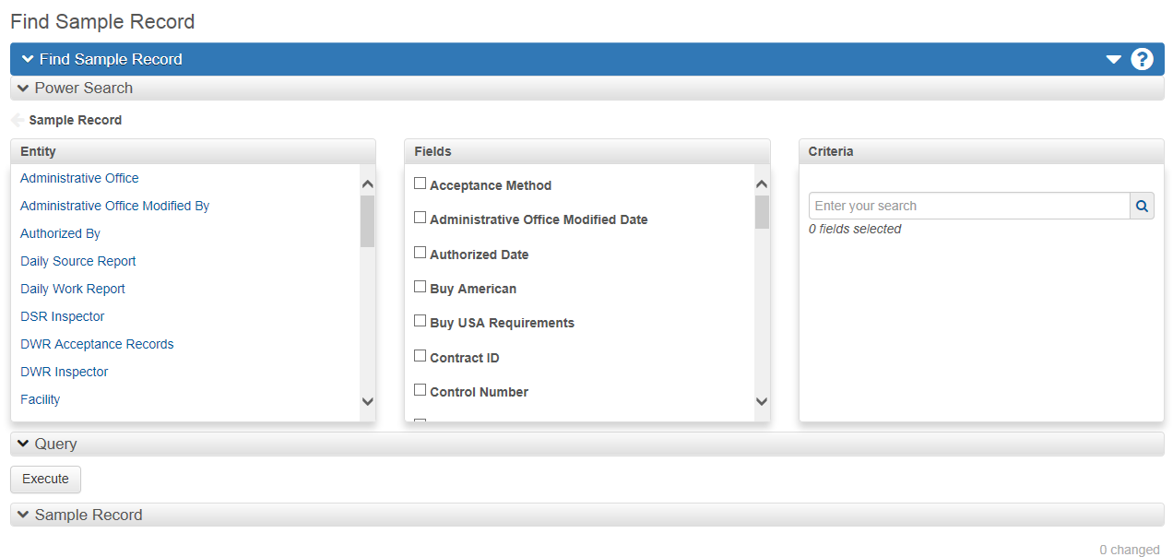

Using the slide bar next to the **Entity** block, the user can select what module of AWP they want to search in for associated sample records.

By double clicking one of the **Entity**’s, the Entity options change by “stepping down” one level. The “**Fields**” block will change as well with pertinent options to narrow your search each time the **Entity’s** change. You can “step up” to go back by clicking on the blue arrow just above the **Entity** box.

Once you have selected a **Entity**, check the box next to the **Field(s)** you want to include in your search.

To make a simple search using only one field, checkmark the box next to the **Field** identified and enter the **Criteria** to search. Click on the magnifying glass at the end of the field.

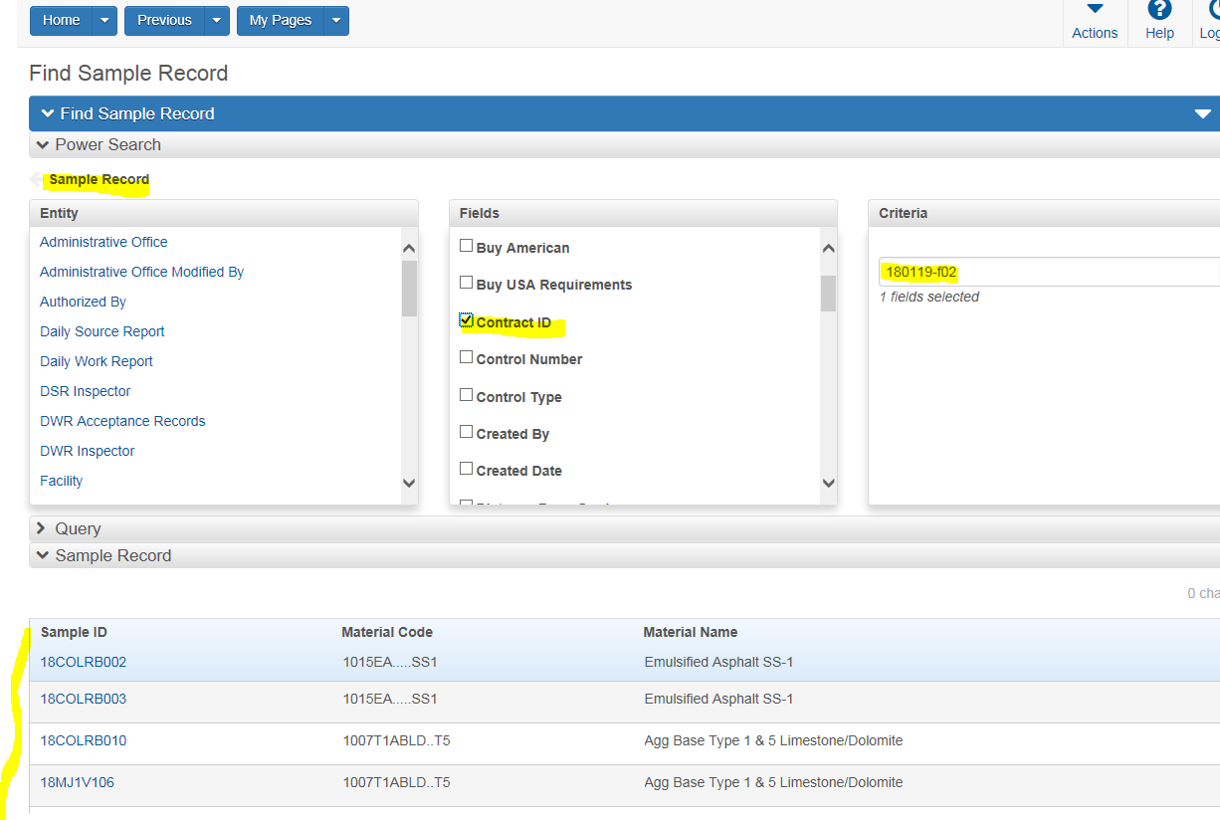

The sample records can be accessed directly from here by clicking on the ID number.

To make a search using multiple fields, checkmark the boxes next to the **Field** identified. Once the user clicks on the magnifying glass at the end of the field the Query populates displaying the multiple filters in play. The user must than enter the **Criteria** in these filters and use the “Execute” button to activate the search.

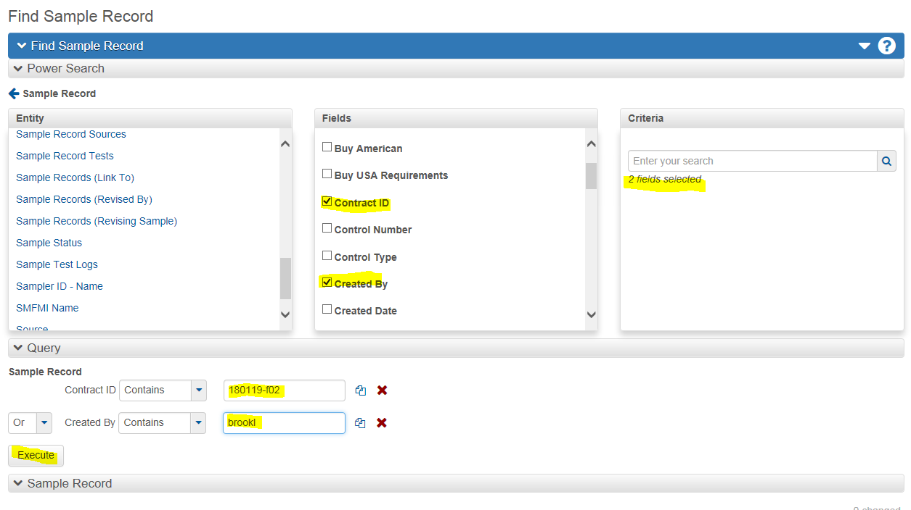

End of Quick Reference Guide