Roadway JSP Instructions

A. Syncing JSP SharePoint Site to view in Explorer 2
B. Selecting Your JSPs 5
C. Adding to and Editing Table of Contents (TOC) 8
D. Tips and Tricks 10
1. View the Navigation Pane 10
2. To Rearrange the JSPs Within Your Document. 10
3. Formatting Instructions for Job Special Provisions 11
4. Adding a JSP not Found in the Database 11
5. How to Setup the Heading 1 Style 12
6. Adjusting Your Heading 1 Indent 16
7. Updating JSP with Current Version 18
8. Turn Off Use CTRL + Click to Follow Hyperlinks of TOC. 20

Syncing JSP SharePoint Site to view in Explorer

NOTE: You may not have authority to map a network drive. If you do not have the authority, you will need to contact your local IS staff and have them map the SharePoint site for you. Most employees should have the authority to map a network drive.

- Open with SharePoint Online the internal JSP SharePoint Site under Central Office Design/ Engineering Policy/JSP.
  - You can copy or enter the following text or:
https://modotgov.sharepoint.com/sites/DE/JSP/Forms/JSPByTitle.aspx

  - You can Select the following:
    - Open SharePoint
    - Click Divisions & Business Offices
    - Click Design
    - Under Sections- Click Engineering Policy
    - Click JSP

- When the JSP SharePoint Site opens, click to the right of the JSPs, as shown by the red arrow below, this will make your LIBRARY tab at the top left corner of your screen appear (Circled in Red).
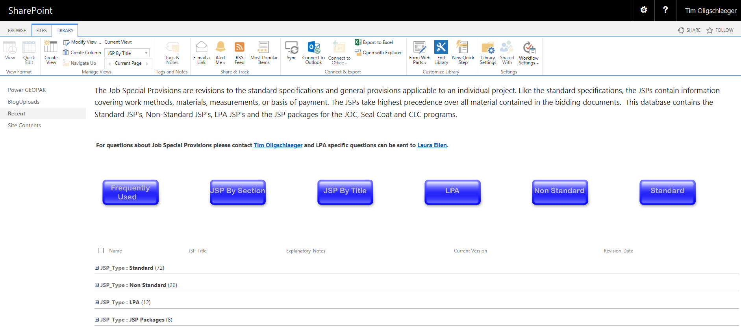
righ

- Click on the LIBRARY tab and scroll over to and click on Sync.

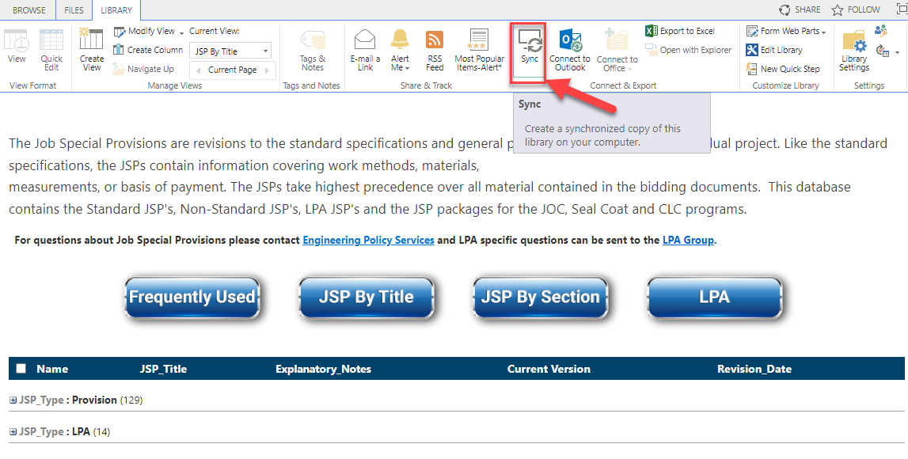

- In the Explorer window, synced locations will show up under Missouri Department of Transportation.

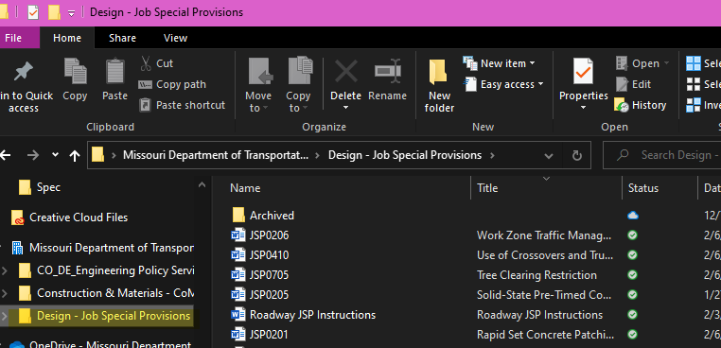

- To the right of the columns near the top just right of the Size column, right-click and put a check next to Title. This will show the title of the JSPs.

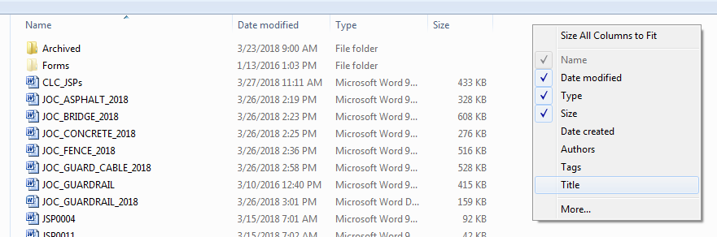

- You can drag the Title column over next to the Name column that has the JSP numbers in it.
- In order to display the titles, you’ll need to right click on the status—and change it to “always keep on this device” instead of in the cloud.
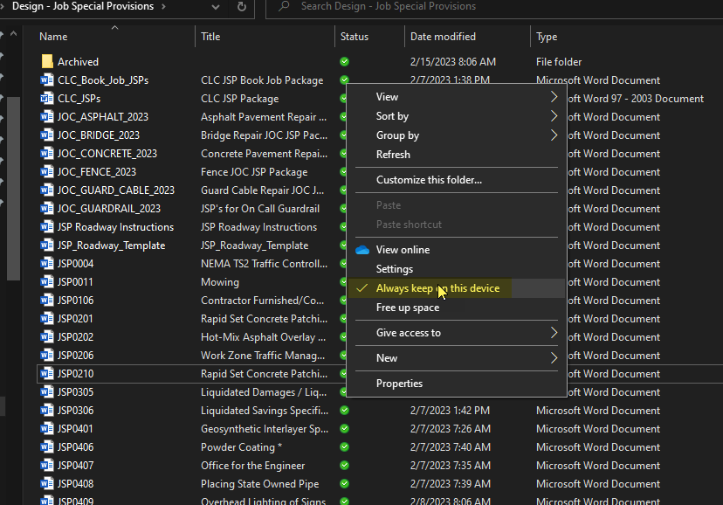

- Pin this Database to Quick Access.
  - Right Click on Quick Access.
  - Click “Add current location to Favorites”
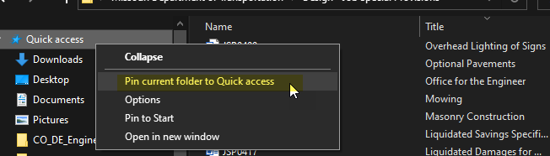
  - The pinned folder will appear at the bottom of the list

Selecting Your JSPs

- Open the JSP Database by:
  - Click the Pinned - JSP Database or
  - Open up the internal JSP SharePoint site under Central Office Design/ Engineering Policy/JSP or
  - Copying the following text to SharePoint or Internet Explorer.
https://modotgov.sharepoint.com/sites/DE/JSP/Forms/JSPByTitle.aspx

- Click on the Provisions JSPs and select the Roadway_JSP_Template. You will want to click on Open in Word. You can also open this file up from the JSP drive you synced above.
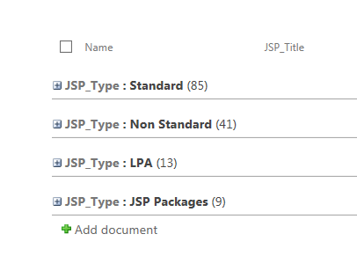
You will not see the above mentioned screen if you click on the Quick Access- JSP Database. All the JSPs will be shown.
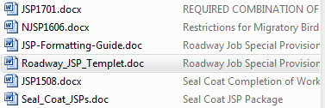
Standard JSP
Non-Standard JSP

JSP Package
LPA JSP
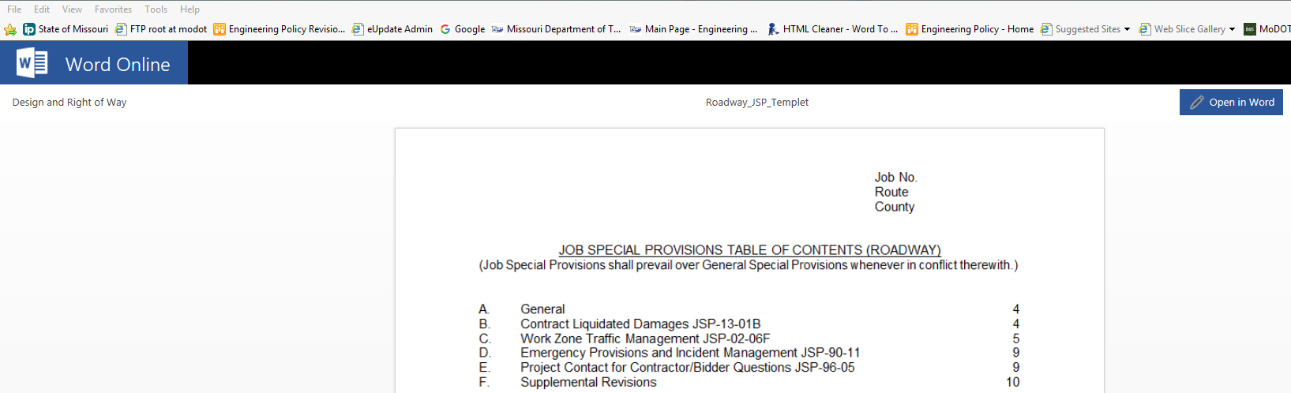

- Click on File – Save As. In the File name box, enter a new name for the file and click Save.

- To add JSPs to your document, place the cursor three lines below the last JSP allowing two blank lines between JSPs.
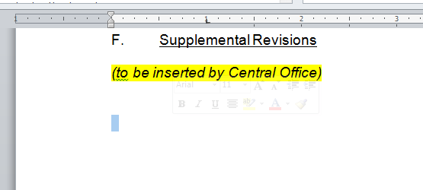

- Click on the Insert tab.

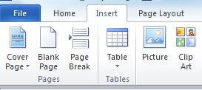

- Over on the top right side click on the Object drop down arrow and click on Text from File.

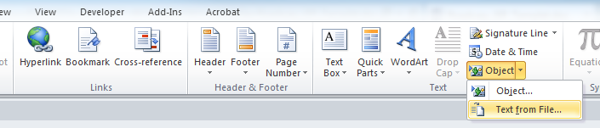

- Select your JSP drive you synced previously or the Pinned - JSP Database you created.

- Select the JSPs you would like to add. You can select multiple files by holding down the Ctrl button. Files will be placed in your document in the order they were selected. It is best to keep the number of files selected to fewer than 15 with a max of 20.

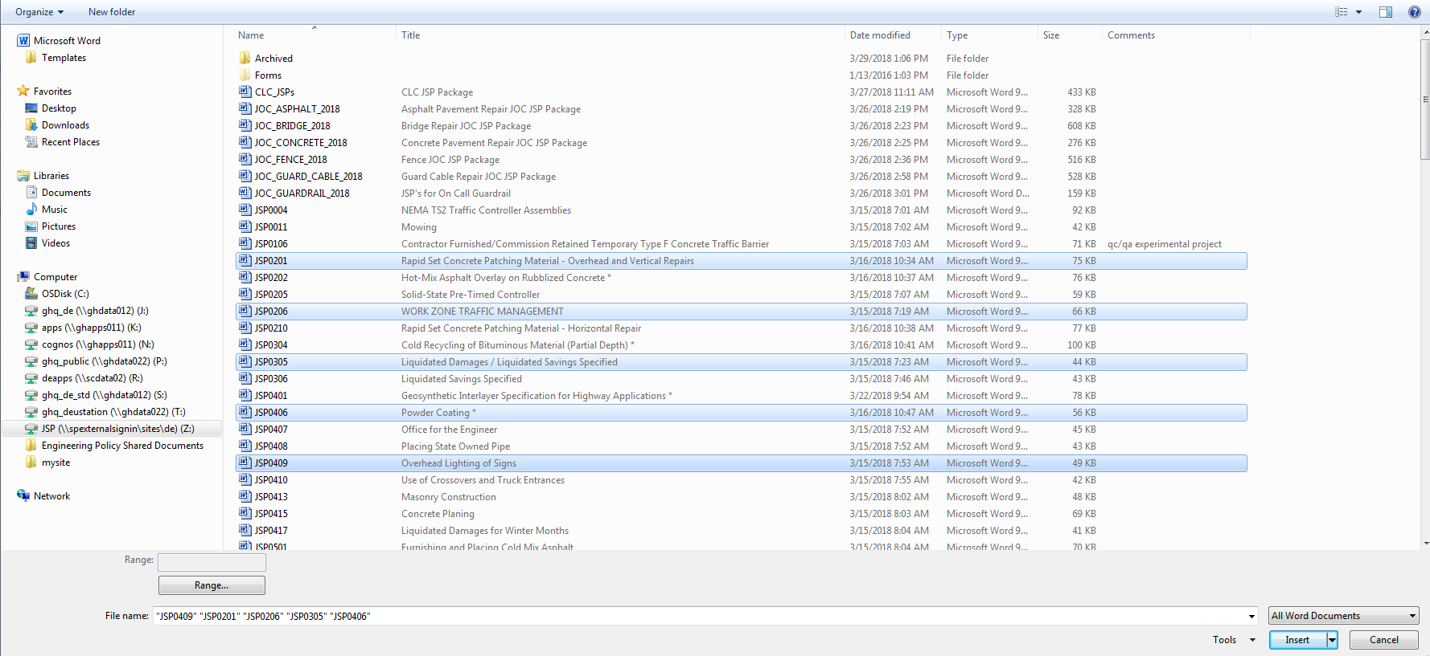

- Once you have your files selected click Insert.

- Note: When clicking on Object – Text from File to select additional JSPs it may change the way the JSPs are viewed in the Insert File box, most notably the JSP titles won’t be listed (see below). Click on the synced JSP drive to view the JSPs with the titles shown.

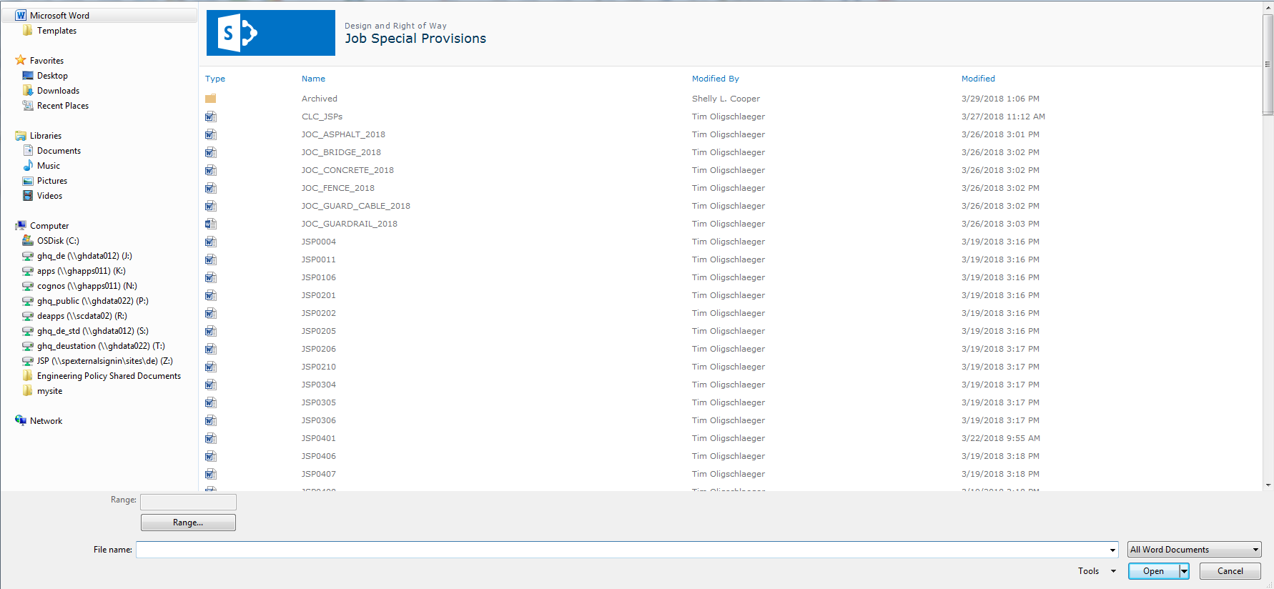

Adding to and Editing Table of Contents (TOC)

- With your JSPs added to your document you will need to update the TOC on the first page. Right-click on the TOC and click on Update Field. 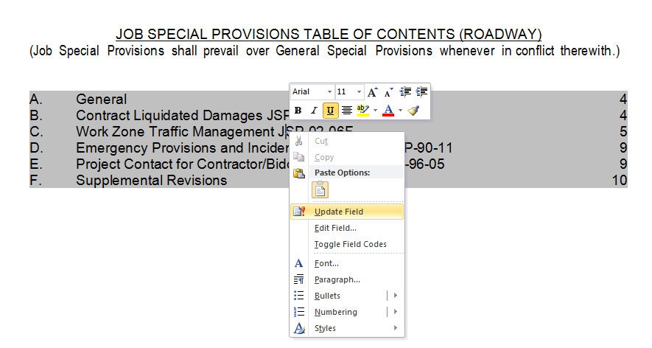

- Click Update entire table and click OK.
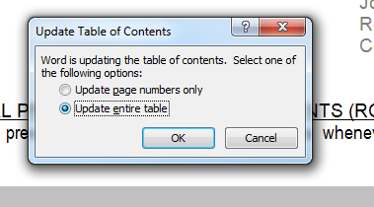

- Your new JSPs are now added to the TOC.
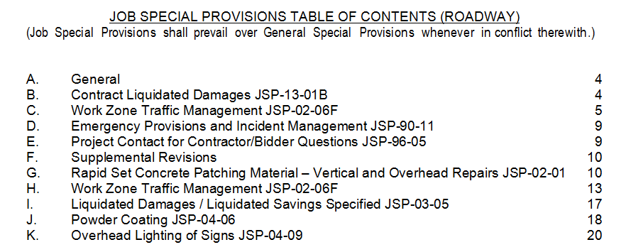
Note: Make sure you update your TOC after any changes and it is updated before submitting your JSPs to Central Office.

All modified JSPs shall have the JSP number removed from the table of contents and JSP heading to show it has been modified.

Please note we changed the formatting of the JSP Title. In the past the JSP Title was all Capital Letters. Now the JSP Title is first letter of every major word is capitalized. This takes up less space in the TOC and looks better. Reference JSP G above. If this were all capital letters the title would not fit on one line.

Tips and Tricks

View the Navigation Pane
  - Click on the View tab and check the Navigation Pane. The Navigation Pane allows you to navigate through the document by heading, by page or by searching for text or objects.

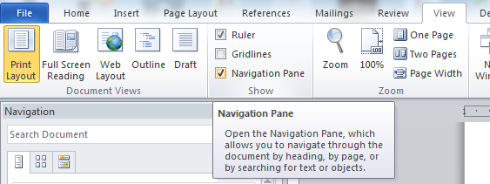

To Rearrange the JSPs Within Your Document.
- Click on the JSP in the Navigation pane and drag it to the location in the Navigation pane you want it to end up
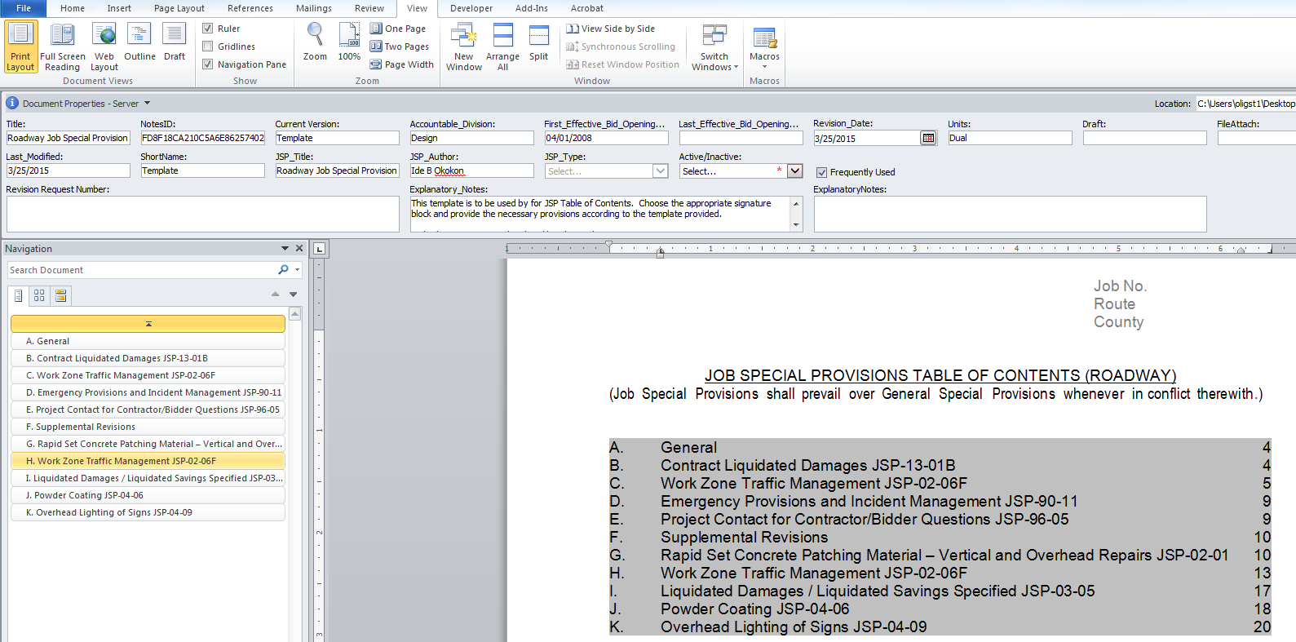
Note: Remember to update your TOC.

Formatting Instructions for Job Special Provisions

- Heading Shall be First Letter Capitalized and Underlined (Arial 11 Font)

1.0 Paragraphs. Paragraph number (1.0, 1.1, 1.2, etc), then TWO SPACES, then the paragraph title followed by a period, then another TWO SPACES, then begin the text of the paragraph.

1.1 Paragraph number and paragraph title should be BOLD.

1.2 Put a blank line between each paragraph.

2.0 Fonts. Use Arial 11 font, single-spaced. For Microsoft Word users, use tables when necessary.

3.0 Page Settings. Use margins of 1" left and right, 1" top and 0.5" bottom. All text should be fully justified.

4.0 Rule

4.1 When referencing a Missouri Standard Specification Section number, use Sec # (ex. Sec 401.2). Example. (This work shall be in accordance with Sec 301.) Do not include the phrase “of the Missouri Standard Specifications.”

4.2 When referencing a Job Special Provision number while in the JSP as follows: Example. (The contractor shall follow the test methods described in section 5.1 of this provision.)

Adding a JSP not Found in the Database

- Click where you want to add a JSP. This could be at the end of your document or at a location within your JSPs.
- Create the JSP by typing or pasting the JSP in the set of JSPs.
  - Follow the Formatting Instructions for Job Special Provisions above.
- Select the JSP’s Heading
- Click the Heading 1 Style to apply the style sheet to the heading.
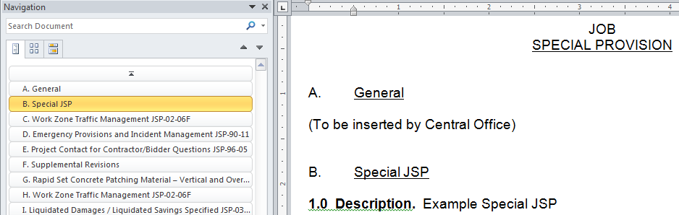
- Applying the Heading 1 Style to the heading of your JSP will be automatically letter the JSP and the heading will be displayed in the Navigation pane. See the Special JSP added below.

Note. Don’t forget to update your TOC.

How to Setup the Heading 1 Style

- Right Click on the Heading 1 Style.
- Click on Modify…
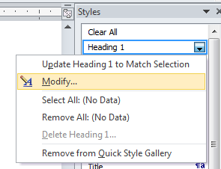

- Setup up Heading 1 with the properties as shown below.

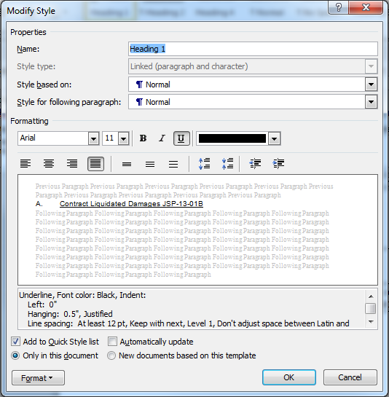
- Click on Format in the bottom left hand corner and select Numbering.

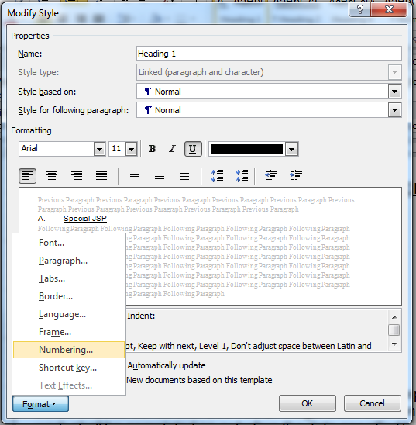

- Select the numbering format with the arrow shown below. Click OK and Click OK. Your Heading 1 Style should be updated.

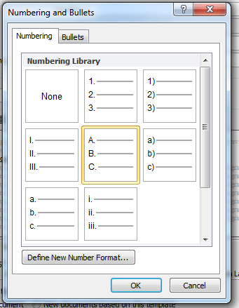

Adjusting Your Heading 1 Indent

- If your heading indent is incorrect you can easily adjust it by right-clicking on the numbering letter to the left of you heading and selecting Adjust List Indents.
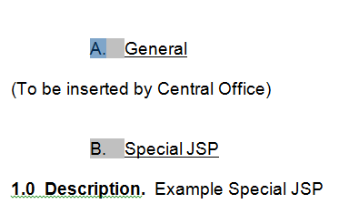
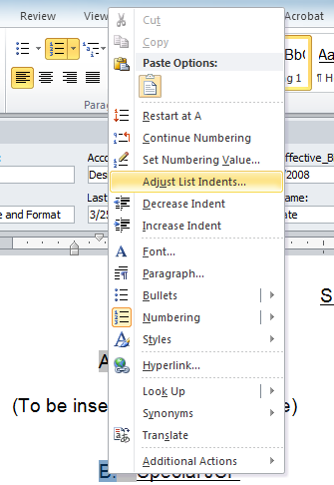

- Change Number position to 0, this will move the number position all the way to the left as originally setup. Click OK.
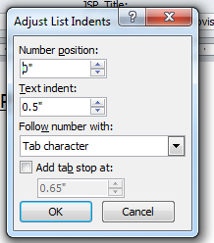

- You will get a popup stating your changes will be applied to each paragraph with a Heading 1 style. Click Yes

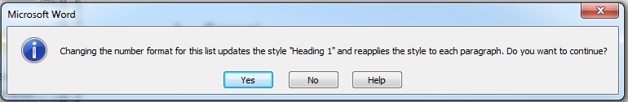

- You should see your Headings and Numbering moved over as requested.
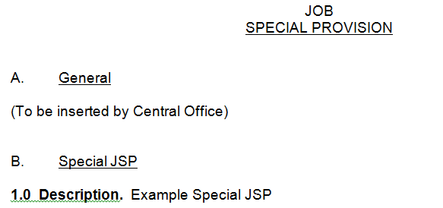

Updating JSP with Current Version

- Open up the internal JSP SharePoint site under Central Office Design/ Engineering Policy/JSP. https://modotgov.sharepoint.com/sites/DE/JSP/Forms/JSPByTitle.aspx

- Select the JSP you want to update in your set JSPs. You will want to click on Open in Word.

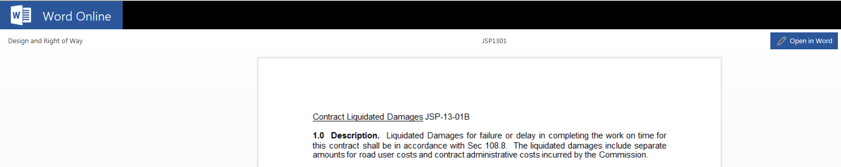

- With it opened in word, Right-click on the JSP heading in the Navigation Pane and Click on Select Heading and Content. This will select the heading and all of its contents.

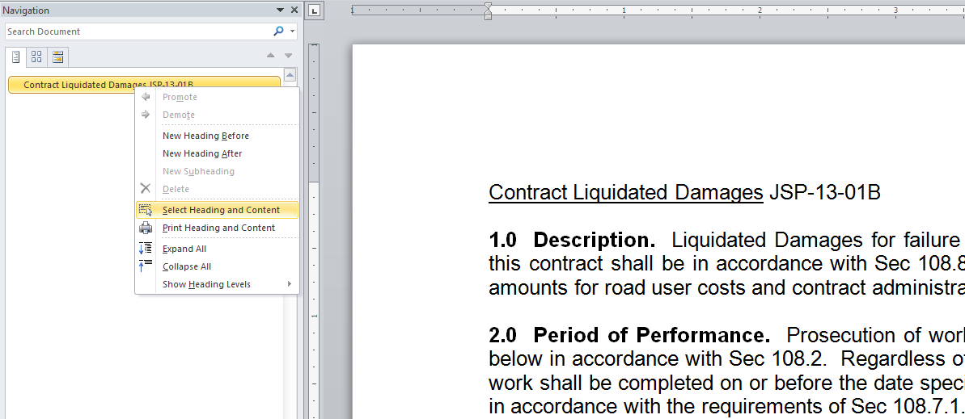

- Click Copy

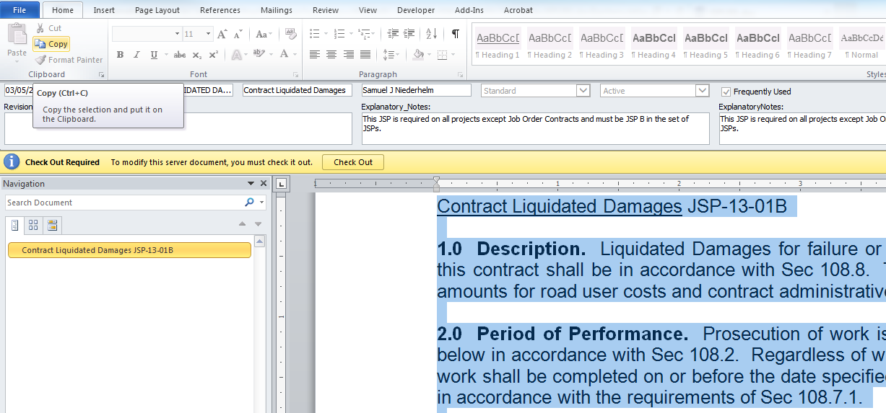

- In your JSP document you want to update, Right-click on the JSP in the Navigation Pane that needs to be updated and Click on Select Heading and Content. This will select the heading and all of its contents.

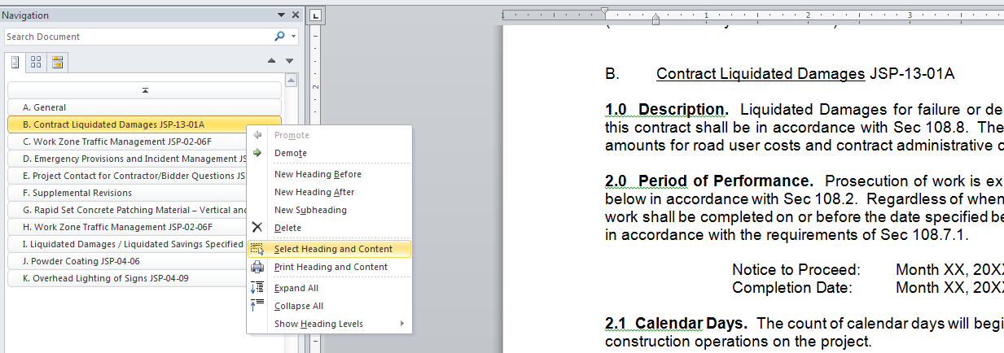

- Click Paste. You should see your JSP updated in your document with the current version you copied from the SharePoint Site.

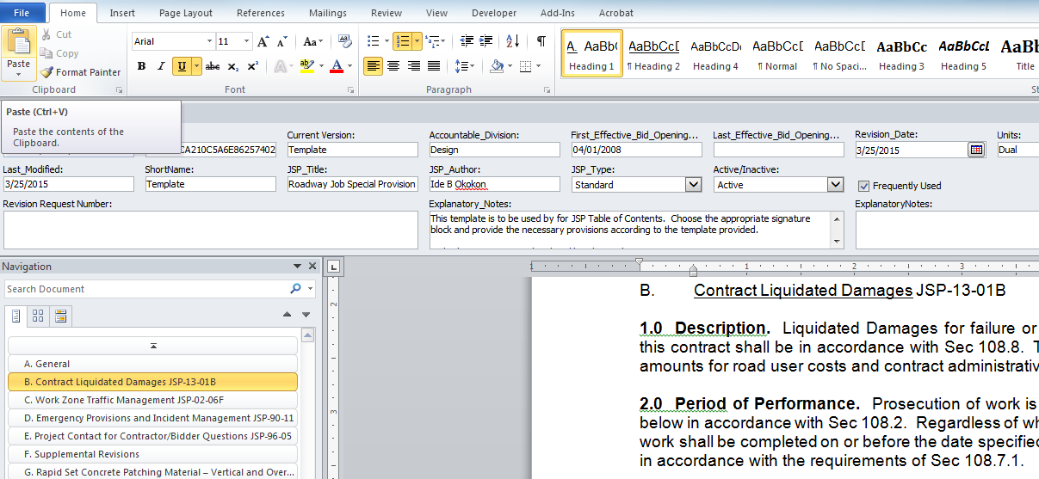

Turn Off Use CTRL + Click to Follow Hyperlinks of TOC.

  - The TOC uses hyperlinks to take you to the appropriate page for each heading. The default setting for word is to have you hold down CTRL + click on the hyperlink for the link to work. If you wish you can turn this off by following the steps below.

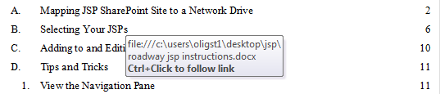

  - Click on File, and then Click on Options.

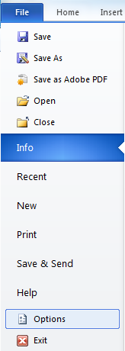

  - Click on Advanced.

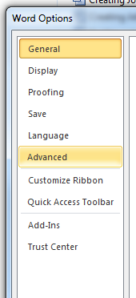
  - Uncheck Use CTRL + Click to follow hyperlink.

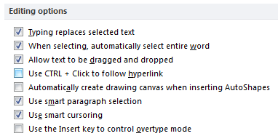

- Now you will be able to Click on the hyperlinks without having to hold down the CTRL button. This does change how you modify the hyperlinks. You will have to hold down the CTRL button + Click in the hyperlink to place your cursor, which then allows you to make your edits. This does not change how you update the TOC.

