Lump Sum Temporary Traffic Control JSP-22-01A

1.0 Delete Sec 616.11 and insert the following:

616.11 Method of Measurement. Measurement for relocation of post-mounted signs will be made to the nearest square foot of sign area only for the signs designated for payment on the plans. All other sign relocations shall be incidental. Measurement for construction signs will be made to the nearest square foot of sign area. Measurement will be made per each for each of the temporary traffic control items provided in the contract.

616.11.1 Lump Sum Temporary Traffic Control. No measurement will be made for temporary traffic control items grouped and designated to be paid per lump sum. The list of lump sum items provided in the plans or contract is considered an approximation and may be subject to change based on field conditions. This is not a complete list and may exclude quantities for duplicate work zone packages used in simultaneous operations. The contractor shall provide all traffic control devices required to execute the provided traffic control plans for each applicable operation, stage, or phase. No measurement will be made for any additional signs or devices needed except for changes in the traffic control plan directed by the engineer.

2.0 Delete Sec 616.12 and insert the following:

616.12 Basis of Payment. All temporary traffic control devices authorized for installation by the engineer will be paid for at the contract unit price for each of the pay items included in the contract. Whether the devices are paid individually, or per lump sum, no direct payment will be made for the following:

(a) Incidental items necessary to complete the work, unless specifically provided as a pay item in the contract.

(b) Installing, operating, maintaining, cleaning, repairing, removing, or replacing traffic control devices.

(c) Covering and uncovering existing signs and other traffic control devices.

(d) Relocating temporary traffic control devices, including permanent traffic control devices temporarily relocated, unless specifically included as a pay item in the contract.

(e) Worker apparel.

(f) Flaggers, AFADs, PFDs, pilot vehicles, and appurtenances at flagging stations.

(g) Furnishing, installing, operating, maintaining, and removing construction-related vehicle and equipment lighting.

(h) Construction and removal of temporary equipment crossovers, including restoring pre-existing crossovers.

(i) Provide and maintaining work zone lighting and work area lighting.

616.12.1 Lump Sum Temporary Traffic Control. Traffic control items grouped together in the contract or plans for lump sum payment shall be paid incrementally per Sec 616.12.1.1. Alternately, upon request from the contractor, the engineer will consider a modified payment schedule that more accurately reflects completion of traffic control work. No payment will be made for any additional signs or devices needed except for changes in the traffic control plan directed by the engineer. Additional items directed by the engineer will be paid for in accordance with Sec 109.4. No adjustment to the price will be made for overruns or underruns of other work or for added work that is completed within existing work zones.

616.12.1.1 Partial payments. For purposes of determining partial payments, the original contract amount will be the total dollar value of all original contract line items less the price for Lump Sum Temporary Traffic Control (LSTTC). If the contract includes multiple projects, this determination will be made for each project. Partial payments will be made as follows:

(a) The first payment will be made when five percent of the original contract amount is earned. The payment will be 50 percent of the price for LSTTC, or five percent of the original contract amount, whichever is less.

(b) The second payment will be made when 50 percent of the original contract amount is earned. The payment will be 25 percent of the price for LSTTC, or 2.5 percent of the original contract amount, whichever is less.

(c) The third payment will be made when 75 percent of the original contract amount is earned. The payment will be 20 percent of the price for LSTTC, or two percent of the original contract amount, whichever is less.

(d) Payment for the remaining balance due for LSTTC will be made when the contract has been accepted for maintenance or earlier as approved by the engineer.

616.12.1.2 Temporary traffic control will be paid for at the contract lump sum price for Item:

Item No. | Unit | Description
616-99.01 | Lump Sum | Misc. Lump Sum Temporary Traffic Control

DRAFTER’S NOTE: Traffic control items included in the lump sum pay item shall be limited to only those items listed below. All other items on the Summary of Quantities Sheet (2BS) that have a quantity shown must be marked with an asterisk and footnote added “NOT INCLUDED IN MISC. LUMP SUM TEMPORARY TRAFFIC CONTROL.” An example is shown below.

List of items included in lump sum traffic control:
616-10.05 – Construction Signs
616-10.08 – Advanced Warning Rail System
616-10.10 – Relocated Signs
616-10.20 – Channelizer (Drum-like)
616-10.25 – Channelizer (Trim Line)
616-10.26 – Channelizer (Vertical Barrier)
616-10.30 – Type III Moveable Barricade
616-10.33 – Directional Indicator Barricade
616-10.40 – Flashing Arrow Panel
616-10.47 – Type III Object Marker
616-10.55 – Sequential Flashing Warning Light
616-10.70 – Tubular Marker
616-11.20 – Installing “Drive Smart” Sign
616-11.33 – Installing “Point of Presence” 96” x 48” Sign
616-11-34 – Installing “Point of Presence” 36” x 48” Sign

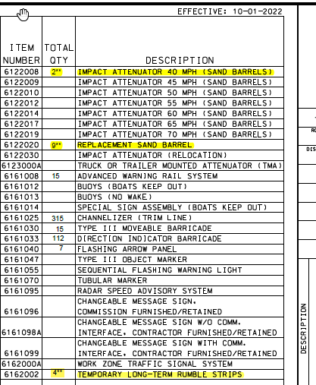

Example Quantity Sheet

