# Full Depth Reclamation with Cementitious Material NJSP-22-01A

**1.0 Description.** This work shall consist of reclaiming (pulverizing) the in-place material to the depth and width shown on the plans. A binder agent, water, and other additives, if required, shall be incorporated into the reclaimed material. The combined material shall be spread and compacted in accordance with the plans and specifications and as directed by the Engineer. This process will herein be referred to as Full Depth Reclamation (FDR).

**2.0 Material.** All material shall be approved by the Construction and Materials Division or in accordance with Division 1000, Material Details, and specifically as follows:

|  |  |
| --- | --- |
| Item | Section |
| Emulsified Asphalt | 1015 |
| Water | 1070 |
| Cement | 1019 |

**2.1 Cement Material.** The type and amount of cement material to be used shall be determined by the mixture design. Portland cement is referenced in this specification.

**2.2 Reclaimed Asphalt Pavement (RAP) and Underlying Material.** RAP and underlying material shall consist of the existing asphalt material, existing base course material, and/orsubgrade material. The underlying materials shall be free of roots, sod, topsoil, weeds, wood, or any material deleterious to its reaction with the cementitious stabilizing agent. The gradation of the processed (pulverized) material shall meet the requirements in Section 6.1 of this provision.

**2.3 Corrective Aggregate.** Corrective aggregate may be required to supplement the existing material gradation and meet the performance requirements of the mix. Corrective aggregate may consist of limestone screenings, crush rock, RAP, crushed concrete, or other approved crushed materials.

**2.4 Other Additives.** If necessary, other additives such as set retarders, lime, or pozzolans may be used to produce a mixture in accordance with Section 3.0. The type and percentage used shall be described in the submitted design recommendation.

**2.5 Water.** Water shall be added to achieve the desired moisture content. Water added shall be free from deleterious concentrations of oils, alkalis, salts, sugars, vegetation, as well as other organic, chemical, or deleterious substances. The water shall not cause an adverse effect on either the cementitious stabilizing agent or the reclaimed mixture. If the water is of questionable quality, it shall be tested in accordance with AASHTO T 26 or ASTM C 1602.

**3.0 Mixture Design.** The contractor, using material obtained directly from the project site, shall submit a mix design tested in accordance with Appendix 1. Significant changes in the type of bituminous or underlying materials encountered during sampling shall warrant a separate mix design. The FDR mix design submitted by the contractor shall meet the following criteria.

|  |  |
| --- | --- |
| **FDR MIX DESIGN** |  |
| **Property** | **Criteria** |
| Compressive strength, AASHTO T 22, 7-day, psi | 200 (Min.) |
| Compaction effort for strength samples, AASHTO T 99, Method C | 96 % of MOD (min) |
| **MIX DESIGN GRADATION REQUIREMENTS\*** | |
| Percent Passing 3/4" Sieve* | 100 |
| Percent Passing No. 4 Sieve | 45 (min) |
| Percent Passing No. 200 Sieve | 5 (min) |

* Maximum size for laboratory mix design, field pulverized material shall meet the gradation requirements listed in Section 6.1.

In addition to meeting the above criteria, the contractor shall report the results of their mix design on the form provided in Appendix 2.

**4.0 Equipment.**

**4.1 Reclaimer.** The reclaimer shall be self-propelled and capable of fully reclaiming the existing road to the depth required, incorporate the cement material and water, and mix the materials to produce a homogeneous material. The minimum power of the reclaimer shall be 400 horsepower unless waived by the engineer. The machine shall be capable of reclaiming no less than 8 feet (2.4 m) wide and up to 12 inches deep in each pass. A machine with a width less than 8 feet (2.4 m) may be approved by the engineer upon demonstration of sufficient mixing capabilities. The reclaimer shall have an integrated water injection system for adding water or slurry with a full width spray bar consisting of a positive displacement pump interlocked to the machine speed so that the amount of water or slurry being added is automatically adjusted with changes in machine speed. Individual valves on the spray bar shall be capable of being turned off as necessary to minimize cement material overlap on subsequent passes.

**4.2 Motor Grader.** A motor grader for pre-shaping, aerating, spreading and final shaping of the material is necessary. The motor grader shall have a cross slope indicator.

**4.3 Rollers.** Compacting of the reclaimed mix shall be completed using self-propelled rollers, complete with properly operating scrapers and water spray systems. The number, weight and types of rollers shall be as necessary to obtain the required compaction throughout the entire FDR thickness. A pneumatic roller of adequate size, a vibratory padfoot roller with an 84-inch wide drum equipped with knockdown blade, and a single or double drum vibratory steel roller with a 10 ton minimum weight may be used in any combination to achieve density.

**5.0 Construction Methods.**

**5.1 Weather Limitations.** FDR operations shall be completed when the atmospheric temperature, measured in accordance with MoDOT Test Method TM-20, is 50 F (10 C) and rising. All equipment shall be off the road 30 minutes before sunset when constructed under traffic. The weather shall not be foggy or rainy and shall not call for freezing temperatures within seven days after placement of any portion of the project.

**5.2 Vegetation Removal.** Grass and other vegetation shall be removed from the edge of the roadway to be reclaimed to prevent contamination of the material during the reclaiming operation.

**5.3 Pulverization.** Prior to the addition of cementitious material, the roadway shall be pulverized to the depth and width shown on the plans using a self-propelled reclaimer meeting the requirements of Section 4. The roadway shall be pulverized to form a homogeneous mixture and be brought to the desired moisture content by means of an integrated water injection system.

**5.3.1 Pre-milling.** Coldmilling, if required, shall be performed to the depth and width shown on the plans prior to pulverization.

**5.3.2 Corrective Aggregate.** Corrective aggregate, if required, may be placed either prior to or following pulverization but before the addition of any cementitious material. If applied following pulverization, the granular material shall then be blended with the reclaimed material by means of additional full depth mixing to form a homogeneous mixture prior to the application of cementitious material.

**5.4 Cement Material Spreading.** Cement material shall be applied to the pulverized surface with a spreading device capable of uniformly spreading the amount required. The spreading device shall be capable of spreading the cement material both laterally and longitudinally in an even and accurate manner. Spreading with a motor grader or pneumatic blower shall not be allowed. Additives shall be introduced by a calibrated device through wet or dry methods. The FDR operation shall be suspended when winds create an excessive amount of blowing dust or blowing cement material.

**5.5 Reclaiming and Compaction.** Operations shall be scheduled so that the elapsed time between the initial mixing of the cement material and the completion of padfoot rolling does not exceed 30 minutes. If using dry stabilizer, water application shall only be done through the reclaimer's integrated water injection system during mixing. If the 30 minutes is exceeded on an uncompacted lift, the uncompacted material will be retreated as directed by the Engineer. Proposals may be submitted to the Engineer including the use of alternate methods, alternate equipment or set retarding additives, if suitable laydown and compaction is not achieved. **Final rolling pass shall be completed within one hour of the initial mixing.**

**5.6 Initial Compaction.** The breakdown roller, padfoot or pneumatic, shall not be behind the reclaimer by more than 500 feet (150 m). The padfoot roller, applying high amplitude and low frequency, or the pneumatic roller shall perform initial compaction at enough passes until the roller walks out of the material. Walking out for the padfoot roller shall be when light is clearly evident between all of the pads at the material-padfoot drum interface. Walking out for the pneumatic roller shall be when no significant wheel impressions are left on the surface.

**5.7 Shaping.** After the completion of padfoot rolling, any remaining padfoot marks shall be removed and the material spread using a motor grader to cut no deeper than the depth of the padfoot marks. The desired slope and shape shall be achieved. After the first day of cement material addition, the reclaimed base shall not be shaped to prevent chunking.

**5.8 Intermediate and Final Compaction.** The vibratory double-drum steel roller and pneumatic roller shall compact the bladed material. The best combination of number of passes and order of rollers shall be used to meet compaction requirements. The finish roll shall not be Hi vibratory mode.

**5.9 Curing.** Within two hours after adding the cement material and water, a diluted CSS-1 emulsified asphalt material meeting the requirements of Sec 1015, shall be applied in accordance with Sec 413.40. The CSS-1 emulsified asphalt shall be diluted with 50% water or as directed by the engineer. The NanoTac® emulsion additive, shall be mixed into the diluted emulsion at 0.35% by weight of the emulsion or as directed by the NanoTac® representative. Contact information regarding the NanoTac® is provided as follows:

Rick Bird

rbird@asmg.com

(775) 690-8513

The final emulsified asphalt mixture shall be applied in two passes with each pass having an application rate of 0.1 gallons per square (gal/sy) to produce a total application rate of 0.2 gal/sy. The reclaimed surface shall be wetted with a light water spray prior to placement of the first pass of emulsified asphalt. Blotter sand may be required if traffic experiences pick up of the emulsion.

**5.10 Smoothness.** The completed surface shall not vary more than 0.25 inch (6 mm) from the lower edge of a 10-foot (3 m) straight edge placed on the surface parallel and transversely to the centerline. The contractor shall correct humps exceeding this tolerance by trimming, milling or abrasive grinding. Feathering shall not be permitted for repair of low areas. Depressions exceeding the specified depth tolerance shall have a tack coat applied and filled with asphalt concrete just prior to placement of the final surfacing.

**5.11 Traffic.** Completed portions of FDR stabilized base can be opened immediately to low speed local car traffic, provided the curing material is not impaired. Construction equipment and heavy truck traffic shall not be allowed on the completed FDR stabilized base until a proof roll is conducted to verify the stability of the FDR layer. Proof rolling shall be performed by driving a tandem dual wheel loaded dump truck or equivalent piece of equipment over the FDR finished product. The contractor shall order his work to provide for prompt placement of the bottom lift of the asphalt course to minimize raveling of the base from traffic exposure. The maximum period of traffic exposure on any given section of FDR stabilized base shall not exceed 14 calendar days as measured from, and counting the day that the stabilized base is first opened to traffic, to the day that the first lift is placed unless otherwise approved by the engineer.

**5.12 Repairing.** Areas in the recycled roadway that develop cracking and/or settlement after the full depth reclamation process shall be repaired. These repairs shall be by deep patching and completed prior to placement subsequent layers. The existing asphalt surfacing material, base and subgrade soil as required shall be removed and replaced with the type of asphaltic concrete being produced on the project at that time and properly compacted to produce a stable repair.

**5.13 Equipment Innovation.** Other methods and equipment as approved by the engineer will be allowed.

**6.0 Quality Control.** The contractor shall be responsible for quality control (QC)of all material and the reclaiming process. The form in Appendix 3 shall be used to document QC test results. Sampling and testing frequency shall meet the minimum requirements described herein or defined in the contractor's QC plan.

**6.1 Material Sizing.** Samples of the reclaimed material shall be obtained before beginning initial compaction. The processed (pulverized) material shall meet the following gradation requirements. A sieve analysis shall be conducted at a minimum of two tests per day. The resulting gradation shall be compared to the mix design gradations to determine any necessary changes to the cementitious or corrective aggregate material content. Sampling procedures shall be in accordance with AASHTO T 168.

|  |  |
| --- | --- |
| **Sieve Size** | **Minimum % Passing by Weight** |
| 2.0 in. (50mm) | 100 |
| 3/4" in. (19 mm) | 70 |
| No. 4 (4.75mm) | 40 |
| No. 200 (0.075mm) | 5 |

**6.2 Cement Material Content.** The amount of cement material used shall be as recommended from the mix design. Any changes to the cement material content will need to be approved by the engineer prior to altering the content. The percentage of cement material added shall be checked by determining the amount used by meter readings or truck weight (mass) tickets and by estimating the quantity of road reclaimed - depth, width, length, and estimated in-place density by Proctor density, mix design or field check, or by nuclear density. On the first day of FDR operations, the cement material content shall be determined at a minimum on the first cement material transport. Adjustments in equipment calibration shall be made if necessary. If adjustments are made, the cement material content shall be checked again. Thereafter, the cement material content shall be determined at a sampling frequency of a minimum of one test per day.

**6.3** **Moisture Content.** Moisture content shall be checked by microwave oven in accordance with ASTM D 4643 or equivalent methods, such as a nuclear gauge, direct heating or infrared. Minimum sample size shall be 700 grams for the microwave procedure after the material has been screened through a %-inch (19.0 mm) sieve. If the average moisture content is not **within one percent of the optimum moisture content (corrected for oversized particles),** then the moisture content shall be adjusted by moisture addition with a water truck or by aeration. If the moisture content has been manipulated, the moisture content shall be re-checked. The moisture content sample shall be to the depth of reclamation and taken by any suitable method. The sides of the sample hole shall be perpendicular to the road surface. Samples shall be kept sealed until the samples are ready for testing. The moisture content shall be checked, at minimum, of every 1000 feet on the first day of FDR. After the first day, moisture content sampling frequency shall be at a minimum of three tests per day or as directed by the Engineer.

**6.4 Depth Control.** The reclaiming depth during all operations shall be monitored regularly to determine compliance with the plans. The depth shall be determined on each side of the reclaimer pass and shall be adjusted immediately as necessary. Depth control shall be verified once per day. The contractor shall take precautions so as not to damage any existing drainage or pipes. Any pipes damaged by the contractor shall be repaired or replaced at the contractor's expense as directed by the engineer.

**6.5 Reclaimed Material Compacted Density.** Density shall be a **minimum of 96%** of the maximum dry density (MDD) corrected for oversized particles and determined in accordance with AASHTO T 99, Method C. Adjustments to the MDD for oversized particles shall be determined in accordance with ANNEX A1 of AASHTO T 99. Density shall be determined according to MoDOT Test Method TM-41. A minimum of two test strips shall be completed to determine the optimum rolling pattern to obtain the required density. Test strips failing to meet the required density shall be reprocessed. Test strips meeting density requirements shall remain as part of the finished work. Care shall be taken not to over-roll the mat based on visual observations of check cracking or shoving. A new rolling pattern may need to be established if conditions change or it found the required density is not achieved. After acceptance of the test strips, the minimum testing frequency shall be every 1000 feet.

**7.0 Quality Assurance.** Samples will be taken daily to determine the density and moisture content are in compliance with this specification.

**8.0 Method of Measurement.** Work as described for FDR will be measured to the nearest 0.1 square yard of the completed sections for the depth specified. Final measurement will not be made except for changes authorized by the engineer

**9.0 Basis of Payment.** The accepted quantities of FDR shall be paid at the contract unit bid price for item number 405-50.10, Full Depth Reclamation, per square yard. Portland cement will be included in the unit bid price for Full Depth Reclamation. For estimating purposes, 6.0 % or 8 % Portland cement for FDR by weight (mass) of the reclaimed material was used for the plan quantity for the two different sections. No separate payment will be made for other cementitious materials, water, and/or other additives needed for compliance with this specification.

**9.1 Adjustment to Plan Quantity.** Adjustments to the total percent of cement used in the mix design may be allowed to optimize the performance of the FDR layer.

**9.1.1** In the event the percentage of cement material required to meet Section 3.0 of this provision increases by more than +2% (total of 10% or more cement material) of the total planned mix design quantity shown in the Laboratory FDR Mix Design Reporting Form, the following unit price for the additional cement material (above 10%) shall be applied via change order.

405-99.10 Misc. Full Depth Reclamation Cement Material at $135 per ton.

**9.1.2** Payment for adjusted quantities of cement will be measured to the 0.1 tons for accepted quantity of material as approved by the engineer.

# **APPENDIX 1 - Mix Design Procedures**

**10.0 Sampling.** A field sampling plan using auger borings (ASTM D 1452), cores, and/or other determinations should be established to determine if more than one design shall be performed. The sampling plan should be established using a pattern that results in a representative sample of the asphalt pavement and underlying material. If pre-milling is required, the sampling depth will need to take into account the thickness of the pre-milling. Samples of the asphalt pavement and underlying material should be kept separate during the sampling process. Sections of the roadway with significant changes in the type of asphalt pavement or underlying material should be delineated and treated as separate sampling units. A separate mix design shall be performed for each delineated sampling unit. In addition, sections where the FDR process will encounter more than a 2-inch (50 mm) difference in the average bituminous thickness shall have separate designs performed. A minimum sample size of 350 pounds (160 kg) (asphalt pavement + underlying material) will be required for each mix design.

**10.0.1 Processing.** Once the roadway samples have been examined and the number of mix designs determined, the asphalt material shall then be crushed to produce RAP. A ledge stone aggregate crusher or similar laboratory equipment should be used to generate a RAP gradation that will be similar to that produced by the FDR process (i.e. 100% passing a 2" sieve). To facilitate crushing of the asphalt material, the material may be placed in a 0° F freezer for 24 hours prior to processing. The generated RAP should then be mixed with the underlying material at the percentages to be encountered in the field. Percentage should be based on dry weight of RAP and underlying material and the depth of FDR shown on the plans. Attention must be given to any pre-mill depth and its effects on what the remaining thickness of HMA will be for the FDR process. A sieve analysis of the blended material shall be conducted as stated in Section 10.2. This sieve analysis shall be considered the initial gradation. Although the initial gradation should be similar to that produced by the FDR process, specimens prepared for mix designs shall only use the portion that passes the 0.75 in. (19.0 mm) sieve. A moisture-density relationship of the blended material, without stabilizing agent, shall then be determined. After determining the moisture-density relationship of the untreated blended material, the blended material shall then be treated with a cementitious stabilizing agent at various rates and compacted and tested in accordance with this provision.

**10.1 Material Evaluation.** The plasticity characteristics of underlying fine-grained soils shall be determined in accordance with ASTM D 4318 or AASHTO T 90 and T 89. A sieve analysis of the blended material (RAP + underlying material) shall be conducted in accordance with ASTM C 136 or AASHTO T 27. A moisture-density relationship of the blended material, without stabilizing agent, shall be determined in accordance with AASHTO T 99, Method C. A moisture-density relationship of a treated blended material is not necessary. Experience with previous projects has shown that the differences between the OMC and MOD for a treated and untreated sample are typically negligible. The results of the material tests shall be documented and reported on the FDR Mix Design Reporting Form in Appendix 2.

**10.2 Number of Specimens/Mixing.** A minimum of three cement material contents that bracket the design cement material content shall be chosen, typically 4, 6, and 8 percent for Portland cement by dry weight of blended material.

**10.2.1** Three specimens for each of the three cement material contents shall be produced for strength testing.

**10.2.2** A mechanical mixer shall be used that has a bowl of 10-12 inches (250-300 mm) in diameter. The mixer shall rotate on the mixer's axis at 50 to 75 revolutions per minute. A mixing paddle which makes contact with the bottom and side of the bowl shall rotate on the mixing paddle axis at twice the bowl rotation rate and in the opposite rotation direction as the bowl. Other mixers providing complete and uniform mixing may be used.

**10.4 Compaction.** Each strength specimen shall be compacted at the optimum moisture content (OMC) determined from Section 10.2. Compaction shall be performed in accordance with AASHTO T 99, Method C, or ASTM 0558, Method B. A separate and new representative sample of the blended material should be used for each specimen; compacted material shall not be reused. Extrude the sample from the mold and record the weight of the compacted sample for density determination. The moisture content of each sample shall be determined by obtained left over, uncompacted, material from each specimen.

**10.5 Curing Before Testing.** After extruding and weighing the compacted specimens, the specimens shall be sealed to prevent loss of moisture and moist-cured for a period of 7 days at 75° F.

**10.6 Strength Test.** Test the cured specimens in accordance with AASHTO T 22, except the length - diameter correction will not be applied.

**10.7 Optimum Cement Material Content.** Determine the optimum cement material content by plotting the average compressive strength versus the cement material content. As a factor of safety, the optimum cement material content selected from the mix design shall produce an average compressive strength of at least 50 psi above the minimum requirement of Section 3.0.

**APPENDIX 2 – Laboratory FDR Mix Design Reporting Form.** At least 30 days prior to performing any reclaiming activity on the project, the contractor shall submit the following FDR mix design information to Central Office – Construction and Materials, Field Office for approval.

**Laboratory FDR Mix Design Reporting Form**

|  |  |  |
| --- | --- | --- |
| **Contractor:** | **Date:** | |
| **Project No.:** | **Location:** | |
| **FDR MIX DESIGN REPORTING FORM**  **Results of Laboratory Testing** | | |
| **Laboratory Test \*** | | **Laboratory Results** |
| Sieve Analysis (for Moisture-Density Relationship)  AASHTO T 27 (crushed HMA & corrective aggregate, if required) | |  |
| 3/4” Sieve (% Passing) (100% Required) | |  |
| No. 4 Sieve (% Passing) (Min 45% Required) | |  |
| No. 200 Sieve (% Passing) (Min 5% Required) | |  |
| Moisture-Density Relationship  AASHTO T 99 – Method C (without cementitious material) | |  |
| Optimum Moisture Content (OMC) | |  |
| Maximum Wet Density (MWD) at OMC | |  |
| Maximum Dry Density (MDD) at OMC | |  |
| % Corrective Aggregate (if required) | |  |
| FDR Mixture Compressive Strength, ASTM D1633, Method A | |  |
| Compressive Strength, Min. Required @ 7 days, 200 psi | |  |
| Target Moisture Content of Specimen | |  |
| **Material Information** | | **Target Material Content** |
| % Cement (by weight of MDD) | |  |
| % Other Additives (if needed):  •  •  • | |  |
| **Target Field Moisture Content** | | |

Target Field Moisture Content: (%)

(Moisture content of lab specimen at optimum compressive strength. Field moisture shall be within 1 percent of this value.)

*Submit attached to this form supporting Laboratory Reports with applicable graphs.

Reviewed by: Date:

 Approved

MoDOT Construction & Materials

 Rejected

# **APPENDIX 3 – FDR Quality Control Data Sheets**

|  |  |
| --- | --- |
| Date: | Project / location: |
| QC personnel: | Phone: |
| Temperature at start of day: | Temperature at end of day: |
| Climate conditions: | |

**Results of mix design**

|  |  |
| --- | --- |
| Optimum moisture content (OMC) |  |
| Maximum Dry Density at OMC. |  |
| Wet Density at OMC. |  |
| Recommended field moisture range: | Recommended cementitious material content: |

**Corrective Aggregate**

|  |  |  |  |  |  |  |
| --- | --- | --- | --- | --- | --- | --- |
| Station / location |  |  |  |  |  |  |
| Type and source |  |  |  |  |  |  |
| Length, ft |  |  |  |  |  |  |
| Width, ft |  |  |  |  |  |  |
| Weight, lb |  |  |  |  |  |  |
| Rate, lb/SY |  |  |  |  |  |  |

**Test strip for sand cone or nuclear density**

|  |  |  |  |  |  |  |  |  |  |
| --- | --- | --- | --- | --- | --- | --- | --- | --- | --- |
| Location | | Station | Wet | density, cf | | Moisture, % | Corrected Moisture, % | Dry density, pcf | Notes |
|  | |  |  | | |  |  |  |  |
|  | |  |  | | |  |  |  |  |
|  | |  |  | | |  |  |  |  |
|  | |  |  | | |  |  |  |  |
|  | |  |  | | |  |  |  |  |
| Average | |  |  | | |  |  |  |  |
| Operator | | Gauge model | Gauge | | Serial # |  |  |  |  |
|  | Final roller pattern: | | | | | | | | |

 Density measurements not required. Final roller pattern:

# Material Tests

|  |  |  |  |  |  |  |
| --- | --- | --- | --- | --- | --- | --- |
| Station / location |  |  |  |  |  |  |
| Max. size – 2” |  |  |  |  |  |  |
| Sieve Size – 1.75” |  |  |  |  |  |  |
| % Passing No. 4 |  |  |  |  |  |  |
| Moisture content, % |  |  |  |  |  |  |
| Cementitious material content, % |  |  |  |  |  |  |
| Wet Density, pcf |  |  |  |  |  |  |
| Dry density, pcf |  |  |  |  |  |  |
| Proctor dry density, pcf |  |  |  |  |  |  |
| Percent of reference density |  |  |  |  |  |  |

Reported by:

**DRAFTERS NOTE: APPENDIX 4 IS TO BE A SEPARATE DOCUMENT SUBMITTED AS AN ELECTRONIC DELIVERABLE.**

**APPENDIX 4 – Additional Information (Informational Purposes Only)**

The information provided in this Appendix is for general information only. The contractor is responsible for conducting the necessary testing and submitting a mix design that complies with this specification.

**Pavement Cores**

Seven 12-in diameter pavement cores were taken throughout the project limits on Route N in Stoddard County, MO from Route AB to Bell City limits south of Route 91. The core thicknesses varied approximately between 8.0” to 12.0” thick, as shown in Table 1. In most of the cores, the asphalt pavement below 3” consists of very soft, severely stripped, unstable material that was difficult to recover. The asphalt mixtures consisted of a gravel type aggregate with a combination of asphalt binder, emulsions, and cutbacks depending on the depth and era that it was placed. Core samples were crushed in MoDOT’s Central Office laboratory using a ledge stone aggregate crusher to product the RAP material for FDR.

**Table 1. Route N, Stoddard County – Pavement Core Thicknesses**

|  |  |  |  |
| --- | --- | --- | --- |
| **Route N_Stoddard County_Core Thicknesses** | | | |
| **Core Thicknesses Between Route AB and Route Y** | | | |
| Core No. | Lane Direction | Location | HMA Pavement Thickness |
| 1 | NB | 6.1-mile n/o US-60 | 8.0 in. |
| 2 | NB | 7.6-mile n/o US-60 | 8.5 in. |
| 3 | NB | 8.3-mile n/o US-60 | 9.5 in. |
| **Core Thicknesses Between Route Y and Route 91** | | | |
| 4 | NB | 11.3-mile n/o US-60 | 10.0 in. |
| 5 | NB | 12.5-mile n/o US-60 | 11.0 in. |
| 6 | NB | 13.3-mile n/o US-60 | 12.0 in. |
| 7 | NB | 14.4-mile n/o US-60 | 12.0+ in. |

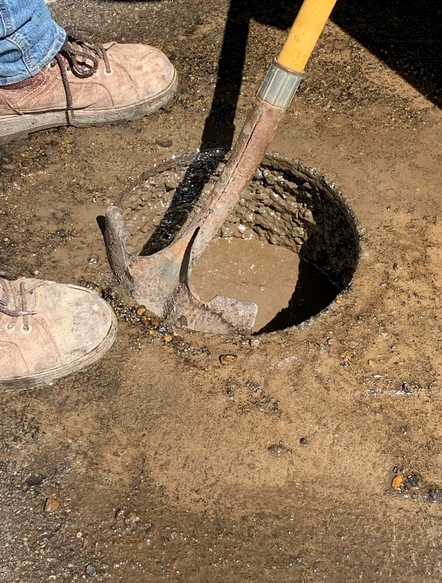

**Dynamic Core Penetrometer Testing**

Dynamic Core Penetrometer (DCP) testing was conducted below the pavement to determine soil stability. The DCP results are shown in Table 2. The Illinois Bearing Ratios (Similar to California Bearing Ratio) were a mixture of stiff (IBR > 7) to very soft (IBR < 3). The softest areas appeared to be north of Log 12.5 with the pavement distress illustrated below.

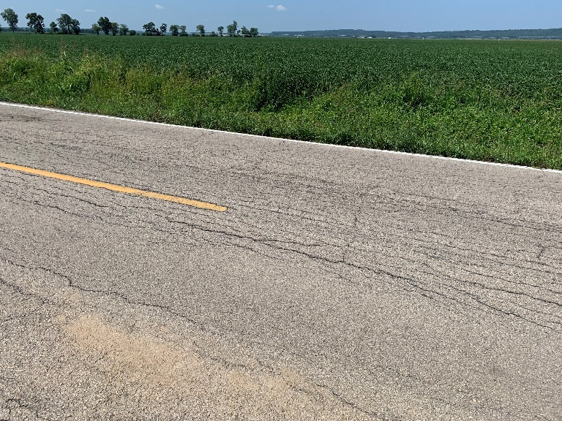

Table 2 Route N, Stoddard County – DCP Results

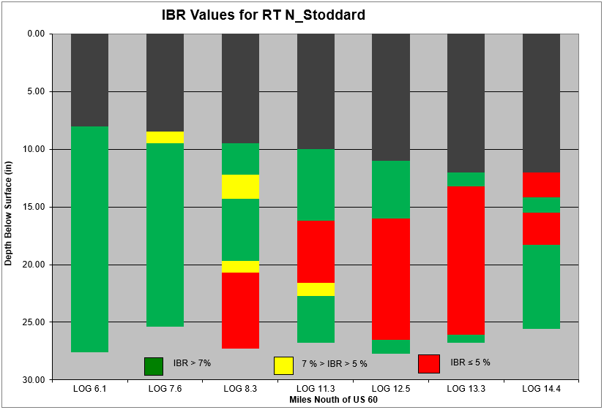

**Preliminary Mix Design Information for Section 1**

Based upon the pavement core thicknesses and preliminary results, this project would need divided into two separate sections with two separate mix designs.

One section (Section 1) would be between Route AB (Log 5.78) and Route Y (Log 10.888) for approximately 5.1 miles. The average thickness of cores in Section 1 was 8.5 inches and the preliminary design was based upon 10-inch Full Depth Reclamation (85% coldmillings/15% Subgrade Soil) with 6 percent Type 1 Portland Cement. An assumed unit weight of 145 pcf was used for the RAP and an average dry unit weight of 105 pcf was used for the soil. The combined gradation from two locations (Log 6.1 and Log 8.3) representing a blend of 85% RAP/15% Soil is provided as follows:

**LOG 6.1** **LOG 8.3**

 

Some of the soil properties in Section 1 was tested; however, there was an insufficient amount of material collected to run proctors of the subgrade material. The Atterburg limits from Log 8.3 are as follows:

|  |  |  |
| --- | --- | --- |
| **Subgrade Soils**  **from Route AB to Route Y (Log 8.3)** | | |
| Liquid Limit | Plastic Limit | Plasticity Index |
| 33 | 20 | 13 |

Moisture-density relationships were conducted in the first section for the 85/15 (RAP/SOIL) in accordance with AASHTO T 99, Method C with 100% of the material passing the 3/4-inch sieve. Note: The asphalt material was run through an aggregate crusher and the ¾-inch material was separated from the remaining material. The moisture-density results from the two locations within Section 1 are shown below.

**Section 1 – LOG 6.1 - (85% RAP and 15% SOIL + 6% cement by weight)**

|  |  |  |  |  |  |
| --- | --- | --- | --- | --- | --- |
| **LOG 6.1** | | | | | |
| **Proctor Data – 85%/15% RAP+Soil Blend @ 6% Cement** | | | | | |
| Rte. AB to Rte. Y | Point 1 | Point 2 | Point 3 | Results | |
| Dry Density, pcf | 124.7 | 127.1 | 123.4 | MMD | 127.1 |
| Moisture Content, % | 6.2 | 9.1 | 10.5 | OMC | 9.1 |

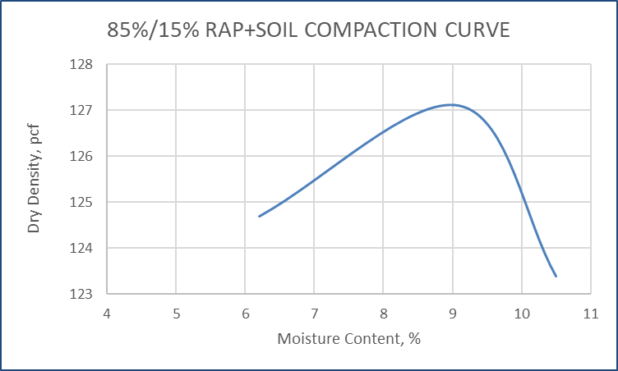

**Section 1 – LOG 8.3 - (85% RAP and 15% SOIL)**

|  |  |  |  |  |  |
| --- | --- | --- | --- | --- | --- |
| **Proctor Data – 85/15 RAP+Soil Blend** | | | | | |
| Rte. AB to Rte. Y | Point 1 | Point 2 | Point 3 | Results | |
| Dry Density, pcf | 113.8 | 123.5 | 120.8 | MMD | 123.5 |
| Moisture Content, % | 5.6 | 8.7 | 11.6 | OMC | 8.7 |

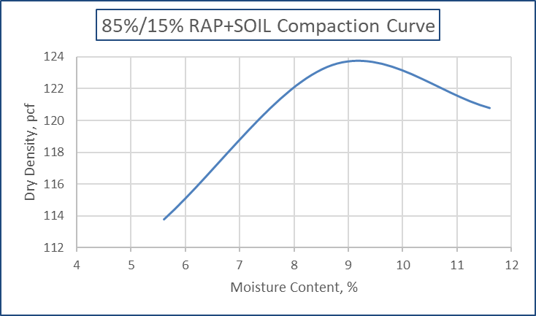

**Estimated Mix Designs in Section 1 – Route AB to Route Y**

Historically, 6% cement is the targeted cement content used in a Full Depth Reclamation process in Missouri. Type I Portland Cement was used for each mix design. Specimens fabricated from the materials from Section 1 – Log 6.1 (Route AB to Route Y) at a are provided in the following tables:

|  |  |  |  |  |
| --- | --- | --- | --- | --- |
| **Section 1 Compressive Strength @ 6% Cement** | | | | |
| **85%/15% RAP+SOIL with 6% Cement / MDD: 127.1 pcf OMC: 11.7%** | | | | |
| Cyl ID | Cyl.  Dim  (in) | Load  (lbs) | Strength  (psi) | Avg 7-Day  Compressive Strength (psi) |
| 1 | 4x4 | 3,875 | 308 | **339** |
| 2 | 4x4 | 4,655 | 370 |

**Preliminary Mix Design Information for Section 2**

The other section (Section 2) would be between Route Y (Log 10.88) and the Bell City Limits (south of Route 91; Log 14.64) for approximately 3.8 miles. The average thickness of cores in Section 2 was 11.25+ inches and the preliminary design was based upon the following:

* Coldmilling and Removing 3-inches of the existing surface and
* Pulverizing and Reclaiming 10-inches of the remaining thickness (~8.25” RAP + ~1.25” SOIL).

This average design combination would be (82.5% coldmillings/17.5% Subgrade Soil). An assumed unit weight of 145 pcf was used for the RAP and an average dry unit weight of 105 pcf was used for the soil. The combined gradation of the 82.5% RAP/17.5% Soil is provided as follows:



Some of the soil properties in Section 2 was tested; however, there was an insufficient amount of material collected to run proctors of the subgrade material. The Atterburg limits from Log 13.3 are provided as follows:

|  |  |  |
| --- | --- | --- |
| **Subgrade Soils**  **from Route Y to Bell City Limits @ LOG 13.3** | | |
| Liquid Limit | Plastic Limit | Plasticity Index |
| 42 | 21 | 21 |

Moisture-density relationships were conducted in the first section for the 82.5%/17.5% (RAP/SOIL) in accordance with AASHTO T 99, Method C with 100% of the material passing the 3/4-inch sieve. The results of this test are shown below.

|  |  |  |  |  |  |  |
| --- | --- | --- | --- | --- | --- | --- |
| **Proctor Data from Log 12.5 – 82.5%/17.5% RAP+Soil Blend** | | | | | | |
| Rte. Y to Bell City Limits | Point 1 | Point 2 | Point 3 | Point 4 | Results | |
| Dry Density, pcf | 101.2 | 110.7 | 113.4 | 93.0 | MDD | 113.4 |
| Moisture Content, % | 5.0 | 8.7 | 12.0 | 16.6 | OMC | 10.3 |

**Estimated Mix Designs in Section 2 – Route Y to Bell City Limits**

Type I Portland Cement was used for each mix design. Specimens fabricated from the materials from Section 2 – Log 12.5 (Route Y to Bell City Limits) with 6% cement are provided in the following tables:

|  |  |  |  |  |
| --- | --- | --- | --- | --- |
| **Section 2 Compressive Strength @ 6% Cement** | | | | |
| **82.5%/17.5% RAP+SOIL with 6% Cement / MDD: 113.4 pcf OMC: 10.3%** | | | | |
| Cyl ID | Cyl.  Dim  (in) | Load  (lbs) | Strength  (psi) | Avg 7-Day  Compressive Strength (psi) |
| 1 | 4x4 | 2,799 | 220 | **250** |
| 2 | 4x4 | 3,527 | 280 |

Since Section 2 thickness varied from 10 to 12-inches+ and a 3-inch coldmilling could significantly affect the amount of soil incorporated into the RAP/SOIL blend, more moisture-density relationships were conducted to show this variability. The material from Log 12.5 and 13.3 were combined to provide enough material. The moisture density results for a 70%/30% RAP/SOIL blend from Logs 12.5 and 13.3 is as follows:

|  |  |  |  |  |  |
| --- | --- | --- | --- | --- | --- |
| **Proctor Data – 70%/30% RAP+Soil Blend** | | | | | |
| Rte. Y to Bell City Limits | Point 1 | Point 2 | Point 3 | Results | |
| Dry Density, pcf | 115.9 | 117.8 | 114.4 | MMD | 117.8 |
| Moisture Content, % | 7.5 | 11.1 | 14.2 | OMC | 11.1 |

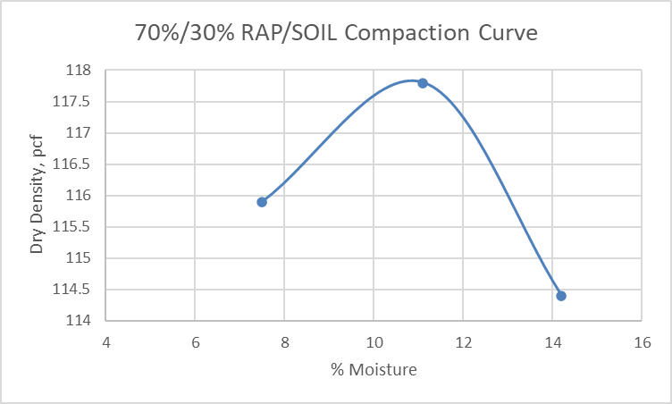

The moisture density results for a 100%/0% RAP/SOIL blend from Logs 12.5 and 13.3 is as follows:

|  |  |  |  |  |  |
| --- | --- | --- | --- | --- | --- |
| **Proctor Data – 100%/0% RAP+Soil Blend** | | | | | |
| Rte. Y to Bell City Limits | Point 1 | Point 2 | Point 3 | Results | |
| Dry Density, pcf | 103.6 | 107.8 | 105.6 | MMD | 107.8 |
| Moisture Content, % | 5.6 | 9.3 | 10.3 | OMC | 9.3 |

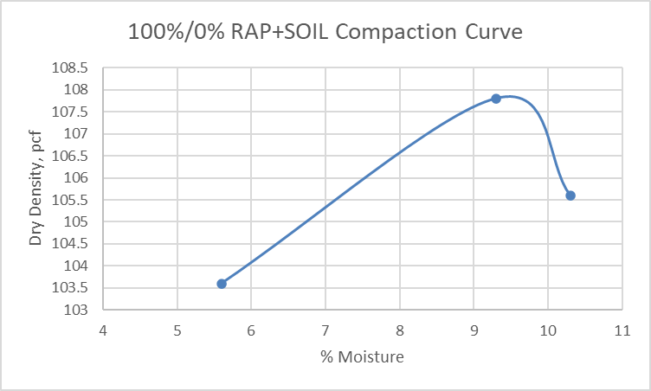

**Estimated Mix Designs**

Type I Portland Cement was used for each mix design. Specimens fabricated from the materials at Logs 12.5 and 13.3 from Section 2 (Route Y to Bell City Limits) at the two extreme combination was investigated @ 6% cement: (1) a 70% RAP/ 30% Soil Ratio and (2) a 100% RAP/ 0% Soil Ratio. The results from these two scenarios are provided in the following tables.

|  |  |  |  |  |
| --- | --- | --- | --- | --- |
| **Section 2 Compressive Strength @ 6% Cement** | | | | |
| **70%/30% RAP+SOIL with 6% Cement / MDD: 117.8 pcf OMC: 11.1%** | | | | |
| Cyl ID | Cyl.  Dim  (in) | Load  (lbs) | Strength  (psi) | Avg 7-Day  Compressive Strength (psi) |
| 1 | 4x4 | 2,997 | 240 | **240** |
| **Section 2 Compressive Strength @ 6% Cement** | | | | |
| **100%/0% RAP+SOIL with 6% Cement / MDD: 107.8 pcf OMC: 9.3%** | | | | |
| Cyl ID | Cyl.  Dim  (in) | Load  (lbs) | Strength  (psi) | Avg 7-Day  Compressive Strength (psi) |
| 1 | 4x4 | 1,135 | 90 | **95** |
| 2 | 4x4 | 1,262 | 100 |

Due to the risk of not having enough fines in the thicker sections in Section 2; the cement content for this section was increased to 8%. Specimens fabricated from the materials at Logs 12.5 and 13.3 from Section 2 (Route Y to Bell City Limits) at a are provided in the following:

|  |  |  |  |  |
| --- | --- | --- | --- | --- |
| **Section 2 Compressive Strength @ 8% Cement** | | | | |
| **70%/30% RAP+SOIL with 8% Cement / MDD: 117.8 pcf OMC: 11.1%** | | | | |
| Cyl ID | Cyl.  Dim  (in) | Load  (lbs) | Strength  (psi) | Avg 7-Day  Compressive Strength (psi) |
| 1 | 4x4 | 4,272 | 340 | **340** |
| **Section 2 Compressive Strength @ 8% Cement** | | | | |
| **100%/0% RAP+SOIL with 8% Cement / MDD: 107.8 pcf OMC: 9.3%** | | | | |
| Cyl ID | Cyl.  Dim  (in) | Load  (lbs) | Strength  (psi) | Avg 7-Day  Compressive Strength (psi) |
| 1 | 4x4 | 2,047 | 163 | **172** |
| 2 | 4x4 | 2,268 | 180 |

According to the compressive strength results, if no clay material is introduced into the RAP material in the FDR structure; the required strength may not meet the minimum specification of 200 psi. For a thicker 12-inch plus structure, additional fines in the mix design, deeper coldmilling prior to the 10-inch FDR; or increase the total thickness of FDR treatment may be required to meet the specification.

For estimating purposes, a 10-inch FDR with 6% Type 1 Portland cement was used for Section 1 from Route AB to Route Y.

For Section 2 (Route Y to Bell City Limits), a 3-inch coldmill followed by a 10-inch FDR w/ 8% Type 1 Portland cement was assumed from Route Y (Log 10.88) to Log 12.5.

In Section 2 from Log 12.5 to the Bell City Limits (Log 14.64); a 3-inch coldmill followed by a 12-inch FDR w/ 8% Type 1 Portland cement was assumed to account for the increased thickness of the existing asphalt and to introduce enough fine material to achieve compressive strength.