Exhibit A – Saline County, Route WW (aka Morrow Street), City of Marshall
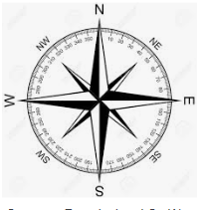
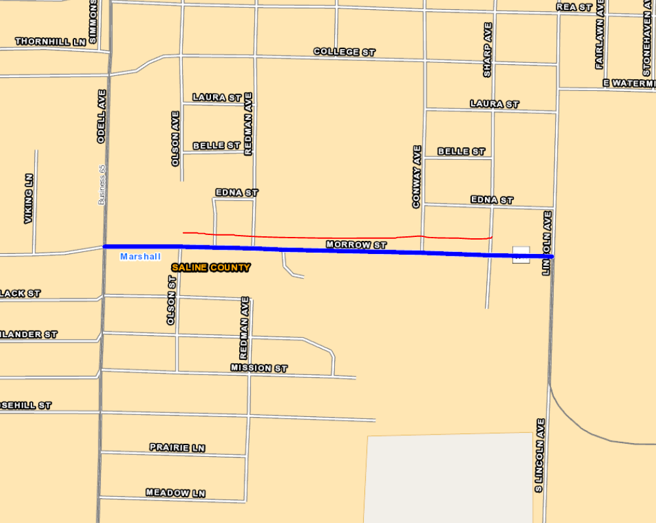
Remove the north segment between Olson St. and Sharp Ave. as shown in Red.

