Example 1:
Find bridge latitude and longitude
Latitude and Longitude

Latitude and Longitude Finder on Map Get Coordinates (latlong.net)

Bridge "latitude": 36.575, & “longitude”: -89.678 and site class = D.
Note: Longitude value should be negative.

Web link: doi.org/10.5066/F7NK3C76
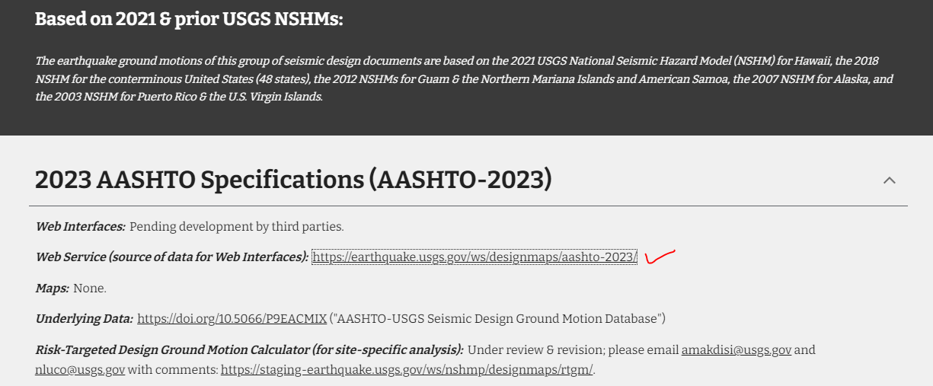

Input latitude, longitude, and site class in following link, execute and download results to find risk-targeted design response spectra information. If following link do not work than open link from above.

NSHMP Static Data Services (usgs.gov)

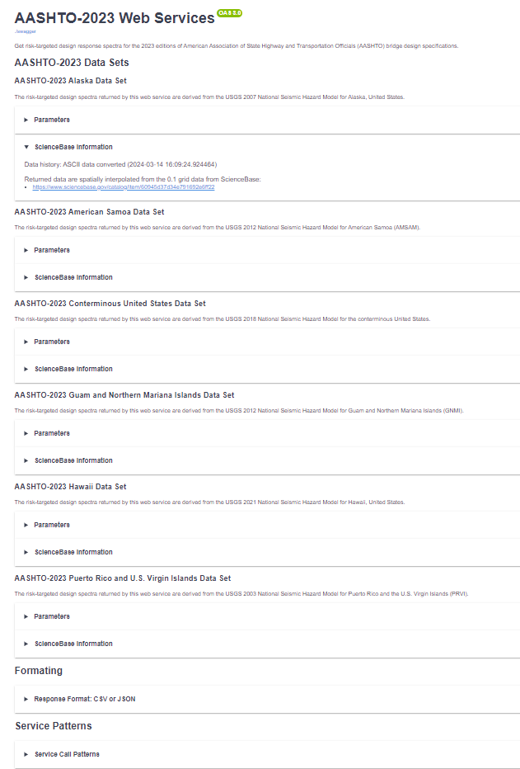
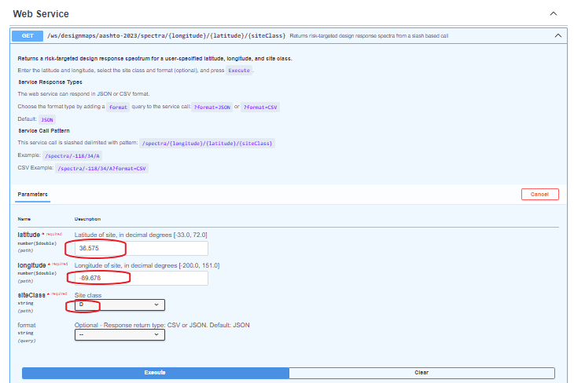

Responses/Results:

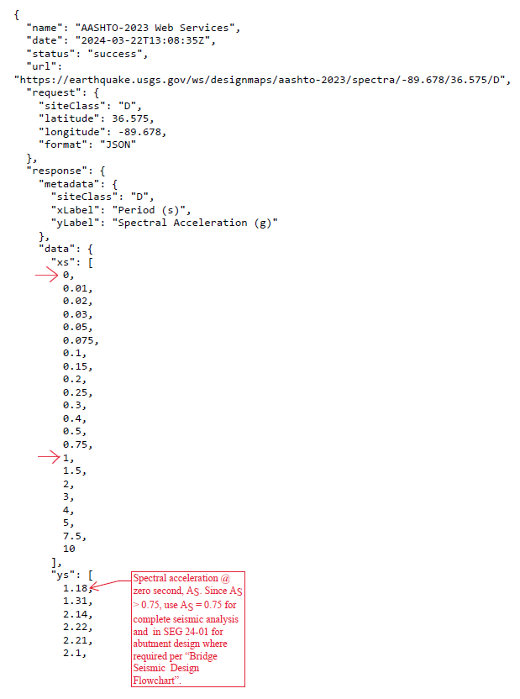
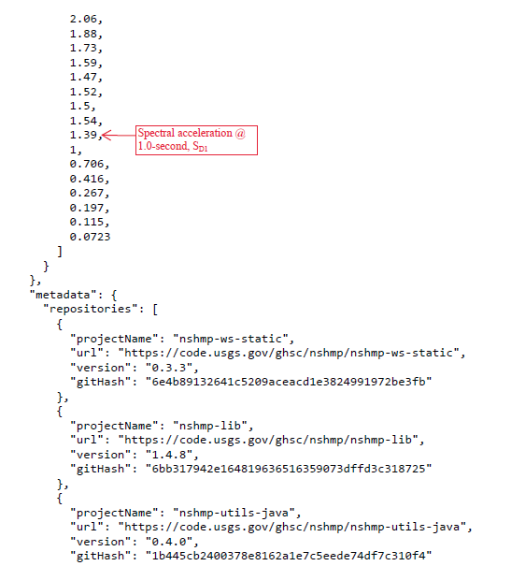

To input response spectrum information in WinSeisab or other seismic design software as shown below. :

Open new/existing WinSeisab file.
Click “Bridge data” tab => Loads

