How to Document a Historic Bridge for Mitigation

Bridges are an integral part of the transportation system, crossing major rivers and small streams. They can be eligible for listing on the National Register of Historic Places (NRHP) for their association with historical events such as the development of important roadways and highways (such as being an important farm-to-market road, or Route 66), the opening of an area for development, politics/government, or for agricultural or commercial development. Bridges can also be significant engineering works.

The purpose of mitigation documentation is to research and record that history and explain the significance of the bridge. Documenting a historic bridge for mitigation consists of three things:
- A historical narrative that explains the history of the bridge, providing an understanding of the events that led to the construction of the bridge, obstacles overcome during the construction of it, and alterations made since construction. The narrative should also include discussion of earlier crossings at the location and what happened to them, any controversy about the bridge or the roadway leading to it, and its impact on the local economy.
- A bridge description and bridge plans. If bridge plans are available the bridge description can be a short, reader friendly description. If plans are not available, the description needs to be a technical description of the bridge including a description of the components of the bridge.
- Archival photographs, taken to the standards specified in the Memorandum of Agreement (MOA) for the project.
The level of documentation is the result of consultation between the Federal Highway Administration (FHWA), the State Historic Preservation Office (SHPO), the Missouri Department of Transportation (MoDOT), the local participating agency and any consulting parties. It will be identified in the project MOA. For convenience, a copy of the Levels of Bridge Documentation (State Level) For Section 106 Mitigation of Adverse Effect is attached.

This guide will provide advice on research questions that should be considered during the documentation process and resources that are available to answer the questions. It is not intended to be comprehensive, each bridge is unique and will therefore have a unique history, but it should provide the researcher with ideas to successfully complete the documentation process.

Historical Narrative
The historical narrative places the bridge within the context of the community and the bridge type. It should explain why the bridge is important.
An introductory paragraph should provide the bridge names, including historic and common names, the roadway the bridge is located on, the bridge number and the feature crossed. It should provide an overview of the significance of the bridge and explain that the bridge will be replaced by a specific project, which should be described (including the project number). A location map identifying the bridge location should be included.

Historical Significance
Some questions that should be considered and answered in the narrative are:
- Is this the first crossing in this location? If not, what other types of crossings were there at this location, e.g. ford, ferry, earlier bridges. Why, when and how were these earlier crossings removed? County histories may provide clues to this. Newspaper research into the construction of the bridge will often discuss previous crossings.
Many county histories can be found online at the State Library or State Archives or through local libraries. County histories may provide background information on the development of the county, the transportation system in the county, disasters which affected the transportation system and key political figures at the time.

- When was this bridge built? The bridge plate, if it survives, provides clues. The Missouri Historic Bridge Inventory and Bridgehunter.com are also resources to help in determining a date. The best source for a date is the letting date of the contract and newspaper articles about the construction of the bridge.
- What feature does this bridge cross? Is it a navigable river? After 1906 a permit was required to bridge a navigable river, and permission from the U. S. Congress was necessary. Bills granting permission, for one year or with a specific deadline, can be found in the United States Statutes at Large. Before the Corps of Engineers would issue the permit a public meeting would be held, these were advertised in and covered by local newspapers.
- Was the bridge and road part of a boom development period in the county? Was it constructed using county issued bonds?
- Is the bridge associated with a particular community? Did it improve access or passage through a community? Did this allow the development of agriculture or settlement?
- Were other roads and bridges being built at the same time? Did this bridge play a role in the development of a regional transportation network?
- Was the bridge constructed by the State Highway Department and later taken over by the County? Was it constructed by the County and taken over by the State Highway Department?
- How much did the bridge cost to construct?
Contemporary accounts of the planning and construction of the bridge can be gleaned from local newspapers. Local newspapers may be available at local libraries or historical societies. They may also be available at the State Historical Society of Missouri in Columbia. The on-line directory of newspapers on microfilm assists in determining which newspapers the State Historical Society has. These accounts provide the local perspective on the planning for the bridge and its importance. Of special interest may be articles relating to the dedication of the bridge.

If the bridge was constructed as a toll bridge the documentation should include information on the efforts to free the bridge and the celebration of the freeing.

Information on the letting and the issuance of bonds can be found in County Commission Minutes. These are found in the County Courthouse, and many have also been microfilmed and

are available at the Missouri State Archives. A Directory of county records available on microfilm at the Missouri State Archives is available.

Historic maps, including historic topographic maps, county plat maps and atlases and county highway maps will show the evolution of the transportation system. The State Historical Society of Missouri has many of these resources available in the Research Center in Columbia.

Information on the history and evolution of roads and links to other sources is available through the Missouri Department of Transportation Library MoDOT History Resources.

Information on projects constructed by the State Highway Department can be found in the Biennial Reports of the State Highway Board (1st and 2nd) or Commission (3rd through 30th). Use Project History Maps to identify the project number (a guide for using these maps is attached).
Biennial Reports are available at the Missouri State Library and at most major state universities in Missouri. Some are available online; see the link on the MoDOT History Resources page.

Historic photographs enhance the bridge documentation, especially images of the bridge under construction. Historic photographs may be found in the collections of local historical societies. For example, a project to raise the portal and sway bracing of a bridge would be enhanced with images of the portal bracing being erected, such as Figure 1, below.
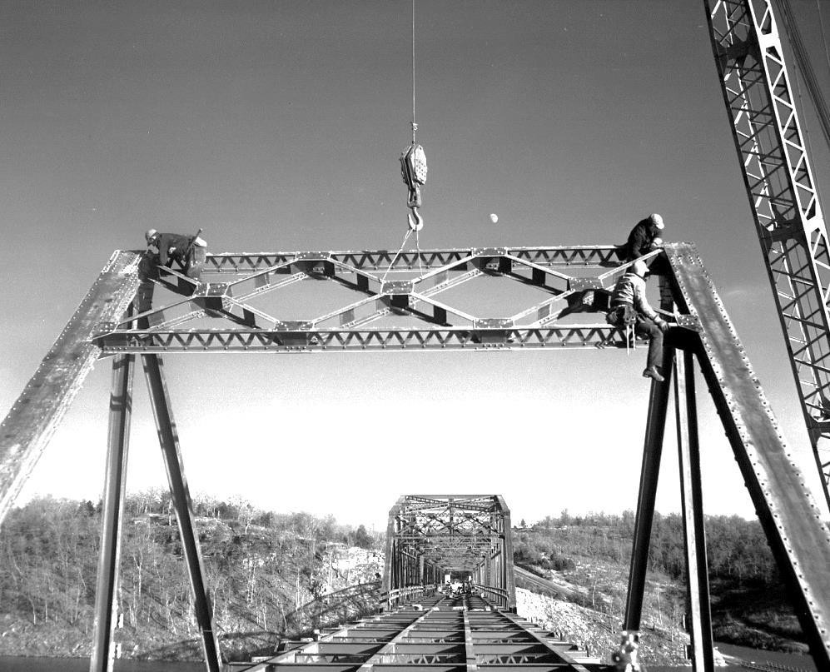
Figure 1: Portal bracing being erected, Theodosia Bridge, Ozark County
Engineering Significance
The narrative should discuss the engineering significance of the bridge as compared to similar examples statewide and nationally. The Introduction to the Missouri Historic Bridge Inventory will provide information on bridge development and specific bridge types in Missouri. The

Context for Common Historic Bridge Types will provide information on many common bridge types from a national perspective.
Designer, Builder & Fabricator
Information on the bridge designer, truss fabricator and contractor should be provided, with the exception of well documented examples such as M. E. Gilloiz, consult with SHPO and MoDOT to determine if the designer, fabricator or contractor has already been well documented.

To develop this section of the narrative, consider:
- When was the company founded? Is this an early example of their work?
- Did the company construct many bridges? How many bridges can be credited to the company?
- Did the company construct many bridges in the area?
- How does this bridge compare with other examples of their work?
Some bridge builders are discussed in the introductory material of the Missouri Historic Bridge Inventory. Bridgehunter.com contains a search feature that allows the researcher to determine how many documented examples of a bridge a firm is responsible for, and easily compare those examples—the searches can be nationwide or restricted to Missouri only.

Information on Missouri based companies may be found through the Business Search feature of the Corporations Division of the Missouri Secretary of State Office. The search results will provide the company charter number, the date of creation and the term of the charter. The filings will show any scanned documents, which could include a copy of the charter.

Bridge Description
The bridge description should reference the bridge plans (if available) so that the more technically inclined know where to go for what they are looking for, and the archival photographs so the less technically inclined know what is being described. The less detailed the plans are, or when plans are not available, the more detailed the description needs to be.
The bridge description should be an overview of the bridge. It should include:
- The type of bridge—concrete deck girder, Parker through truss, concrete open spandrel, etc.
- The total length of the bridge—including the main span and approach spans
- The total number of spans
- The number of main spans and the length of the main spans
- The number of approach spans and the length of the approach spans
- The skew, if any
- The primary materials used in the bridge: concrete piers and abutments, steel trusses, concrete deck, concrete girders, etc.
- The number of piers and bents and the type: for example, three concrete flow through piers. If the piers or bents have any stylistic detailing provide a brief description of the style: art deco, streamlined, brutalist, etc.

- If the bridge is a truss bridge, mention the number of panels in the truss and how large the panels are
- If the bridge is a girder bridge, mention the number of girders and any details of the bridge that distinguish it
- Describe anything that is unusual about the physical characteristics of the bridge, for example, modified truss panels
- Briefly describe any major historic alterations
Provide ample photographs and the bridge plans (provide the original plans as paper in the report, provide the plans and all rehabs on the CD that accompanies the report).

Archival Photographs
Photography for mitigation purposes will be done to Historic American Engineering Record (HAER) or NRHP standards. As with the narrative, the appropriate photography requirements are the result of consultation among the SHPO, MoDOT, the local government and any consulting parties. Generally, HAER photography would be used for nationally significant bridges or for those representing a rare property type and the accompanying documentation would also be to that standard. The National Park Service is consulted before preparing HAER documentation.

Guidance on HAER photography and documentation can be found on the National Park Service HAER web-site. Guidance on NRHP photography can be found on the National Register portion of the National Park Service web-site. If using the NRHP standards, 8X10” finished photographs are generally required, since these images will be the last photographs taken of the bridge, and that format will allow for more easily viewed prints.
According to the HAER guidelines, bridge photographs should include:
- General views of all sides of the bridge
- Detail views of the portals, portal connections, upper chord connections, vertical members, traffic deck, bridge plates, manufacturer’s plates, and any decorative features
- If accessible, the floor beams and stringer system, as viewed from underneath should be photographed
- Abutments, piers and bents
- Approach details
Bridge photography is best done in winter, when vegetation does not obstruct views of the bridge. If project timing does not allow for winter photography, it may be necessary to have obstructive vegetation cleared prior to photographing the bridge.

Kaitlin O’Shea, in her blog, Preservation in Pink, gives illustrated guidance on “How to Photograph a Bridge” (2 February 2012).

The SHPO should be consulted about the selection of photographs before printing. This consultation can be done via mail or e-mail. This ensures that adequate views will be presented in the documentation.

References:
Baughn, James
2015 Bridgehunter.com: http://www.bridgehunter.com: accessed 9 June 2015.

Constitution Society
2015 United States Statutes at Large: http://constitution.org/uslaw/sal/sal.htm, accessed 9 June 2015.

Fraser, Clayton
1996 Missouri Historic Bridge Inventory (draft), Loveland, CO: Fraserdesign. On-line http://epg.modot.org/documents/Historic_Bridge_Inventory/, accessed 9June 2015.

Missouri Department of Transportation
2015 MoDOT Transportation Library: MoDOT History Resources: MoDOT History Resources - MoDOT Transportation Library - Guides at Missouri State Library, accessed 9 June 2015.

2015 Project History Maps: http://www.modot.org/business/contractor_resources/ProjectHistoryMaps.htm, accessed 9 June 2015.

Missouri Secretary of State, Corporations Division
2015 Business Search: https://bsd.sos.mo.gov/BusinessEntity/BESearch.aspx?SearchType=0, accessed 9 June 2015.

Missouri State Archives
2015 County Records on Microfilm: http://www.sos.mo.gov/archives/resources/county/croll.asp, accessed 9 June 2015.

National Park Service
2011 “HABS/HAER/HALS Photography Guidelines,” HAER Guidelines: http://www.nps.gov/hdp/standards/haerguidelines.htm, accessed 9 June 2015.

2013 “National Register Photo Poly Factsheet,” National Register Policy: http://www.nps.gov/nr/publications/bulletins/photopolicy/index.htm, accessed 9 June 2015.

O’Shea, Kaitlin
2012 “How to Photograph a Bridge,” Preservation in Pink, February 2, 2012: https://preservationinpink.wordpress.com/2012/02/02/how-to-photograph-a-bridge/, accessed 9 June 2015.
Parsons Brinkerhoff & Engineering and Industrial Heritage
2005 A Context for Common Historic Bridge Types, NCHRP Project 25-25, Task 15: http://www.trb.org/NotesDocs/25-25%2815%29_FR.pdf, accessed 9 June 2015.

State Historical Society of Missouri
2015 Missouri Newspapers on Microfilm at the State Historical Society of Missouri, Newspaper Collection | The State Historical Society of Missouri, accessed 9 June 2015.

Levels of Bridge Documentation (State Level) For Section 106 Mitigation of Adverse Effect

This guidance serves for information purposes, and examples provided are not intended to be considered an inclusive list. The researcher should consider the individual bridge being researched and should develop the themes associated with that bridge. The appropriate level of bridge documentation shall be determined through consultation between the FHWA, SHPO, MoDOT, the local government and other consulting parties.

For all levels of documentation include:
- Location map showing bridge location
- Identifiers (County, Route, Feature crossed, MoDOT or County Bridge Number (Not Fraser Inventory Number), Project Number), include all items on the lists or explain why an item is not included.
- Historic and Common Name(s)
- Historic Photographs if they can be located
Bridge projects described in the State Highway Commission Biennial Reports shall be documented at Level I or Level II.

Level I: the highest level of documentation—for bridges over major rivers, for example, the Mississippi or Missouri River or the main tributaries to these rivers, and bridges with Criteria A or B associations as well as Criterion C.
- Drawings—as built or final construction plans for bridge (including rehabs), if extant (if drawings are not available a detailed technical description will be required).
- Photographs* (8” X 10” format) showing elevations of the bridge, substructure, important connections, all span types, and other significant details; images should be taken, printed and labeled according to NRHP/MoSHPO standards.
- Bridge description--A reader friendly bridge description narrative shall include; if bridge plans are not available, this should be a technical description of the bridge. The description should reference the mitigation photographs and plans to identify features of the bridge.
- Written history—should be the product of primary and contemporary sources as much as possible; it should address significant themes associated with the bridge, for example:
  - Engineering significance (Criterion C)—explain how and why the bridge is significant from an engineering perspective; discuss its relationship to surviving bridges of the same type in region and state. Also explain:
    - Who designed the bridge? Is it a standard bridge type or did it require modification from standard plans?
    - Who constructed the bridge? Include fabricator and contractor for truss bridges. Were they well-established companies? Did they have history of contracts with the state/county/city? Did they build a large number of bridges? How many of their bridges survive?

  - Transportation significance--explain how the bridge fit into the larger transportation system. Consider:
    - Construction of the bridge, including planning and actual construction
    - Address any issues encountered during bridge planning that had to be overcome (opposition, etc.)
    - Address any issues encountered during construction and how they were resolved (weather, etc.)
    - How was the bridge perceived by the community—eagerly anticipated, apathetically, etc.? Was it received differently in various parts of the larger community?
    - Was the bridge built as part of a new road or replacing an earlier crossing? If replacement, of what type—ford, ferry or earlier bridge?
  - Social History—did important events associated with American culture occur on the bridge or is it associated with a route significant in American culture? (Examples would be civil rights marches that crossed bridge, bridges associated with Route 66, bridges associated with early farm-to-market roads, bridges associated with seedling miles of highway, etc.)
  - Commerce—was the bridge important in the economic development of a community or did local business leaders promote the bridge? If so, explain how they were involved. If the bridge was a toll bridge, explain how the toll structure was set up, who collected the tolls, how long the tolls were collected, if possible what the toll rates were, local attempts to free the bridge, and when it became a free bridge.
  - Planning – Was the bridge built or incorporated into a Parkway? Was the bridge built as part of a larger development? Was the planning for the bridge tied up in litigation related to its construction or the construction of an associated highway?
  - There may be other broad patterns in American History that the bridge is associated with. Consultation between the SHPO, FHWA, MoDOT, the local government and other consulting parties will help to determine the appropriate areas of significance for the bridge.
  - Examples of sources to utilize include: MoDOT Bridge and Commission Records (if State Highway Department Constructed the bridge); County Commission Minutes (if County constructed the bridge); contemporary newspapers; trade journals; diaries; builder or engineering company records; County Histories; etc.
  - An example of a Level I mitigation document is the Daniel Boone Bridge available for viewing at: https://epg.modot.org/forms/general_files/DE/ENV/Daniel_Boone_Bridge_J1000_Report.pdf
Level II: a moderate level of documentation—for bridges over small rivers/major creeks, with no significant association with historical contexts; it is anticipated that most mitigation will fall into this level. See Level I comments above
- Drawings—as built or final construction plans for bridge (including rehabs), if extant (if drawings are not available a detailed technical description will be required).

- Photographs* (8” X 10” format) showing elevations of the bridge, substructure, important connections, all span types, and other significant details; images should be taken, printed and labeled according to NRHP/MoSHPO standards.
- Bridge description--A reader friendly bridge description; if bridge plans are not available, this should be a technical description of the bridge. The description should reference the mitigation photographs and plans to identify features of the bridge.
- Written history—should be the product of primary and contemporary sources as much as possible; should address significant themes associated with the bridge, for example:
  - Engineering significance—explain how and why the bridge is significant from an engineering perspective; discuss its relationship to surviving bridges of the same type in region and state. Also explain:
    - Who designed the bridge? Is it a standard bridge type or did it require modification from standard plans?
    - Who constructed the bridge? Include fabricator and contractor for truss bridges. Were they well-established companies? Did they have history of contracts with the state/county/city? Did they build a large number of bridges? How many of their bridges survive?
  - Transportation significance—explain how the bridge fit into the larger transportation system. Consider:
    - Construction of the bridge, including planning and actual construction
    - Address any issues encountered during bridge planning that had to be overcome (opposition, etc.)
    - Address any issues encountered during construction and how they were resolved (weather, etc.)
    - How was the bridge perceived by the community—eagerly anticipated, apathetically, etc.? Was it received differently in various parts of the larger community?
    - Was the bridge built as part of a new road or replacing an earlier crossing? If replacement, of what type—ford, ferry or earlier bridge?
  - An example of a Level II document is the Branson Bridge and can be viewed at: https://epg.modot.org/forms/general_files/DE/ENV/SHPO_Report_Taney_65,_76_Bridge_over_White_River_(Lake_Taneycomo)_at_Branson_J0705R.pdf

Level III: a well-documented inventory form with continuation sheets—for bridges over small streams away from populated areas, lettered routes in rural areas; these may include small bridges that were built as part of a large project and bridges which may be contributing to a district or landscape or may be individually eligible and a type with many documented examples. It may also be used when there is a context for the type developed (or being developed) which will explain the overall background for the resources.
- Drawings—as built or final construction plans for bridge (including rehabs), if extant (if drawings are not available a detailed technical description will be required).
- Photographs* (8” X 10” format) showing elevations of the bridge, substructure, important connections, all span types, and other significant details; images should be taken, printed and labeled according to NRHP/MoSHPO standards.

- Completed MoSHPO Bridge Inventory/Survey Form, including continuations sheets. The inventory form should include a footnoted history of the bridge, a brief description, and appropriate illustrations to demonstrate the history and significance of the bridge.
- An example of a Level III document is the St. John’s Creek Bridge and can be viewed at: https://epg.modot.org/forms/general_files/DE/ENV/SHPO Report_Franklin YY_St John's Creek Bridge_N0141.pdf

Level IV: a documented inventory form for bridges over minor crossings (small streams/creeks, highways, railroads, etc.) that are not individually eligible but are contributing resources to a larger historic property. It is anticipated few bridges will qualify for this level of documentation.

- Photographs* (5” X 7” format) showing elevations of the bridge, substructure, important connections, all span types, and other significant details; images should be taken, printed and labeled according to NRHP/MoSHPO standards.
- Completed MoSHPO Bridge Inventory/Survey Form. The inventory form should include a concise history of the bridge, a brief description, and statement explaining the significance of the bridge.
Guidance on How to Document a Bridge is available from the Missouri Department of Transportation, Historic Preservation Section.

*Guidance on photographing bridges is available on the Preservation in Pink blog: https://preservationinpink.wordpress.com/2012/02/02/how-to-photograph-a-bridge/

A Brief Guide to finding Project History Maps:

Click on the link to go to the Project History Maps on the MoDOT web-site: http://www.modot.org/business/contractor_resources/ProjectHistoryMaps.htm.

Scroll through the list and select the appropriate county:
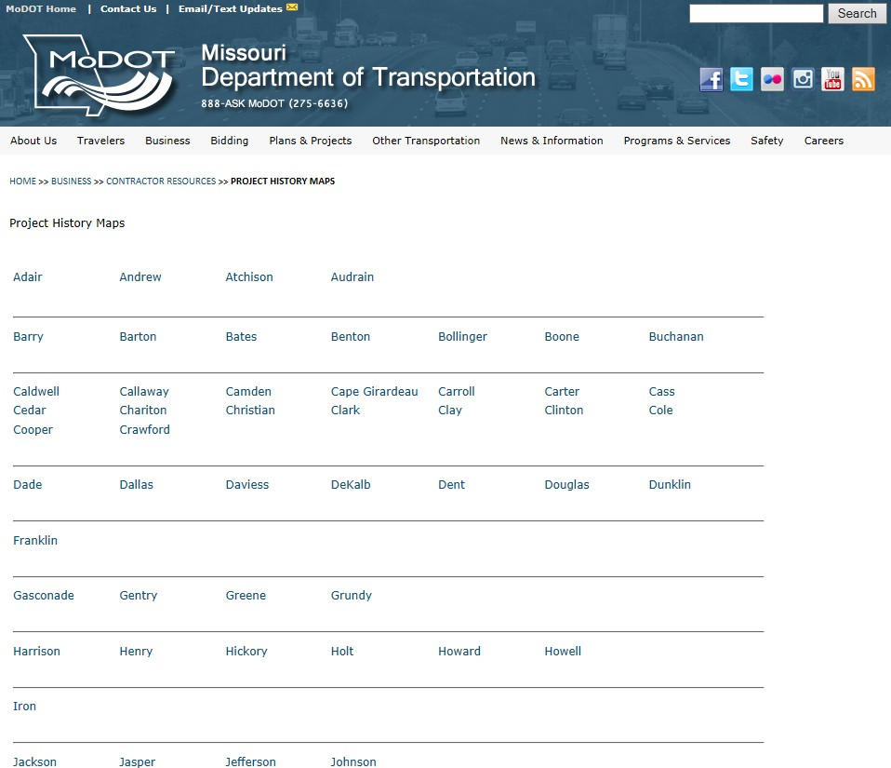

The files will open as pdf files, with all the maps for the county as one file, unless noted on the list.

You will get the project history maps for that county. The yellow notes box shows what route(s) are covered by that page. Use the Adobe page navigation to get to the page that has the route you need (some routes are on more than one page)
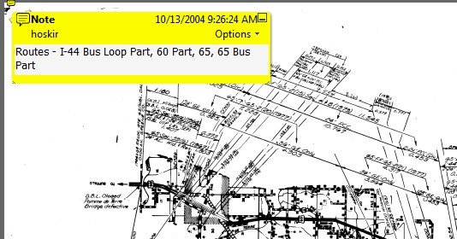
Notes box shows routes covered
Some examples of how historic and old routes are depicted:
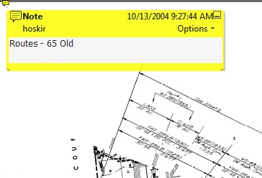
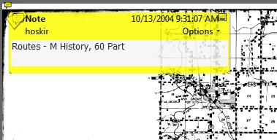
Identifies a historic route not the current route
Identifies a historic route not the current route

The maps will show the project history of a segment of road including previous job numbers, years of construction, length of project and type of project—usually width and surface treatment. An explanation of the abbreviations commonly used in project numbers and in project types follows.
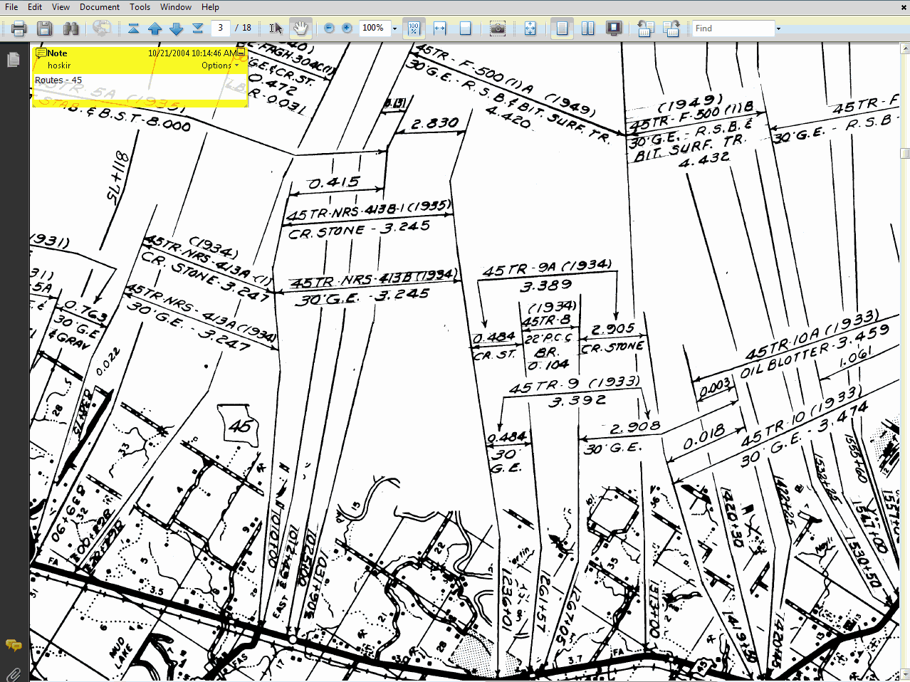
Type of Project
Length
Project Number
Year
There can be several layers of these numbers showing all the resurfacing and widening jobs that have occurred on the route.

Labels and Abbreviations on Project History Maps
Route Labels
The first line identifying the project is generally the project or job number. The older ones start with letters like FAP for Federal Aid Primary; newer ones start with the federal aid funding category like F-BRF. In this case F for Primary and BRF would be for Bridge on Primary system. It could also be I or IS (Interstate), RS for Rural Secondary, etc. The letter S is sometimes used before some projects denoting the state road name, such as SMM meaning State Road MM. Generally, the second number is the route number. For example F - BRF - 50 - 3(33) would be a pavement project involving a bridge on a primary route (50) on the 3rd segment and the 33rd project in that segment. Newer projects might just have numbers like J5P0123. That is a job number, District 5 primary job, no federal money. Really old state jobs have only numbers, i.e., 50-37B. The number in parentheses is the project date.

There are both project numbers and job numbers for records. There are project numbers (for construction) that have most variation, probably denoting federal tracking numbers from various funding programs throughout history. There are also job numbers (for design) that are basically the same format through history with dashes or without, with route names preceding or not.
Abbreviations
BRS, BHS, BRF, BHM associated with Bridge funding
DR is for Defense Roads, associated with Minuteman Missile Silos. US Dept of Defense paid State DOTs to administer projects for culverts, widening, and surfacing for roads needed to transport missiles to silos.

EXT Extension

F, FA, FAP, FAM, FAGH
The F is for Federal, as in Federal Aid Program or Project, as are the variations FA and FAP is probably for Highway, M is probably for Municipality

FI, FAI F is for federal, I is usually for Interstate HES Could be associated with lighting projects
I, IG, IR, ID I for Interstate, G may be for Grading, R may be for reconstruction, D ??? LSI Landscaping Interstate
M Usually for maintenance, but not always

NRM, NRH, NRHM, NRS
NR stands for National Recovery (e.g., National Recovery Act), the last letter identifies the project “subtype,” so NRH is for highways outside of towns on state routes other than

supplementary routes; NRM is for projects within municipal limits other than supplementary routes; NRS is for secondary routes

REF Refund

RS Rural Secondary

S, SU probably Supplementary

SEC SEC for Section number of a project built in stages SNFA FA Federal Aid, SN ???
STP Surface Transportation Program TR Traffic Relief
U Could be for urban

WPH, WPSS Works Progress Highway, Works Progress Supplementary System

WPGH, WPGN, WPSO US Works Program (WPA from FDR's New Deal), G could mean Grade Crossing

Treatment Abbreviations:
Res. resurfacing
AC asphaltic concrete
PCC portland cement concrete
GE graded earth
GE and BRS grading and bridges (pavement done at a later time) Br bridge
BSE Base Widening(?)
DG deck girder
Wid. widening
Grav. gravel
Gran. granular material
Oil Agg oil aggregate surfacing Bit. Mat. bituminous material Oil Agg Tr oil aggregate treatment
Surf. Lev. surface leveling (contract level course, thin overlay)
U.I.P. use in place
LBC lengthened by correction
SBR shortened by relocation
Absorb: a piece of one roadway is absorbed into another (piece of route X becomes part of route Y by relocation)
Aband. a piece of one roadway is given away or abandoned (cut off) on our right of way

