Title VI Minority and LEP Analysis
This guidance outlines the steps for reviewing minority and limited English proficiency (LEP) populations, consistent with the requirements of Title VI.
Please note – a review of minority and LEP populations is required for all documents warranting FHWA review/approval; however, for PCE level documents, this effort is only necessary if the project has the potential for impacts to an LEP or minority population (e.g., acquisition of property, relocation of residences and/or businesses, noise impacts, major traffic disruption(s), etc.).

Identify the Census Tract(s) and Block Group(s) within the Project Area
- Navigate to the U.S. Census Bureau, Advanced Search website:
https://data.census.gov/advanced
- Click “Maps” on the top bar. This will load a map of the United States as shown below.
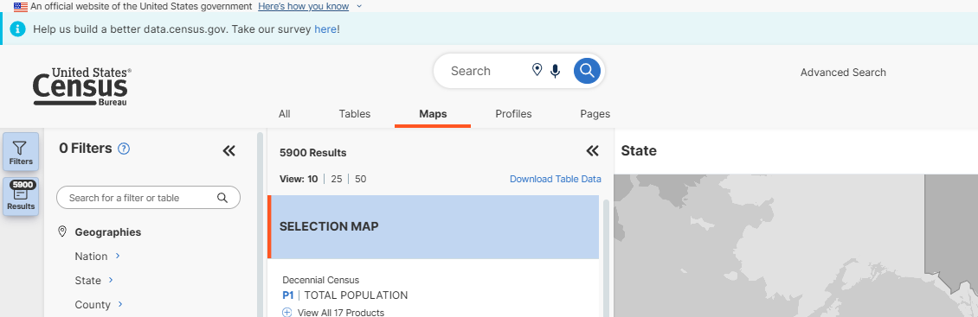
This is the map of the United States that will appear on the web page.

Focus the map on the project county(ies):
- Select “County” under the “Geographies” filter heading to bring up a list of States.
- Choose “Missouri” to bring up the list of counties in Missouri.
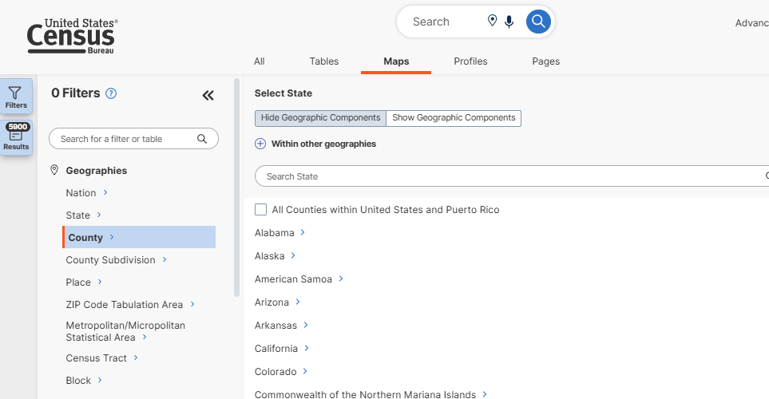

- Select the appropriate project County (Note that if the project spans multiple Counties, multiple Counties can be selected.) Upon selecting the County, the County will be added as a filter on the far left and the map on the far right will update in the background to zoom into the County.

Add all census tracts within the County to the map:
- Select “Census Tract” under the “Geographies” filter heading to bring up a list of states.
- Choose “Missouri” to bring up the list of counties in Missouri.
- Select the appropriate project County.
- Select the top option that states “All Census Tracts within _______ County, Missouri” which adds All Census Tracts as a filter on the far left and updates the map in the background to show the census tract (CT) boundaries and census tract numbers (denoted in dark red linework/text). Showing all census tracts on the map makes it easier to zoom into the project area in future steps and identify which census tracts are within the project area
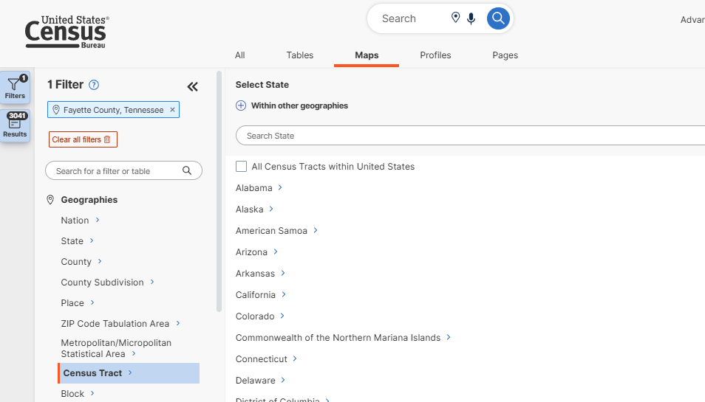

Add all Block Groups within the County to the Map
- Select “Block Group” under the “Geographies” filter heading to bring up a list of states.
- Choose “Missouri” to bring up the list of counties in Missouri.
- Select the appropriate project County.
- Select the top option that states “All Block Groups within _______ County, Missouri” to add all block groups (census block groups or “BGs”) to the filter and update the map in the background to show the block group boundaries and numbers (denoted in light red linework/text). Showing all block groups on the map makes it easier to zoom into the project area in future steps and identify which block groups are within the project area.
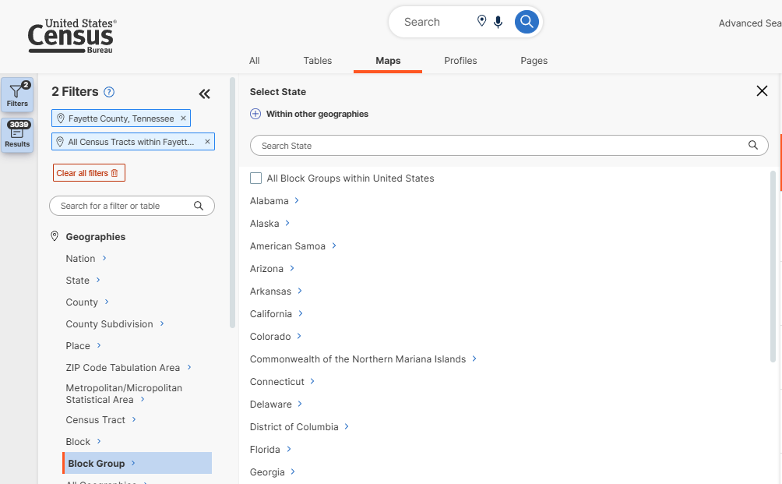

Locate Project Area
- Click anywhere in the map at the far right of the screen to expand/focus on the map.
- Pan/zoom within the map to locate the project area.
- Identify the census tracts and block groups that encompass and/or border any part of the project’s limits. Each census tract and block group will have a unique number. Recall that dark red outlines/numbers denote the census tract while light red outlines/numbers denote the block group.

Download U.S. Census Bureau Data for Title VI Analysis
Two sets of data should be downloaded to complete the Title VI analysis:
- Minority Population Data – Minority populations include Black or African American, Hispanic, Asian American, American Indian or Alaskan Native, and Native Hawaiian or Pacific Islander; and
- Limited English Proficiency (LEP) – LEP populations include those who do not speak English as their primary language and who have a limited ability to read, speak, write or understand English.

Download Minority Population Data from the U.S. Census Bureau Website
- In a new web browser window, open U.S. Census Bureau, Advanced Search website: https://data.census.gov/advanced
- Using the search bar at the top, search for the table code “B03002” (the table code for minority population data). This will add B03002 as a filter on the far left of the screen.
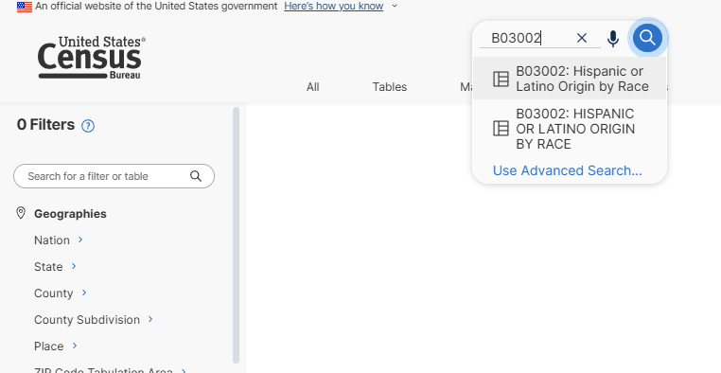

- Add the following as filters (refer to previous sections, as linked) for additional guidance:
  - County (See Section 1.1)
  - Block Groups (See initial steps in Section 1.3– but stop after selecting the project County – then proceed as follows)
    - After having selected the project County, from the list of census tracts that appears expand the census tract(s) that you identified in Section 1.4.
    - Within the expanded census tracts, select the appropriate block group(s) – again, based on your review in Section 1.4. Once selected, the census block groups will appear in the filter at the far left.
    - For projects that extend into multiple census block groups, after adding each census block group to the filter, click on the left-pointing arrow to go back to the full list of census tracts within the project County and repeat these steps to add all relevant census block groups.
**Note** Always enter filters from largest (i.e., State) to smallest (i.e., census block group). If you want the map to zoom to the block groups, add them LAST. If adding Missouri state, County, and nearby Cities (for CE2s), make sure to add those first. The map will stay zoomed on the last item entered.
- Click “Tables” below the search bar. This will display minority population data for the project County as well as project census block groups (note that you may need to scroll to the right to be able to see all minority population data for the project census block group(s))
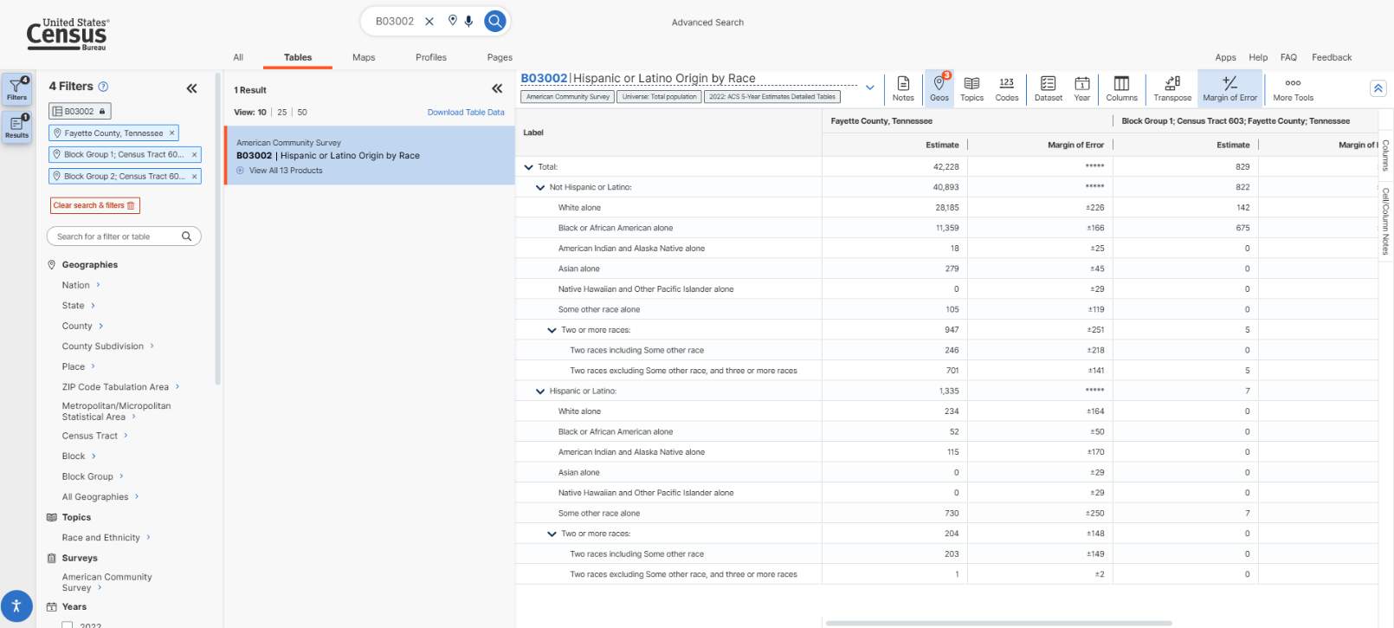
Minority population data.

- Select the latest ACS 5-Year Estimates data available. Note that sometimes, the U.S. Census Bureau website may automatically select ACS 1-Year Estimates data. Thus, to ensure that you have selected the latest available ACS 5-Year Estimates data, click on the dropdown arrow to the right of the name of the data (B03002 | Hispanic or Latino Origin by Race) to expand the data selection options – choosing the latest available “ACS 5-Year Estimates Detailed Tables”. Once you make your selection, the data will automatically update.
**Note** If ACS 1-Year Estimates data (often the default setting) is selected, rather than the latest ACS 5-Year Estimates data, the table may not show all filtered geographies. Select the latest ACS 5-Year Estimates data for all filtered geographies to display.
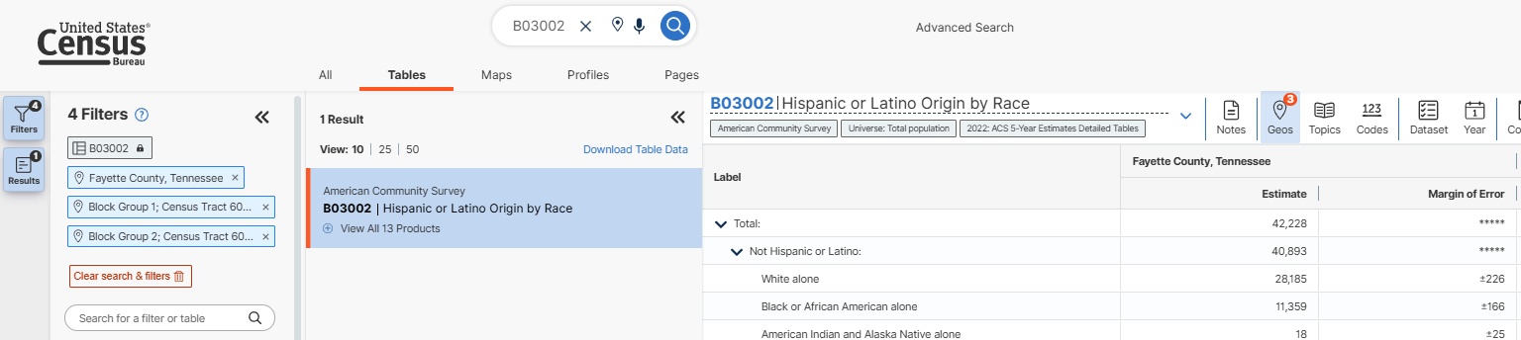

- Once you have confirmed that you have the latest available ACS 5-Year Estimates data for minority populations for the project County and project census block groups, the next step is to download/export the data in excel via the following selections:
  - Select “Excel” in the tool bar at the top. If “Excel” is not visible, select the three dots labeled “More Tools” towards the top right of the screen.
  - Download an Excel file of the LEP data and save it to your project file.
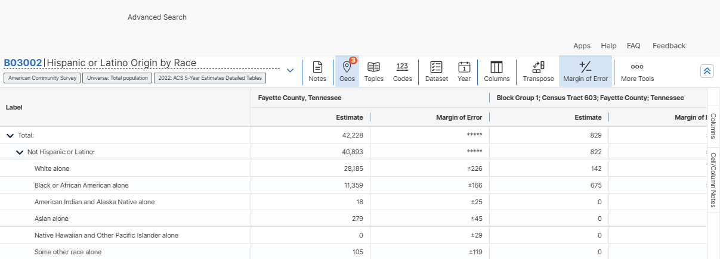

Download Limited English Proficiency (LEP) Data from the U.S. Census Bureau Website

With all project County and census block group filters still active from Section 2.1, follow the steps below to download the LEP population data from the U.S. Census Bureau.
- Without removing any of the filters set up above, use the search bar at the top to search for table code “B16004” (which is the table code for LEP population data). This will add B16004 to the filter on the far left of the screen and update the data to now show B16004 LEP data.
- Click “Tables” below the search bar. This will display LEP population data for the project County as well as project census block groups (note that you may need to scroll to the right to be able to see all LEP population data for the project census block group(s)).
- Select the latest ACS 5-Year Estimates data available. Note that sometimes, the U.S. Census Bureau website may automatically select ACS 1-Year Estimates data. Thus, to ensure that you have selected the latest available ACS 5-Year Estimates data, click on the dropdown arrow to the right of the name of the data to expand the data selection options – choosing the latest available “ACS 5-Year Estimates Detailed Tables”. Once you make your selection, the data will automatically update.
**Note** If ACS 1-Year Estimates data (often the default setting) is selected, rather than the latest ACS 5-Year Estimates data, the table may not show all filtered geographies. Select the latest ACS 5-Year Estimates data for all filtered geographies to display.
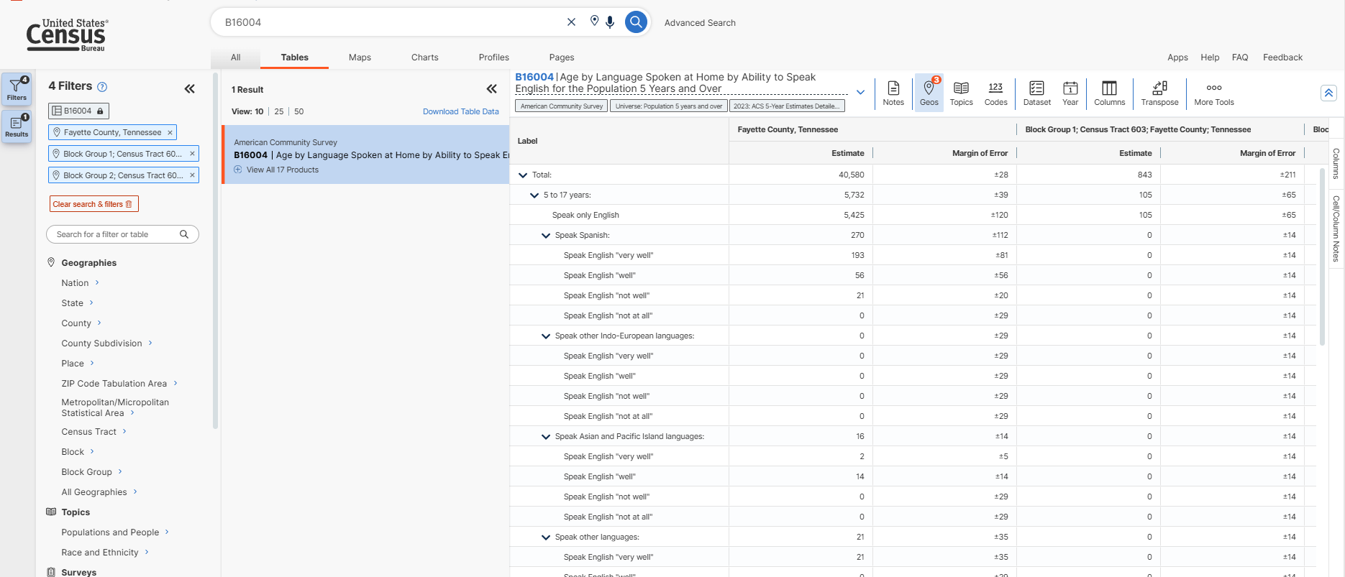

- Once you have confirmed that you have the latest available ACS 5-Year Estimates data for LEP populations for the project County and project census block groups, the next step is to download/export the data in excel via the following selections:
  - Select “Excel” in the tool bar at the top. If “Excel” is not visible, select the three dots labeled “More Tools” towards the top right of the screen.
  - Download an Excel file of the LEP data and save it to your project file.

Analysis of U.S. Census Bureau Data
This step analyzes the data collected above to determine if a minority population is present and to determine whether an LEP population is present and, if so, whether translation assistance is warranted for any planned public engagement.

Minority Populations
Please note – this analysis is required for all documents warranting FHWA review/approval; however, for PCE level documents, this analysis is only necessary if the project has the potential for impacts to a minority population (e.g., acquisition of property, relocation of residences and/or businesses, noise impacts, major traffic disruption(s), etc.).
- Navigate to the “Data” tab in the downloaded Excel file (from Section 2.1) to view the raw minority population data values.
- Calculate the total census block group minority population:
$$Total \left(Row 3 in image below\right)-White Alone \left(Row 5 in image below\right)=Total Minority Population$$

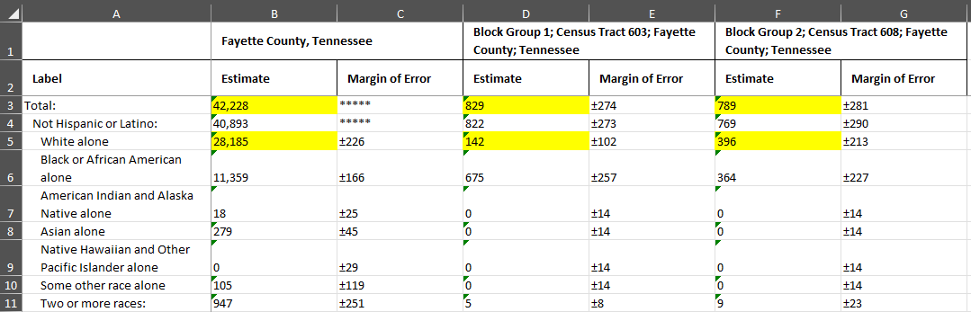
**Note** this calculation can be completed as a formula within the “Data” tab in the Excel file. *Make sure to “Convert all cells to number” by highlighting the cells and clicking the alert icon then selecting “Convert to Number”. Alert icon:
See below for the Total Minority Population calculation for the above example:
CT 603, BG 1  $$829-142=687$$ | CT 608, BG 2  $$789-396=393$$

- Calculate the percent minority for the project census block group (BG(s)):

$$\frac{Total Minority Population (see above)}{Total (Row 3 in image above)}*100=\% Minority$$
**Note** this calculation can be completed as a formula within the “Data” tab in the Excel file. *Make sure to “Convert all cells to number” by highlighting the cells and clicking the alert icon then selecting “Convert to Number”. Alert icon:
See below for the Percent Minority calculation for the above example:

CT 603, BG 1  $$\frac{687}{829}*100=82.9\%$$ | CT 608, BG 2  $$\frac{393}{789}*100=49.8\%$$
- Example of completing the analysis within the “Data” tab in the downloaded Excel file:
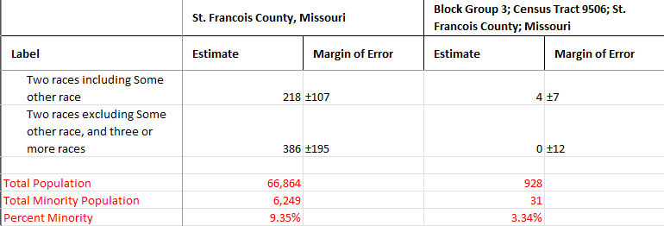

LEP Populations
Please note – this analysis is required for all documents warranting FHWA review/approval; however, for PCE level documents, this analysis is only necessary if the project has the potential for impacts to an LEP population (e.g., acquisition of property, relocation of residences and/or businesses, noise impacts, major traffic disruption(s), etc.).
The threshold for determining the presence of an LEP population is if the population within the project area that speaks a language other than English and also speaks English “less than very well” is greater than 5% of the County population or 1,000 persons or more within the census block group.

- Navigate to the “Data” tab in the downloaded Excel file to view the raw LEP population data values.
- Calculate the total census block group LEP population:
$$\text{Speak English "well" }\text{(all instances)} \text{+ }\text{Speak English "not well"}\text{(all instances)}\text{ +} \\ Speak English "not at all" \text{(all instances)} \left(See images below\right)=Total LEP Population$$

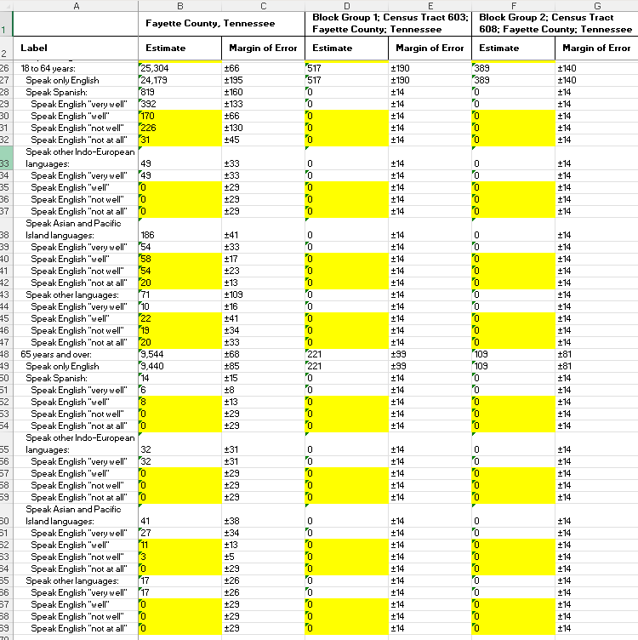
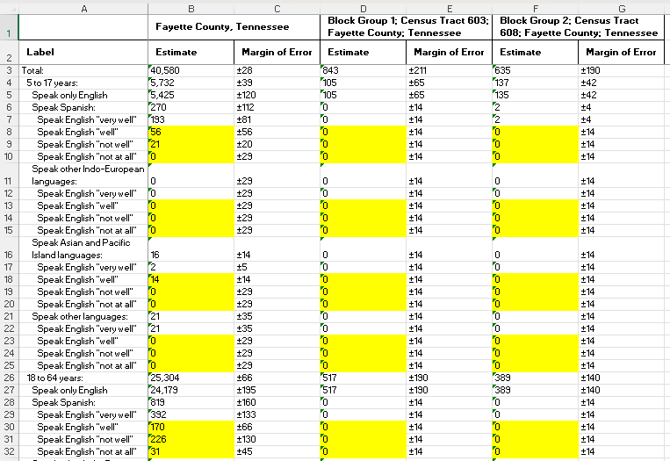

**Note** this calculation can be completed as a formula within the “Data” tab in the Excel file. *Make sure to “Convert all cells to number” by highlighting the cells and clicking the alert icon then selecting “Convert to Number”. Alert icon:
See below for the Total LEP Population calculation for the above example:

CT 603, BG 1  $$0+0+0=0$$ | CT 608, BG 2  $$0+0+0=0$$

- Calculate the percent LEP for the project census block groups:
$$\frac{Total LEP Population (see above)}{Total (Row 3 in the image above)}*100=\% LEP$$

See below for the Percent LEP calculation for the above example:

CT 603, BG 1  $$\frac{0}{843}*100=0\%$$ | CT 608, BG 2  $$\frac{0}{635}*100=0\%$$

- Example of completing the analysis within the “Data” tab in the downloaded Excel file:
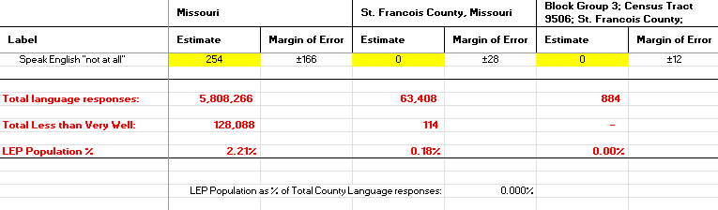

Translation Services Warranted or To Be Offered
For PCEs if a public meeting is planned and for all CE2s, EAs, and EISs:
The District or LPA (as applicable) may need to document that translation services were offered and either a) none were requested or b) if such services were requested, how that request was accommodated if
- the LEP population is:
  - Greater than 5% of the county population, or
  - 1,000 persons or more
and
- An LEP population would be impacted.
Clarification regarding what may constitute impacts –
  - if a project is within an area showing LEP populations exceeding a threshold, assume impacts if a detour is warranted for the project (as this would impact anyone in the area, whether LEP or not).
  - If ROW or easements are warranted and the area has identified LEP populations that exceed the threshold(s), these acquisitions are presumed to be impacts (However, we would not need to get confirmation that the property owner is not an LEP person).

Where the population exceeds a threshold and impacts are anticipated, enter information into the RER/RES indicating that language accommodations are required.

Any NEPA Class of Action Warranting FHWA Review
For a project that warrants review under a CE2, an EA, or an EIS, the results of the above-described efforts would be outlined directly within the RER/RES system and would also be added to the Socioeconomic section within a separate drafted NEPA document and would be analyzed for additional geographic areas.
Demographic data for minority and limited English proficiency (LEP) populations is outlined within a table in CE2s, EAs, and EISs for the following geographic areas:
- State
- County
- City (if applicable)
- Project specific census block groups

County and census block group information for minority and LEP populations can be accessed via the methodology outlined in Sections 1.0 through 2.2 above. For the additional geographic areas, add the following as filters in addition to County and census block group, and otherwise complete the methodology outlined Sections 2.1 and 2.2:
- State
  - Select “State” under the “Geographies” filter heading to bring up a list of states.
  - Choose “Missouri”
- City (if applicable)
  - Select “Place” under the “Geographies” filter heading to bring up a list of states.
  - Choose “Missouri” to bring up a list of cities/towns/places within Missouri.
  - Choose the city/town relevant to your project.
- **Note** Always enter filters from largest (i.e., State) to smallest (i.e., census block group). If you want the map to zoom to the block groups, add them LAST. If adding Missouri state, County, and nearby Cities, make sure to add those before the block groups. The map will stay zoomed on the last item entered.
- **NOTE** If printing a map of the block groups and data, print the map BEFORE navigating out of the map tab and into the tables tab. Otherwise, the map zooms back out.
- Click “Tables” below the search bar. This will display the relevant population data (minority or LEP) for the selected geographic areas (note that you may need to scroll to the right to be able to see all relevant population data)
- Once you have confirmed that you have the latest available ACS 5-Year Estimates data, download/export the data:
  - Select “Excel” in the tool bar at the top. If “Excel” is not visible, select the three dots labeled “More Tools” towards the top right of the screen.
  - Download an Excel file of each set of data under review (minority and LEP data) and save it to your project file.(See Sections 2.1 and 2.2 for more detail).
- Analyze the data via the methodology for each data set, as outlined in Section 3.0.
- Compile the results into a table for inclusion in the NEPA document.

