Searching the Engineering Policy Guide (EPG)

Custom Google Search
The Custom Google Search uses the Google Search engine to search only the EPG Wiki.

If you want to find results that use a very specific phrase, surround your search term in “quotation marks” to only see results that match that exact phrase.

You can also search a document type for example by typing doctype:pdf document name.

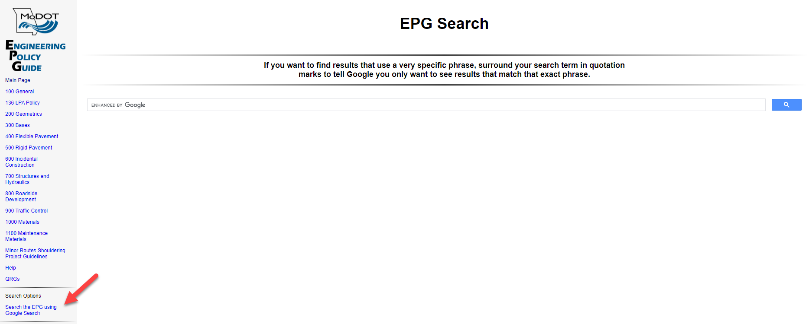

EPG Search Box
The simplest way to search the EPG is to type one or more search terms in the EPG Search Box.
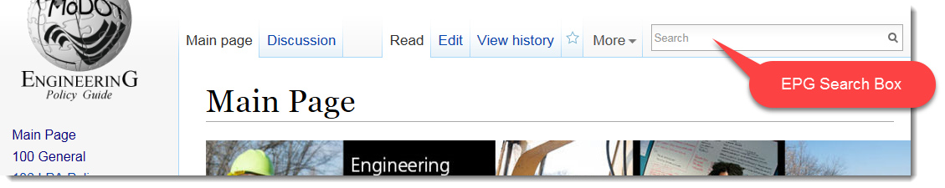
In this example the search term is concrete and 325 results were found. Page titles containing the term are listed in the left column. Pages that contain the search term in the text of the page are listed on the right.
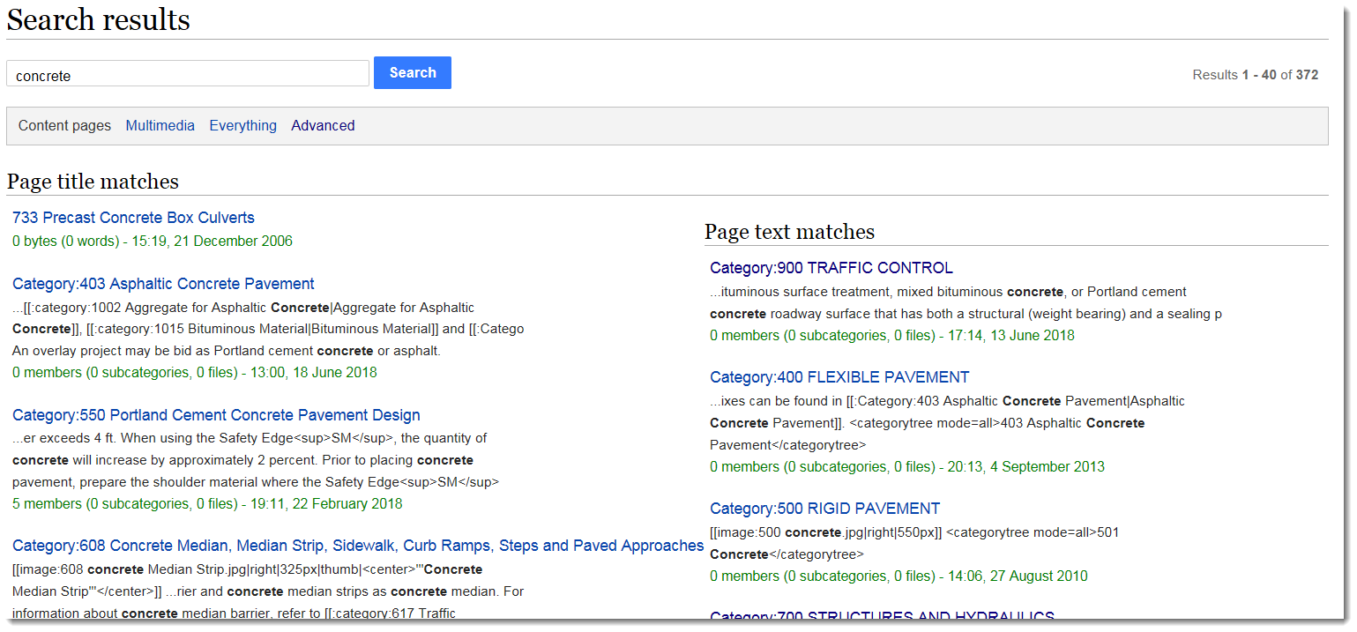

Optional Info
There are some options available when you search EPG articles. These options are automatically setup for you when you search and normally don’t need to be adjusted.
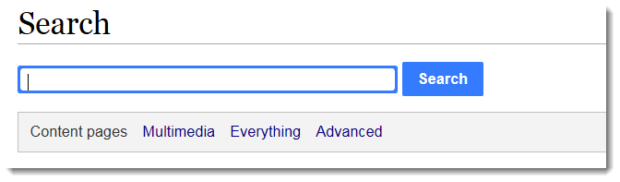
- Content pages: This is the normal EPG article search
- Multimedia: This is the Search Document Filenames search
- Everything: This searches everything in the EPG wiki: articles, document filenames, LPA, Help etc. It does not search the contents of uploaded documents.
- Advanced: This allows you to select what namespaces are searched. Namespaces are the way information is categorized inside the wiki.
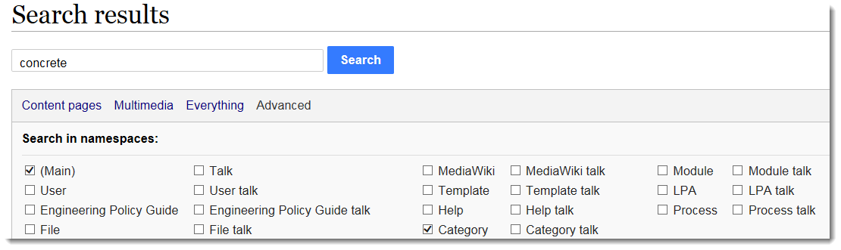Main: EPG articles
User: Unused
Engineering Policy Guide: Unused
File: Uploaded files, also the same as Multimedia
Any of the Talk namespaces: Unused
MediaWiki: Unused
Template: Don’t search (Underlying format of the articles)
Help: Help files
Category: Categories in the EPG and are also articles
Module: Don’t search (Additional wiki functions)
LPA: LPA articles in the EPG
Process: Unused

