Key Wayfinding Requirements
General Information
- The intended purpose of Community Wayfinding is to help visitors find the attributes of a community by first directing them to the key regions/districts within a community and then providing guidance to key destinations within that district. Smaller communities may not be large enough to establish individual districts and may choose to treat their city limits as one district
- Wayfinding signs must be located/installed within the city limits when placed on MoDOT right of way
- Wayfinding signing cannot duplicate existing MoDOT signing to a destination
- If a city wishes to extend their wayfinding signing onto the primary highway system (freeways or expressways), the city wayfinding plan must have three well defined districts
  - Each individual district must be a region containing many destinations
  - Specialized Wayfinding signs are not to be displayed outside of the district boundaries
- Wayfinding signs should direct motorists to the destination along the most direct / best path
- Wayfinding sign programs should start at the core of the district with respect to signing and work their way outward, this is to avoid starting a path for a motorist that is not complete
- Signs installed on city right of way, by federal regulations, are to meet all criteria specified for MoDOT roadway applications, however, MoDOT will not enforce signing on non-state routes
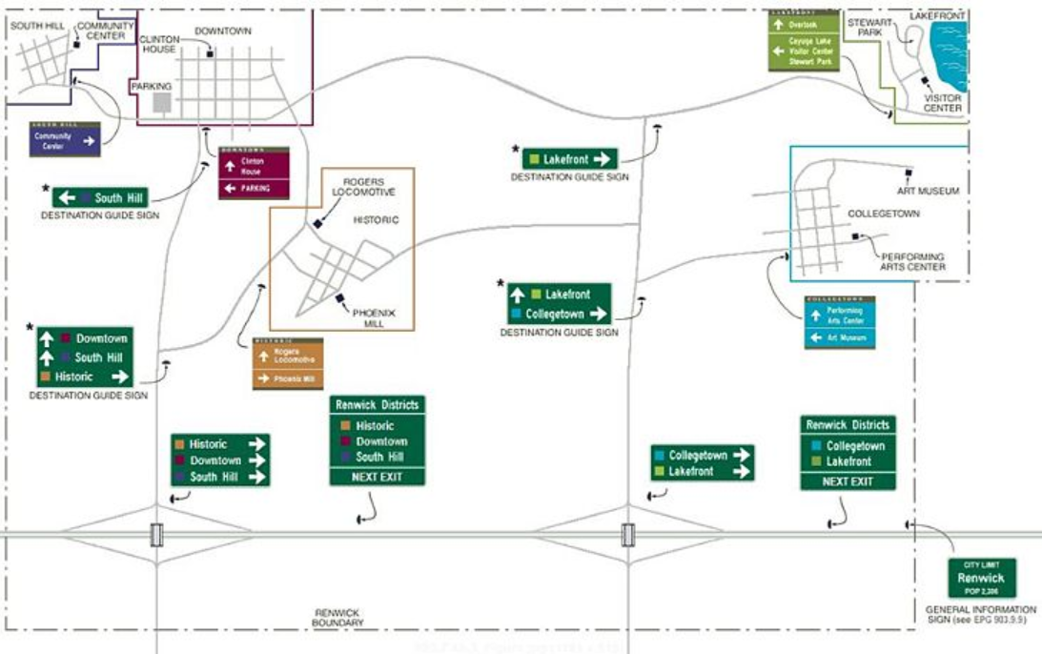
General Format for Wayfinding Signing – Unique Wayfinding Signs Located Within the Boundaries of Each Wayfinding District, Wayfinding Guide Signs Outside of the Districts are Standard White on Green Guide Sign Designs

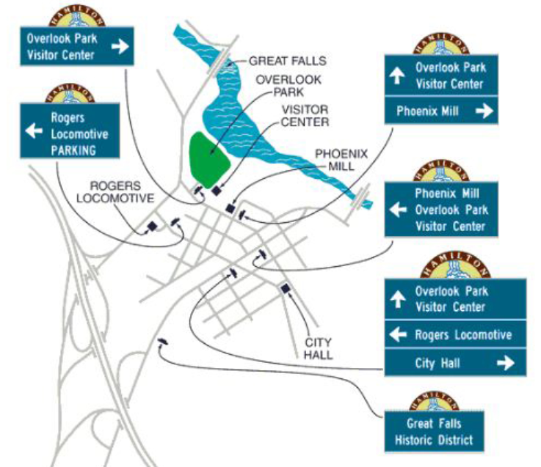
Typical Signing for Sites Within a Wayfinding District

Sign Posts for Wayfinding Signs
- All signs on MoDOT right of way shall be installed on MoDOT breakaway posts installed to MoDOT standards. The type, number of posts and post size required is based on the size of the sign being installed
  - Wood - 4x4 or 4x6
  - Perforated Square Steel Tube (PSST) - 2” or 2.5” square
  - Pipe Post - 2.5” or 4”
  - Wide Flange (I-Beam) post – Structural #1 through #6
  - MASSH 400 Post – a 4” square steel tube post system - this is not a MoDOT design, but it is on the Approved Products List (APL) and can be used for wayfinding
- No modifications or additions can be added to the posts as these items can affect breakaway performance. The only option to modify the appearance of the post is the posts can be painted. Cautionary Note: Painting of sign posts can result in increased maintenance as paint fades tends to look poor over time.
- Posts selected shall be capable of carrying the wind loads/sign size being installed on it in either a single or two post installation. MoDOT has post selection tools that need to be used to determine the post type, size and number needed to support the signs being installed.
- Sign mounting height should be 7’ as measured from the roadway surface to the bottom of the sign with the sign being no closer to the ground than 5’ (in the case where the right of way slopes up away from the roadway) see figure below
- Wayfinding signs shall not interfere with the visibility of other signs and shall be spaced a minimum of 200 feet from any other sign.
- Wayfinding signs shall always be installed on their own sign posts.

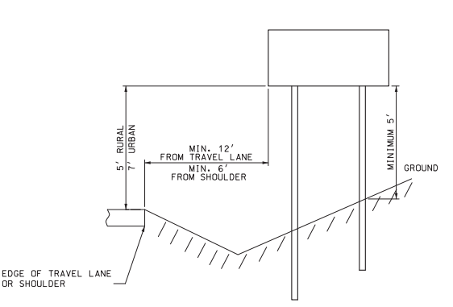
Sign Mounting Height and Offset from Roadway

Breakaway Installations
- 4x4 Wood Posts – These posts are considered breakaway on their own, they simply need to be installed according to standards
- 4x6 Wood Posts – If used these posts must be cross drilled to create weak points so they will breakaway when hit. Orientation of the posts in relation to the direction of traffic and placement and size of hole drilled for breakaways are very important
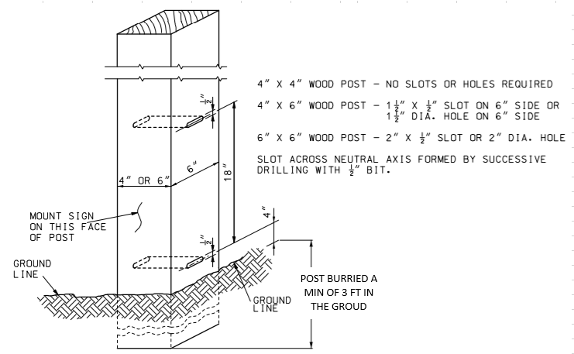

- 2” PSST – 2” PSST posts (a one or two post installation), like wood 4x4 posts, are breakaway on their own and simply need to be installed according to standards. However, ground anchors shall not protrude more than 4” above finished grade to meet federal standards. Keeping the ground anchor as low to the ground as possible promotes durability.
- 2.5” PSST – A single 2.5” PSST post is breakaway on its own, however, when using 2.5” PSST in a two post sign installation, breakaway devices must be added to the installation. The breakaway system used must be on MoDOT’s approved products list.
- Pipe and I-Beam posts are fabricated with the breakaway devices as part of the post anchor system.
- It is very important for any breakaway installation that the ground anchor portion of the device be 4 inches or less above the finished grade around the entire sign, this is to allow a vehicle to pass over the anchor as they impact the sign post.

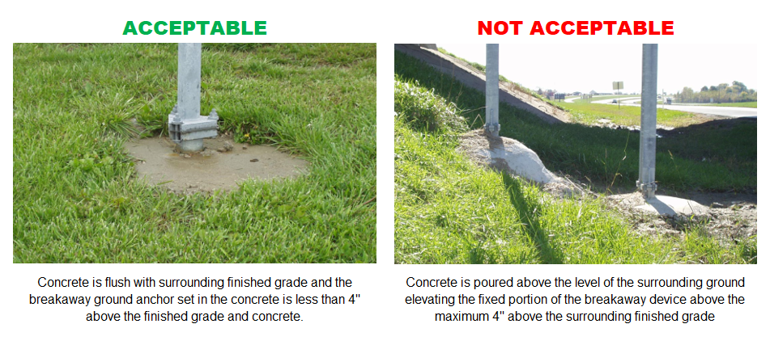

Sign Layouts for Wayfinding Signs
- All signs on MoDOT right of way shall meet federal design criteria, this document outlines those key attributes.
- Freeway, ramp and trailblazer signs outside of the district boundaries shall be white on green displaying the district boundary names only.
  - The sign may display a pictograph or logo to represent the district if these are used to distinguish districts
  - Colored blocks and pictographs are limited to a square area equal to a maximum of 2 times the upper case legend dimension used on the sign.

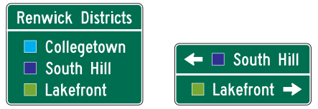
Wayfinding Guide Sign Design Style for Signs Outside Wayfinding District Boundaries
Colored block (or pictographs not shown) can be displayed to help reference district names

- Wayfinding signs within district boundaries can be unique in nature with respect to color and displaying the city logo, however, the general format must meet federal standards with respect to
  - Legend size
  - Arrow design and placement
  - Number of destinations displayed
  - Colors used on the sign

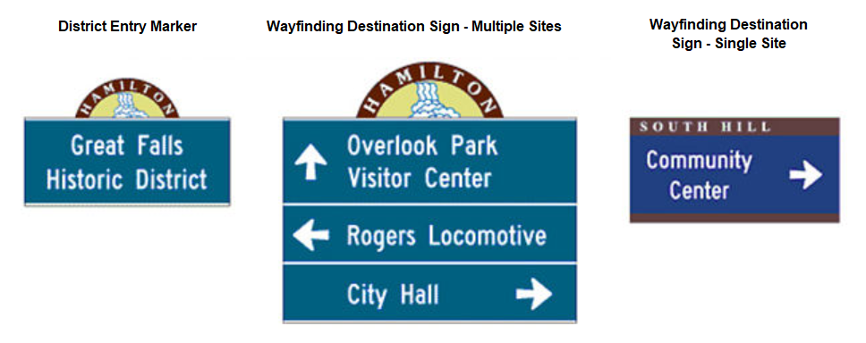
Examples of Wayfinding Sign Design Style for Signs Inside Wayfinding District Boundaries

Number and Placement of Wayfinding Destinations
- In district Wayfinding signs shall be limited to 3 destinations on routes with speed limit 40 mph or greater and a maximum of 4 on MoDOT roadways with speed limits 35 mph or lower.

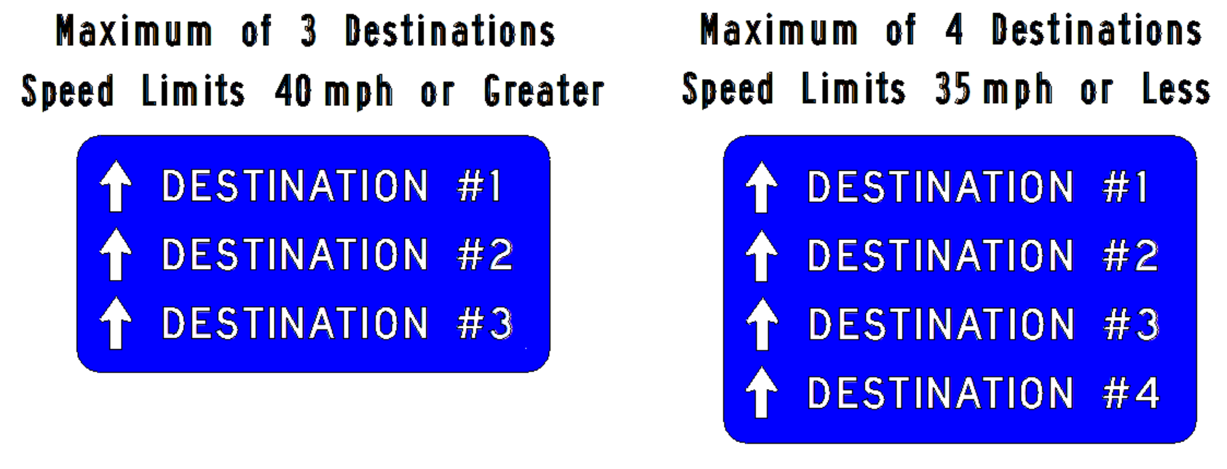
Maximum Number of Destinations Per Sign

- The order of destinations displayed on the sign shall be listed from top to bottom in the following order:
  - destinations ahead/straight - listed first
  - destinations to the left - listed second
  - destinations to the right - listed last.
- Arrows shall be placed along the left edge of the sign, left of the destination and left aligned except for the right arrow which shall be placed to the right of the sign, right of the destination name

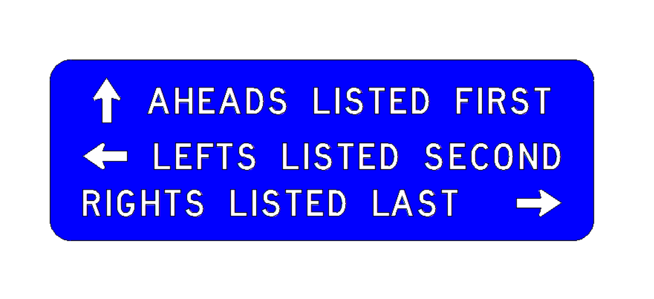
Arrow Placement and Order of Destinations Displayed

Arrows used on Wayfinding Signs
- The arrows used shall be, or closely approximating, the standard federal arrow design
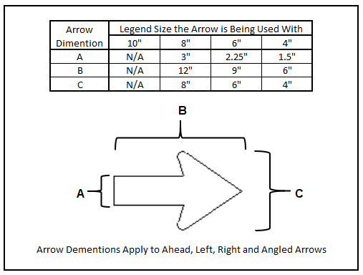
Minimum Arrow Sizes for Wayfinding Signs

- If two or more destinations are in the same direction, they shall be displayed in the order of closest being listed above the destination(s) that are further away
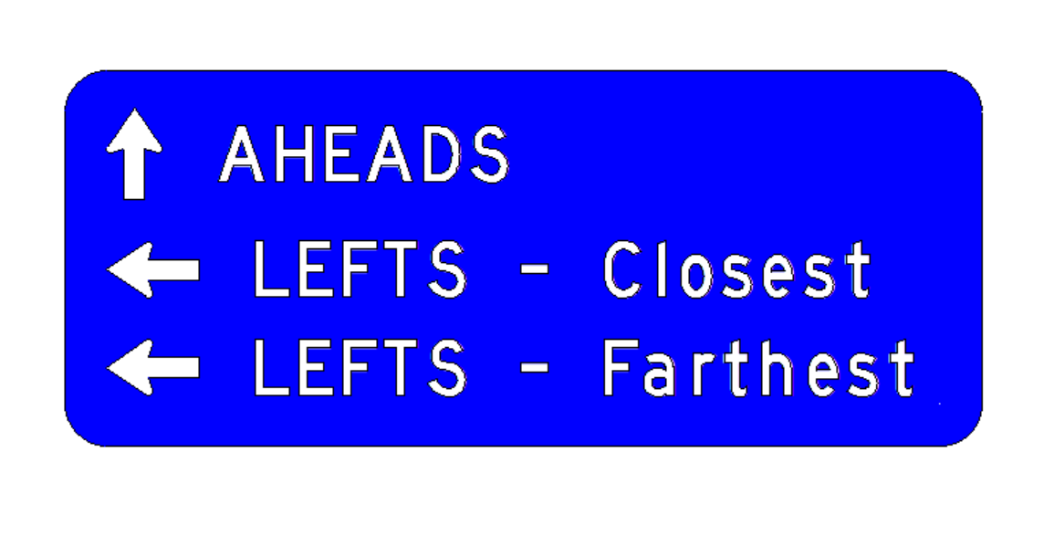
Order of Destinations in the Same Direction

Acceptable Colors used on Wayfinding Signs
- The following colors cannot be used for legend or background colors on Wayfinding sign as they are reserved for specific uses by federal regulations:

  - Red
  - Yellow
  - Orange
  - Pink
  - Purple
  - Yellow-Green
  - Any florescent version of the colors listed above

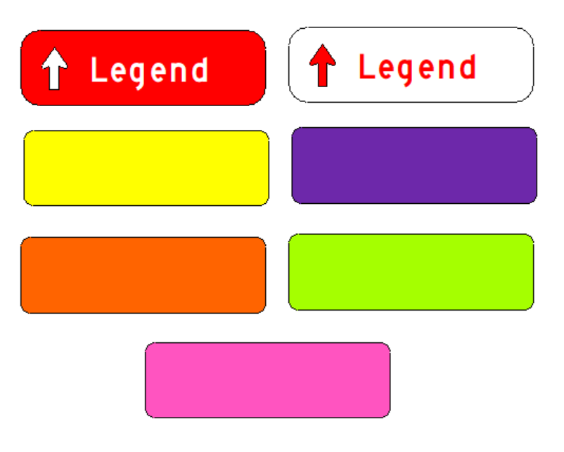
Colors that Cannot be Used as they are Reserved for Specific Applications Under Federal Regulations

- Pantone, non-standard highway colors, are acceptable. As an example, red cannot be used, but a darker burgundy can be used.
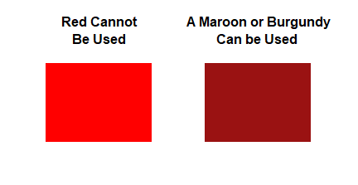
An Example of a Darker Shade of a Standard Highway Color that Can be Used

- Legend and arrows shall be contrasting to the background color for legibility
  - A light colored legend must be placed on a dark colored background – this combination provides the best contrast and legibility with white as the legend on a dark colored background
  - A dark colored legend must be placed on a light colored background

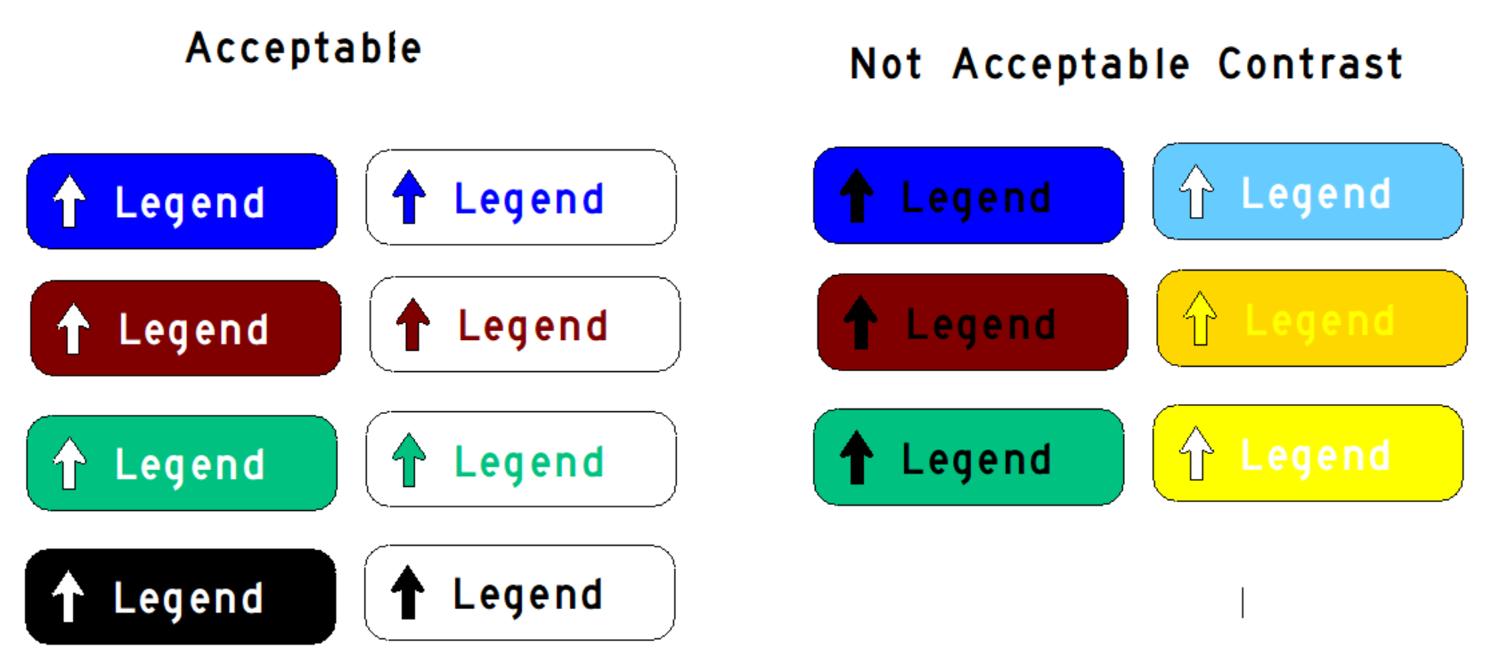
Examples of Acceptable and Not Acceptable Contrasting Legends and Backgrounds

Legend Size and font on Wayfinding Signs
- Legend size must meet federal standards for legibility (destinations shall be upper / lowercase):
  - Freeways – 10”
  - Expressway/multi-lane roadways – 8”
  - Two lane roadways - 6”
  - Two lane routes with speed limits 25 mph or lower – 4”
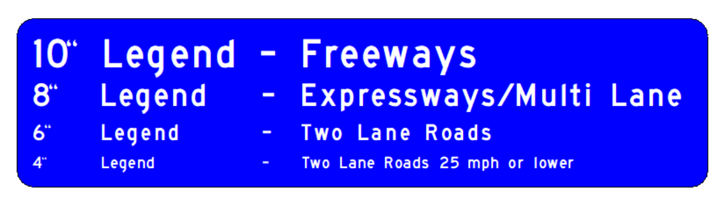
Minimum Sign Legend Size Requirements

- The font used on Wayfinding signs shall use standard Federal Highway Fonts. Font versions are variations in font stroke width, the widest stroke width should be used to maximize legibility. Highway C Font is the smallest font permitted on Wayfinding Signs.

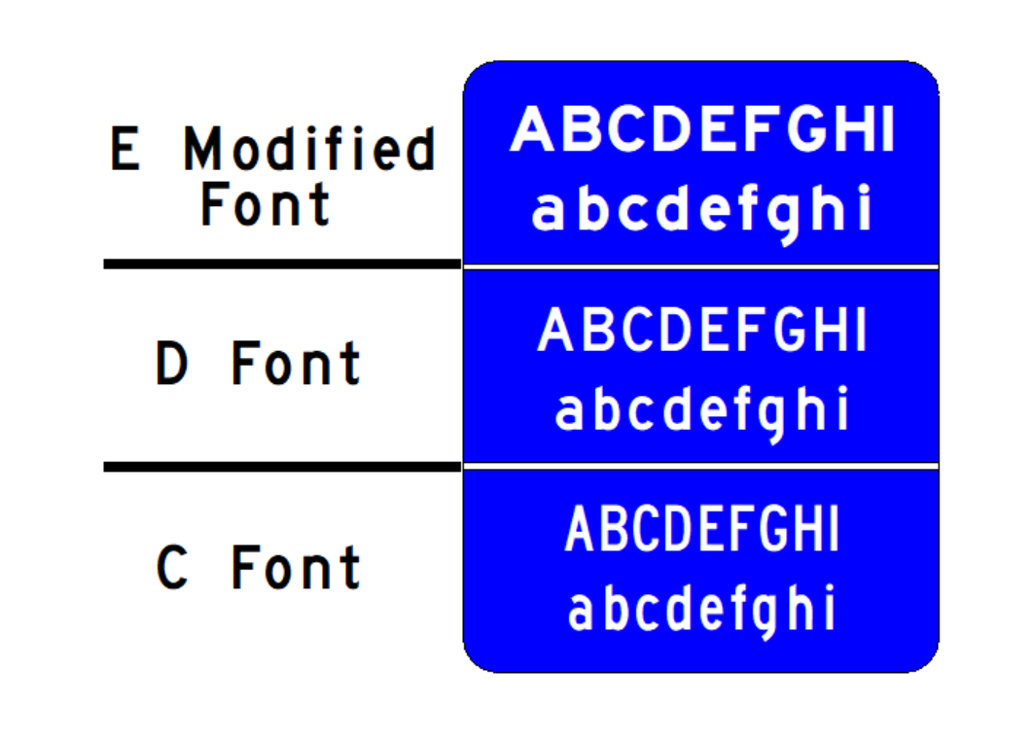
Federal Highway Font Comparisons

Sign Fabrication and Retroreflectivity
- Digital printing technology for highway signs is coming a long way, it allows a much greater variety of colors compared to available standard sign sheeting colors. Non-standard colored inks used in digital printing tend to have a shorter life expectancy and warranty compared to standard highway sign colors.
- All signs on MoDOT right of way shall be retroreflective (both legend and background) so the sign has the same appearance at night as it does during the day.
  - There is no minimum sheeting requirement other than being retroreflective, however, keep in mind the lower grade sheeting (especially the older glass bead technology like ASTM Type I Engineer Grade Sheeting) have a much shorter life expectancy.

