Contents
Create a new Revision Request 1
Creating a Tracked Change document 1
Uploading New or Revised Documents for the EPG 1
Uploading a new file: 2
Updating an existing file: 2

Create a new Revision Request
When you are requesting a change to a Standard Specification, Standard Plan, or EPG article we ask that you create a new Revision Request. When filling out the form please fill out all the fields applicable for your request. For more information on the approval process Click here.

Creating a Tracked Change document
Changes should be created in a word document with Track Changes mode on. You only need copy the portions of the Spec, Standard or EPG article you want to revise (you do not have to copy the whole article if you’re not changing all of it) into word and then edit the document with track changes on so we know what needs to be added and what needs to be taken out. Then attach that file to the Revision Request.
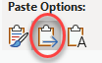
When copying the article into word highlight and select what you want copy from the EPG. When you paste the article into word, right-click in the word document and under the paste options use Merge Formatting.

If you are wanting to change Standard Plans It would be best to redline a PDF and attach it to the revision request.

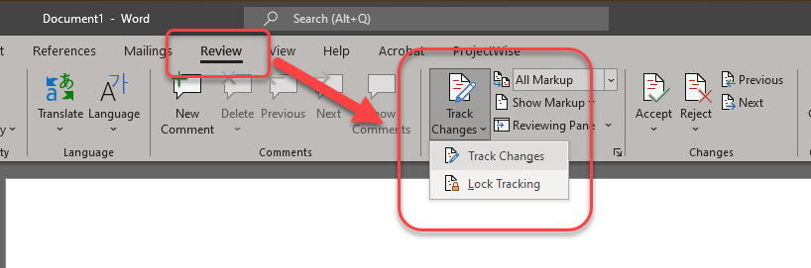
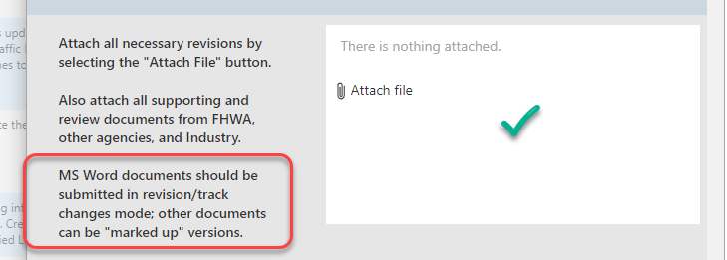

Here are links to a few examples of documents with Track Changes:
- Simple Text Changes
- More Complex Changes
- Standard Plan Markup

If you need help getting started you can always contact engineering.policy@modot.mo.gov

Uploading New or Revised Documents for the EPG

We have created a location in SharePoint for each division to put files that will be replicated over to the EPG overnight. This process will allow us to keep files organized and allow the owners of the documents to update the files when they become outdated or obsolete. Versioning will be used in this document library, that way if we ever need to see an old version of the document it will be in SharePoint and not out on the EPG. If your documents are already stored in eProjects you will not need to move them. The process there works the same as our new sharepoint location

- If you do not have access to your divisions folder or need a folder created, you can either request access on the SharePoint page or you can email engineering.policy@modot.mo.gov.
- You can either store your original file here and edit it at this location or you can just upload a copy.
- Before copying or moving files:
  - Revision dates will not be used in the filenames. If you want a revision date, please put it in the document.
  - Do Not Use spaces in your filename. If you need a space in your document name either use a hyphen or a dash.
- Files will not be deleted from this library. If the file becomes obsolete, we can change the column validation to Archived. This will automatically move the file to the Archive folder and it will be removed from the EPG overnight.

Uploading a new file:

- Make sure there are no spaces or dates in the filename of your document
- Go to the EPG SharePoint file Location
- Select the location where you want to upload your document then just drag and drop it to that location.
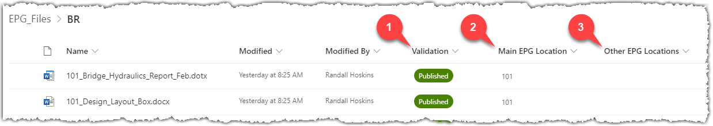
- Once your document has been uploaded you will need to fill out some Metadata.
- Validation will already be set to published, this just means your file will be active in the EPG
- Fill in the Main EPG Location (e.g. 101.5)
- If your document is linked anywhere else in the EPG add those locations in the Other EPG Locations Column
- Since this is a new document you will need to let the EPS Section you put a new file out there that needs to linked and added in the EPG. You can either do this through a Revision Request or you can send an email to Engineering Policy with the name of your document

Updating an existing file:

- If you are editing the document in the EPG files location just edit the file and save it the new version will be updated overnight
- If you are replacing the document the make sure the name is the same and just drag it to the same location, you should get a dialog box select Replace and it will create a new version of the document and it will be uploaded overnight.
- After replacing the file make sure the field Validation is set to Published.
